Complaints Data Sheet Guide

March 2023
Version 10

National Complaints Governance and Learning Team

Return Deadlines
- Collate Monthly
- Return quarterly to nationalcglt@hse.ie
- Deadlines for returns will be advised by NCGLT

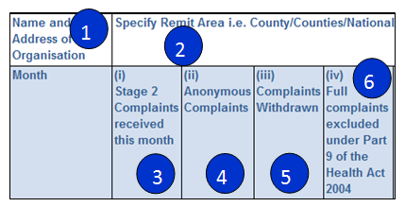
Monthly Complaint Statistics Help

- Enter name here
- In the 'Specify Remit' column enter location: Example "National" or specific counties.
- All fields in column '(i) Stage 2 Complaints received this month' column must have content. Record total figure for complaints received. If no complaints received, enter '0'. This total is accounted for in columns (ii) to (vii).
- Anonymous complaints, these complaints from unknown sources cannot be investigated formally.
- Complaints that have been recorded but subsequently are withdrawn by the complainant.
- The number of complaints where every element of the complaint is excluded under Part 9 of the Health Act 2004 Complaints excluded under Part 9.
- Complaints that have been dealt with informally at Stage 2a by the Complaint Officer, whereby no formal investigation was necessary ie resolved informally.
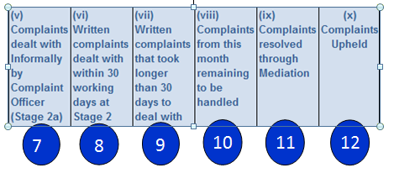
- Complaints that have been investigated and reported on within 30 working days at Stage 2 Formal Investigation.
- Complaints that have been investigated and reported but took longer than 30 working days at Stage 2 Formal Investigation.
- Do not alter any field in ''(viii) Complaints from this month remaining to be handled' column. This is calculated automatically and locked as no input is required. When all complaints received in the month are accounted for in preceding columns, this total will return to Zero.
- Regardless of which stage the complaint has been dealt with, complaints resolved through mediation by a qualified mediator are to be recorded here.
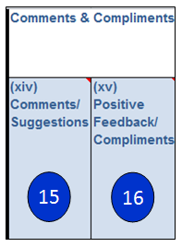
- Complaints Upheld and/or Partially Upheld.
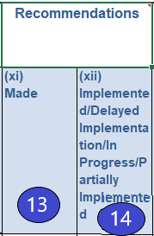

- Recommendations Made: This refers to recommendations made in complaints investigations completed this month, regardless of the stage of the complaints process the recommendations were made in.
- Recommendations Implemented/Delayed Implementation/In Progress/Partially Implemented: This refers to recommendations Implemented/Delayed implemented/In Progress/Partially Implemented this month, regardless of when the recommendations were made.
- Any comments or suggestions received by the complaints officer should be noted here- total figure only.
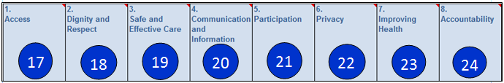
- Total figure for positive feedback received through any staff member regarding a service should be included in here. This includes feedback received throughout the organisation and is not specific to feedback received directly via the complaints officer.

- Access: Our services are organised to ensure equity of access to public health and social care services. Click here for more information on complaints categorised as "Access"
- Dignity and Respect: We treat people with dignity respect and compassion. Click here for more information on complaints categorised as "Dignity and Respect"
- Safe and Effective Care: We provide services in a safe environment, delivered by competent, skilled and trusted professionals. Click here for more information on complaints categorised as "Safe and Effective Care"
- Communication and Information: We listen carefully and provide clear and comprehensive health information and advice. Click here for more information on complaints categorised as "Communication and Information"
- Participation: We involve people and their families and carers in shared decision making about their health care. Click here for more information on complaints categorised as "Participation"
- Privacy: We ensure adequate personal space to ensure privacy in providing care and personal social services. We maintain strict confidentiality of personal information. Click here for more information on complaints categorised as "Privacy"
- Improving Health: Our services promote health, prevent disease and support and empower those with chronic disease to self care. Click here for more information on complaints categorised as "Improving Health"
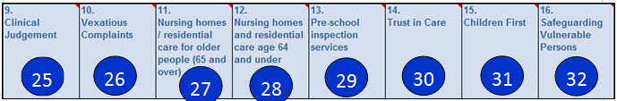
- Accountability: We welcome your complaints and feedback about care and services and work to address your concerns. Click here for more information on complaints categorised as "Accountability"

- Clinical judgement - complaints about decisions made or opinions formed in connection with the diagnosis, care or treatment of a patient. Many complaints include elements on clinical judgement. Although complaints in relation to clinical judgement are excluded under Part 9 of the Health Act 2004, the HSE Policy and Procedure for the management of complaints provides guidelines on how to deal with these complaints. Please see Section 10.1 of the Procedure for the management of complaints in the HSE.
- Vexatious complaints - complaints that are intentionally troublesome. Vexatious complaints are excluded under Part 9 of the Health Act 2004. For guidelines on how to deal with vexatious complaints, please see Section 10.3 of the Procedure for the management of complaints in the HSE.
- Nursing homes / residential care for older people (65 and over) - includes complaints about private nursing homes and long term HSE care facilities.
- Nursing homes and residential care age 64 and under - includes complaints about private nursing homes and long term HSE care facilities.
- Pre-school inspection services- includes complaints made about pre-school inspection services.
- Trust in Care - complaints that fall under 'Trust in Care' guidelines, e.g. allegations of abuse made against staff members.
- Children First - complaints that fall within the remit of 'Children First National Guidelines for the Protection and Welfare of Children, e..g. allegations of abuse of a child.
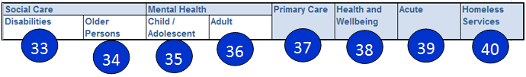
- Safeguarding Vulnerable Persons at Risk of Abuse: To safeguard and protect clients of Disability Services and Older Persons' Services from abuse and neglect.

- Social Care: Enabling people with disabilities to achieve their full potential including living as independently as possible, while ensuring that people are heard and involved in all stages of the process to plan and improve services.
- Social Care: Maximising the potential of older people, their families and local communities to maintain people in their own homes and communities, within existing resource
- Mental Health: Child and Adolescent Community Mental Health Services. Supporting the population to achieve their optimal mental health.
- Mental Health: Adult Mental Health Services. Supporting the population to achieve their optimal mental health.
- Primary Care: Achieving a more balanced health service by ensuring that the vast majority of patients and clients who require urgent or planned care are managed within primary and community based settings, Examples: Community Intervention Teams, Healthcare Associated Infections, Medication Management, Physiotherapy, Occupational Therapy, Orthodontics, Nursing, Podiatry, Ophthalmology, Audiology, Dietetics and Psychology, GP Activity, Opioid Substitution Treatment, Traveller Health, Homeless Services, Needle Exchange, Medical Cards GP Visit Cards
- Health and Wellbeing: Health and Wellbeing is responsible for driving improving the health and wellbeing of Ireland's population. Examples: Immunisations and Vaccines, CervicalCheck, BowelScreen, Diabetic RetinaScreen, Tobacco, Child Health, BreastCheck, Environmental Health - Food Safety, Environmental Health - Sunbeds, Serious Reportable Events
- Acute Services- A wide range of emergency, diagnosis, treatment and rehabilitation services are provided in Ireland's public hospitals both those managed directly by the HSE and those run by voluntary organisations. Our world class national specialist services include heart, lung and liver transplants, bone marrow transplants, spinal injuries, paediatric cardiac services and medical genetics
- Homeless Services- complaints related to Homelessness services.
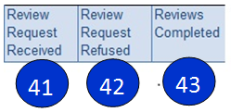
- Number of Review Requests received.
- Number of Review Requests refused under Your Service Your Say.
- Reviews conducted and completed.
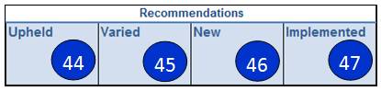

- Review Officer upheld Complaints Officer’s recommendation(s)
- Review Officer altered Complaints Officer’s recommendation(s)
- Review Officer made new recommendation(s)
- Recommendations made by the Review Officer Partially/Fully Implemented

