CHILDRENS SURVEY – SAMPLE
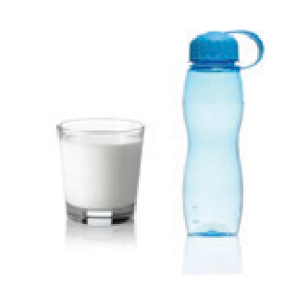

- What did you have to drink in school today? Milk □
Water □ Juice □
Fizzy Drink □
Tea or Coffee □

- Did you have a sandwich, wrap or roll? Yes □ No □

- Have you eaten fruit at school today? Yes □ No □

- Have you eaten anything from the top shelf of the food pyramid at school today e.g. crisps, chocolate, cakes, buns, bars or sweets? Yes □ No □

- What else was in your lunch box?

- Name one thing you like about lunch in school?

- Is there anything that you do not like about lunch in school?

