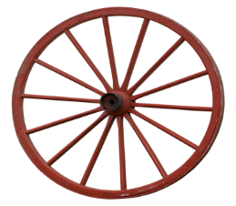 **‘Minding my mind’**

 **Take a break and** **go for a walk!**

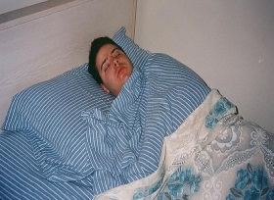 **Get a good sleep it lifts the mood!**

[](https://www.google.com/imgres?imgurl=https://media.istockphoto.com/vectors/healthy-food-vector-diet-for-life-nutrition-modern-balanced-diet-vector-id875565078&imgrefurl=https://www.istockphoto.com/vector/healthy-food-vector-diet-for-life-nutrition-modern-balanced-diet-isolated-flat-gm875565078-244425912&tbnid=Q7DsMwuh2Ut8aM&vet=12ahUKEwivyNzX5KboAhUjkFwKHRnVBGQQMygdegQIARBr..i&docid=Da7aq9DA6Rrv3M&w=1024&h=576&q=healthy%20food%20cartoon&hl=en&ved=2ahUKEwivyNzX5KboAhUjkFwKHRnVBGQQMygdegQIARBr) **Mind the body and the mind!**

[](https://www.google.com/imgres?imgurl=https://st1.thehealthsite.com/wp-content/uploads/2019/11/alcohol-abuse1.jpg&imgrefurl=https://www.thehealthsite.com/news/now-a-drug-that-can-help-reduce-alcohol-consumption-148312/&tbnid=TxbiU4LLOPwWcM&vet=12ahUKEwiA7IfC4aboAhUGLsAKHZACCmkQMygfegQIARBV..i&docid=DlceFK9QWWnneM&w=620&h=330&q=reducing%20alcohol%20consumption&hl=en&ved=2ahUKEwiA7IfC4aboAhUGLsAKHZACCmkQMygfegQIARBV) **Careful …alcohol can bring you down!**

 **Listening to music really lifts the spirits!**