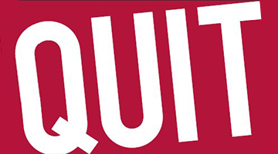
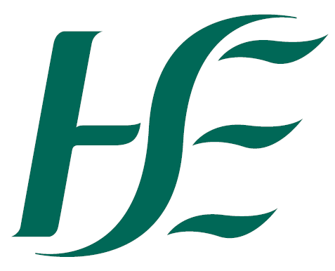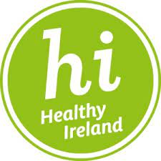

_{TOBACCO FREE CAMPUS}
Quality Improvement Bursary 2022/2023

About - Tobacco Free Ireland Programme (TFIP)
The Tobacco-Free Ireland Programme has one main aim, which is to improve the health and wellbeing of the population. The main purpose of the TFI programme is to take responsibility for and effectively drive the government’s strategy of delivering a Tobacco Free Ireland (i.e. reduce smoking prevalence to less than 5% of the population and protect the next generation of Irish Children from ever taking up smoking and the harms caused by smoking and second hand smoke. We want to show leadership in this area and strive to achieve a complete Tobacco Free Health Service.

Background – Tobacco Free Campus
The HSE as the leading healthcare provider is committed to protection and prevention of illness and disease through a reduction in the use of tobacco and its harmful effects. It developed and launched a Tobacco Free Campus Policy in 2012. The policy aims is to create a healthier tobacco free, clean environment for its staff, patients/service users and visitors. The Tobacco Free Ireland Programme (TFIP) is committed to supporting all services nationally to achieve the highest level of policy implementation and has consistently employed new and creative supportive strategies. The strategy chosen in 2019 was ‘incentivisation’ and the TFC Bursary initiative was planned with the Global Quality Best Practice Standards (GNTH) as a roadmap to foster creative thinking, build supportive processes and address compliance. The initiative was launched under three criteria: Sustainability, Innovation & Engagement of Stakeholders and Monitoring & Compliance Building.

Quality Improvement Bursary
The Quality Improvement Bursary is an opportunity to avail of €5,000 to improve tobacco management and the actions taken to implement this strategy within your service with the benefit of a supportive structure and an identified timeframe. The process provides an opportunity to recognise, value and acknowledge the hard work of staff in the implementation of HSE TFC policy within their service.
What do services need to do?
To be eligible to apply for the bursary, all interested services needed to fulfil the following criteria:
1. Complete the Global Network for Tobacco Free Health Services (GNTH) online self-audit
2. Develop a Quality Improvement Plan (QIP) to guide and support improved policy implementation

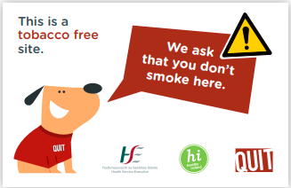 |  | 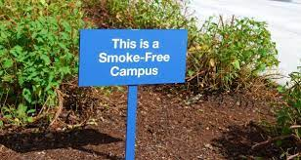

Quality Improvement Bursary 2022/2023
Q & A

What is the purpose of the Bursary?
To improve tobacco management within your service and the actions taken to implement this strategy within your service with the benefit of a supportive structure and an identified timeframe.
Many Health Promotion & Improvement (HP&I) staff also use the bursary process to build relationships and engage new services in TFC policy implementation.

Who can apply and what sections?
Any service under the HSE umbrella and section 38 e.g. The Daughters of Charity and any voluntary hospital.

Where can I find information on sections 38 and 39?
Distinction between section 38 and 39 agencies can be found in your TFC training resource pack.

What are the timelines?
Application Date: 30th June 2022
Audit/QIP Submission for review: 31st January 2023
TFIP submission assessment: 28th February 2023
Prep financial allocation of Funds: 31st March 2023
Funds to be issued by: 09th April 2023
Award ceremony: Summer 2023

What is the GNTH?
The Global Network for Tobacco Free Healthcare Services (GNTH), commonly called the Global Network, is an independent, international, non-profit association that was formed to facilitate action on tobacco within healthcare services. The HSE is a member of the GNTH. For more information, click here https://www.tobaccofreehealthcare.org/

What is the Global Network implementation concept?
The Global Network Implementation Concept is a systematic approach that combines evidence-based standards with a process of self-audit to support sustained commitment and continuous improvement. There are eight global standards. For more information, click here https://www.tobaccofreehealthcare.org/standards/overview

What is GNTH Gold Forum International recognition?
Nomination is accepted when the self-audited high-level implementation of all eight global standards (min. 126pt), identified problems and proposed solutions, has been verified and validated by a robust national process. There should be an identified lead to oversee the process and act
as the authorised submitter for nominations to the GOLD Process. GOLD Forum membership
is for a period of 4 years.

Does ever site receive funding?
In 2021, a total of 44 services fully engaged with the Bursary process and submitted a QIP application. All of these services were funded to varying degrees following assessment by an independent quality improvement expert.

What is the award ceremony and when does this typically happen?
A unique opportunity to showcase the achievements of successful candidates. This will happen after the funds have been issued, possibly May/June 2023.

What do services spend their funding on?
Signage, garden equipment, smoke free space, improving patient and staff facilities

Key achievements and learnings so far….
1. Creative and innovative approaches by staff to policy improvement
2. Enhanced working partnerships between operational staff and HP&I staff
3. The process provided an opportunity to recognise value and acknowledge our Staff
4. Implementation and achievement of other priority programmes, targets and commitments for example MECC training

What are examples of why the QIP did not work in some cases?
Lack of health promotion and improvement staff
Lack of local stop smoking service to refer staff and clients to
Poor engagement with the Healthy Ireland agenda

Where can I find the link to the TFC toolkit?
https://www.hse.ie/eng/about/who/tobaccocontrol/campus/tobacco-free-campus-toolkit-guidance-document-oct-16.pdf

A GNTH Quality Improvement Plan can be downloaded here:
https://www.hse.ie/eng/about/who/tobaccocontrol/campus/gnth-qip.docx

Where can I find the new TFC signage?
The new TFC signage can be found in both Ireland and English here:

What is MECC?
By Making Every Contact Count health professionals can encourage patients to make healthier lifestyle choices during routine contacts to help prevent and manage chronic diseases. For more information, click here https://www.hse.ie/eng/about/who/healthwellbeing/making-every-contact-count/

