Who we are
We are public health nurses (PHNs) and registered general nurses (RGNs) who work together to support and contribute to community services. We also work alongside other health and social care professionals as a team. You can expect a visit from any member of the nursing team.

Where and how we work
PHNs and RGNs are based in health centres and primary care centres. Primary care centres provide many of the health or social care services that you find in your community, outside of the hospital setting. These services are provided by the primary care team, which includes doctors, social workers, nurses, therapists and others.
We provide care in the home, the clinic and local schools. We may also use ‘telehealth’ for our consultations. Telehealth is a phone/video consultation (meeting) to check in to see how you are.
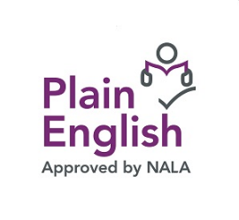

Version Two Sept 2021
Our contact details
Public Health Nurse and or Registered General Nurse
Name
Phone

Name
Phone

Primary Care/Health Centre details:

Monday to Friday
Contact us by phone Monday to Friday between ______ am and _____ pm. If you phone outside these hours, you can leave a message and the nurse will return your call as soon as possible or on the next working day.
Weekend services
(Only available in some regions and always by appointment.)
If you need nursing care at weekends, we may be able to arrange an appointment in your home or at a clinic. You may also have to satisfy other eligibilty conditions.

What we aim to do
As members of the primary care team, we aim to:
- offer a wide range of services to you and your family
- provide this care in the home, local clinics, primary care centres, schools, and at support groups
- provide integrated care in collaboration with your GP (doctor) and within the wider primary care team
- promote health, well-being and social inclusion and prevent hospital admissions
- work with other agencies, such as Tusla (The child and family agency) and local services like homeless and addiction services
Your Service, Your Say
You can contact us about any staff member or service issue by:
- phoning HSE info line, 1850 24 1850
- emailing yoursay@hse.ie
- commenting directly on www.hse.ie
on ‘Your Service, Your Say’
How we keep your information safe (GDPR)
We keep your information (data) safe by managing it in line with the General Data Protection Regulations (GDPR), 2018. If we need to share information with other professionals, we will ask you first for consent.
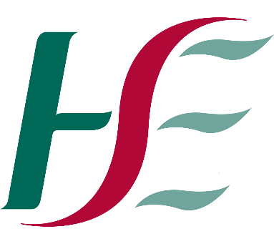
Public Health Nursing Service providing services to help you in your community or home
This leaflet tells you about our services and how to contact us. It also gives you other useful information.
(During the Covid-19 pandemic, the delivery of Public Health Nursing services may need to be prioritised.)
Mission statement
Care Commitment Compasson
Public Health Nursing Services aim to deliver safe, quality, and person centred community nursing care across the lifespan: we are committed to promoting health and wellbeing and enabling people to live healthy and fulfilled lives.
Our services
1. Maternity health service
- We visit all new mothers to assess them after they have had their babies.
- We provide parenting information, support and health promotion tips, including directing parents to helpful services.
- We provide education about, and may check for post-natal depression.
- We provide family planning advice and care.
2. Child health services
- We visit all newborn babies to carry out the ‘heel prick test’ if needed – we take a blood sample to test for eight rare conditions.
- We provide child developmental assessments, health promotion and a safety awareness programme.
- We provide child clinical services, such as care after an operation.
- We give you support and information about feeding your baby, including breastfeeding.
- We carry out hearing tests, vision screening tests, and immunisations in schools.
- We co-ordinate care for children with complex care needs.
- We deal with child welfare and protection issues and work closely with social workers.
3. Services for adults and older people
These services include wound care, injections and end-of-life care in the home.
We accept individuals referred to us from their GP (own doctor) and acute hospitals (hospitals that provide medical and surgical services). You may need to satisfy eligibility conditions to use our clinical services. You may also self refer.
- We provide guidance and information about how best to plan your care. We do this after a full nursing assessment.
- We support, monitor, and assess your care.
- We assess and provide treatment to people after they have left acute hospitals.
- We identify and support applications for home support services like homecare packages.
- We provide health protection and health promotion information and advice to individuals, families and groups.
- We provide palliative and end-of-life care and community oncology (cancer) care.
- We have specialist nurses for managing wounds. In some regions, we also provide continence care (help with toilet-related matters).
- Many areas have specialist palliative teams.
- We provides support to people with disabilities

