 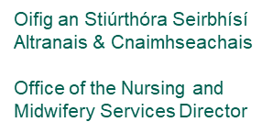

**Transition to Community Nursing Toolkit/Induction**

**For**

**Registered Public Health Nurses**

**And Student PHNs (complete sections as relevant)**

**HSE National Document**

(For Student PHNs commence induction on first clinical placement)

**Version One Dec 2022**

|  |  |
| --- | --- |
| **Staff Member’s Name:** |  |
| **Address** |  |
| **Contact No.:** |  |
| **Start Date:** |  |
| **Assigned Area:** |  |
| **Personnel Number:** |  |
| **Contract type:** |  |

**Table of contents**

**1.0 Introduction to community nursing 3**

**2.0 Transition to Community Nursing Toolkit 7**

2.1 Aim of the toolkit 8

2.2 Objectives of the toolkit 8

2.3 Timeline for completion of the toolkit 9

2.4 iStart Hub HSE Induction 10

2.5 Induction Checklist 10

2.6 Education and Training Record 11

2.7 Competency Self-Assessment 11

2.8 Buddy Nurse System 10

2.9 Mentoring 11

2.10Professional Development Plan 11

2.10 Clinical Leadership Competency Framework 12

**Section 1: Pre-Employment Checklist 12**

**Section 2: Induction Checklist 13**

**Section 3: Education and Training Record 18**

**Section 4: Clinical Skills Self-Assessment 20**

**Section 5: Certificate of receipt of induction 24**

**Appendix 1: Buddy Nurse System 25**

**Appendix 2: Scope of Practice Decision Making Framework 27**

**Appendix 3: Group Membership 37**

**1.0 Introduction to Community Nursing**

The Public Health Nursing Service is a generalist nursing service underpinned by the principles and values of primary care and public health, including those of equity, accountability and evidence-based nursing care, working to public policy agenda and reform.

**Mission statement: “CARE, COMMITMENT, COMPASSION: Public Health Nursing Services aim to deliver safe, quality, and person centred community nursing care across a lifespan: we are committed to promoting health and wellbeing and enabling people to live healthy and fulfilled lives".**

The enhanced community care model is currently being implemented and public health nursing will play a significant role in this change model. Specialist teams for management of chronic disease and care of the older person are in development.

The service is delivered within a range of settings: in the home, health centres, schools and in a variety of community settings. As pivotal teams members, Public Health Nursing staff work in collaboration and partnership with other members of the primary care team and also with acute / community hospital services, voluntary bodies and statutory and non-statutory agencies.

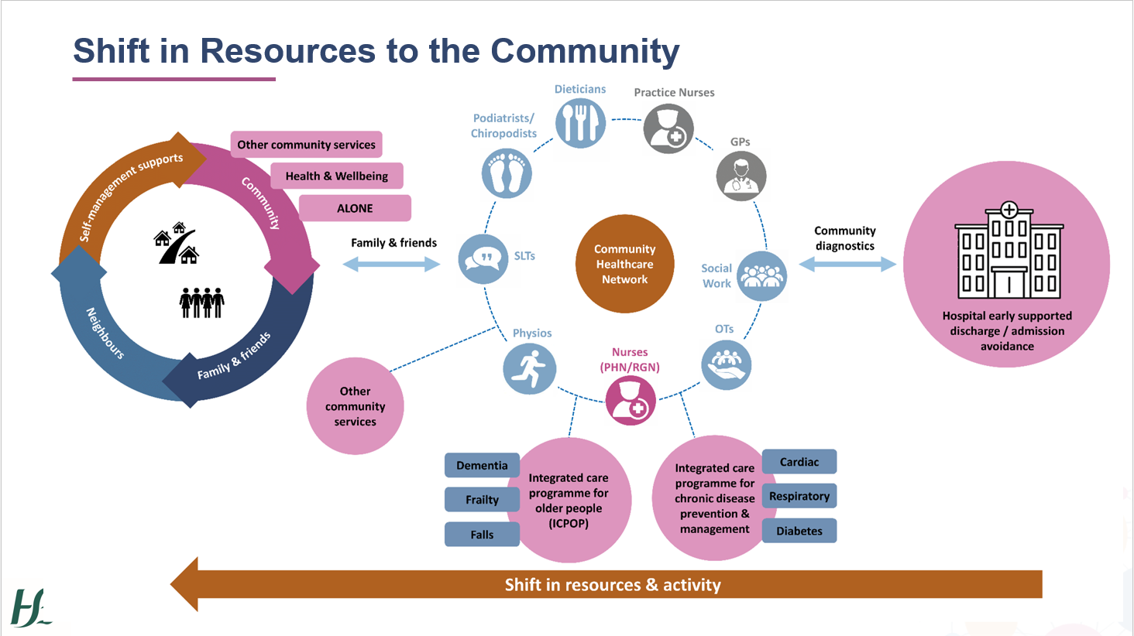

**The Enhanced Community Care Programme will include**:

* Significant enhancement in primary and community care through the following key priorities:
  + Establishment of 96 Community Health Networks (CHNs), providing the foundation and organisational structure through which integrated care is provided locally at the appropriate level of complexity
  + Establishment of 30 community Integrated Care Specialist Teams for Older People
  + Establishment of 30 Integrated Care Specialist Teams for Chronic Disease
  + Progress the implementation of the ALONE Type volunteer model linked to CHNs and COVID-19 community call programme
  + Establishment of Community Intervention Teams to ensure total national coverage
  + Full roll out with interRAI (international Resident Assessment Instrument) - this will replace the current Common Summary Assessment Report (CSAR) paper-based assessment being used. The use of the interRAI SAT assessment will ensure that people receive a comprehensive standard assessment when applying for support, regardless of where they live or who is doing the assessment. Information will be recorded electronically and will be securely stored which allows ease of access to information and reduces duplication of assessments.
* Progress relevant eHealth initiatives
* Expand community diagnostics to improve access for general practice and community specialist teams including access to plain film x-rays, ultrasound, MRI, CT, ECHO and spirometry with a target delivery of 195,000 additional diagnostic tests
* Continue implementation of the 2019 GP Agreement

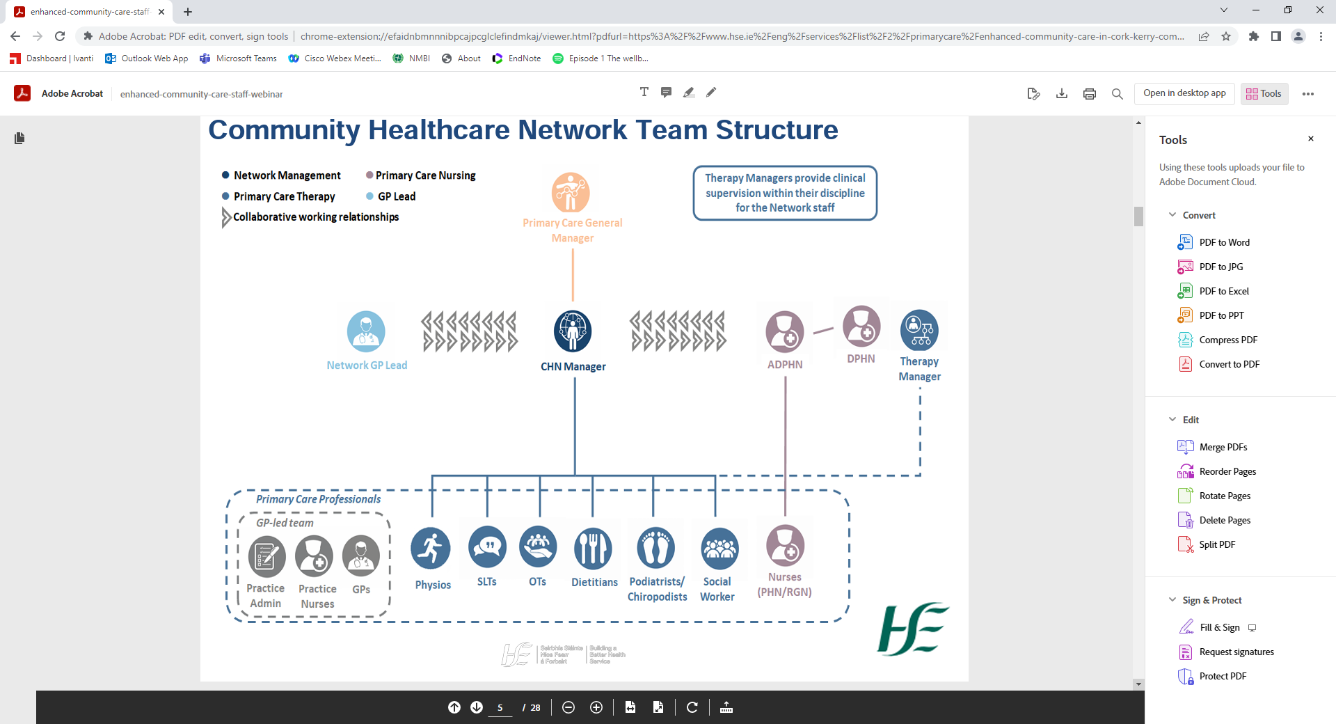

**Director of Public Health Nursing**

Responsible for the clinical and operational governance of Community Nursing within their area.

**Assistant Director of Public Health Nursing**

Support Community Nursing by working collaboratively with the Network Manager, Heads of Discipline, GP Lead and colleagues to deliver integrated care.

**Community Healthcare Network Manager**

Accountable and responsible person for ensuring the delivery of Primary Care services to the population within the defined Network area and working collaboratively with the Heads of Discipline, GP Lead, ADPHN , practice development co ordinators and colleagues to deliver integrated care

**Community Nurses**

Community Nurses are integral to the success of the Networks and continue to work collaboratively with their Primary Care colleagues, as they do today, to ensure standards of care are maintained.

**Public Health Nurses**

PHNs deliver care across the lifespan to individuals, families and communities. The focus of the service is to promote health and well-being, protect the public and provide clinical nursing care to the population through the delivery of high-quality evidence based nursing care.

**Registered General Nurses**

Registered general nurses (RGNs) work alongside the PHN. The primary focus of the RGN is on individual patients and care of the older person. The RGN works closely with the PHN to assess plan and implement nursing care and works in the home and clinic environment. RGNs undertake relevant education and training programmes relative to their role in community nursing.

**Nurse Practice Development Coordinator**

The Nurse Practice Development Coordinator facilitates the development of a continuous process of improvement in nursing practice in the community setting and excellence in the quality of care being provided. The Nurse Practice Development Coordinator strategically plans, develops and evaluates nursing care in collaboration with the nursing management teams and nursing staff.

**Clinical Skills Facilitator**

The Clinical Skills Facilitators (where they are in post) assist in supporting registered nurses (PHNs, RGNS, CNS and ANP) with development of clinical skills and competencies in order to fulfil their professional roles and responsibilities in an ever changing health environment.

**Community Intervention Team**

A Community Intervention Team (CIT) is a specialist, health professional team (including RGNs) which provides a rapid and integrated response to a patient with an acute episode of illness who requires enhanced services/acute intervention for a defined short period of time. This may be provided at home, in a residential setting or in the community as deemed appropriate, thereby avoiding acute hospital attendance or admission, or facilitating early discharge.

The CIT, through its fast-tracked provision of services enhances the overall primary care system, providing access to nursing and home care support, usually from 8am to 9pm, seven days per week.  Referrals are accepted from hospitals, GP’s and other community sources.  Services provided include: Administration of IV antibiotics, acute anticoagulation management; acute wound care and dressings; Urinary related care; Ostomy Care; Medication Management; Enhanced Nurse Monitoring.

**Clinical Nurse/Midwife Specialists**

Clinical Nurse/Midwife Specialists work in a defined area of nursing and midwifery practice. This specialist practice encompasses a major clinical focus of care to patients or clients and their families in community and integrated care settings. The specialist nurse or midwife will work with medical and para-medical colleagues.

**Advanced Nurse/Midwife Practitioners**

Advanced Nurse Practitioner services are provided by nurses who practice at a higher level of capability as independent, autonomous and expert advanced practitioners. The overall purpose of the service is to provide safe, timely, evidenced based nurse-led care to patients at an advanced nursing level. This involves undertaking and documenting complete episodes of patient care, which include comprehensively assessing, diagnosing, planning, treating and discharging patients in accordance with collaboratively agreed local policies, procedures, protocols and guidelines and/or service level agreements/ memoranda of understanding.

Advanced Midwife Practitioner services are provided by midwives who practice at a higher level of capability as independent, autonomous and expert advanced practitioners. The overall purpose of the service is to provide safe, timely, evidenced based midwife-led care to women and babies at an advanced midwifery level. This involves undertaking and documenting complete episodes of maternity care, (assess, diagnose, plan, treat and discharge women and babies), according to collaboratively agreed local policies, procedures, protocols, guidelines and scope of practice in the clinical setting and/or service level agreements/ memoranda of understanding; demonstrating advanced clinical and theoretical knowledge, critical thinking and decision making skills.

**2.0 Transition to Community Nursing Toolkit**

The HSE recognises the benefits of a Transition to Community Nursing Toolkit that supports newly qualified nurses in professional and personal development and also supports retention and recruitment. This toolkit will assist the transition of Return to Practice PHNs ,newly qualified PHNs, Health Visitors nurses recruited to the Irish health service and existing PHNs that transfer within the organisation.

**2.1 Aim of the Toolkit:**

The overall aim of this document is to enhance safe, person centred, high quality nursing care, to all service users accessing community-nursing services.

The toolkit aims to:

* Provide the newly appointed Public Health Nurses (PHN’s) with the knowledge and skills to fulfil their role
* Return to Practice PHNs
* Health Visitors qualified in the UK
* Assist PHN who transfer from one DPHN or CHO to another
* To provide PHN line managers with a framework for induction of PHNs in a standardised manner
* To provide a framework for orientation of nurses to the community for use by the PHN and ‘Buddy’ Nurse

**2.2 Objectives of the Toolkit:**

* To facilitate the PHN in identifying the skills and competency required to work in the community setting
* To provide a framework for supporting induction into the PHN role over a defined period of time
* To standardise practice
* To ensure the PHN has ongoing support from PHN management

**2.3 Timeline for completion of the Toolkit**

**The toolkit consists of the following elements:**

**2.4 iStart Hub HSE Induction**

The i-START Hub has been developed to support induction and orientation of all employees within the Irish Health and Social Care Services. It is one of the many features of the HSeLanD online Learning and Development platform. To access i-START: <https://i-start.HSeLand.ie/>

The HSE have identified 12 core themes that you will find helpful in your new role. It is suggested that you work through each theme as appropriate to your specific needs. This may best be done as a sequential process from 1 to 12 or in an order of your choosing. Ideally this should be completed within 4 months of commencement as part of your induction. When you have explored all twelve themes you should attempt the assessment and when successful you will be awarded a certificate of completion.

**2.5 Induction Checklist**

The induction checklist is completed by the PHN and ADPHN. It contains the following elements:

* Pre-employment checklist
* Organisational Information
* Operational Information
* Human Resource Information
* Travel information
* PCM username and password
* NiSRPs (myselfservice/where in use)
* Health & Safety/Risk Management/Complaints Management/ NIMS forms
* Quality Care Metrics (if in use)
* Provision of equipment
* Relevant PPPGs for Practice/ access to Electronic Policy Portal and other Shared folders

**2.6 Education and Training Record**

The education and training record section includes mandatory and relevant education and training which the newly appointed PHN should complete where relevant. You may already have completed some of these training programmes as part of previous employment in the Irish health service or as part of the iStart Hub programme- you do not need to repeat them unless the certificates are out of date. As part of the induction/PDP process, your education and training requirements will be discussed and agreed with your line manager/ADPHN, including realistic timelines to complete the required education.

**2.7 Competency Self-Assessment**

The PHN should self-assess their ability to complete the clinical skills required for the specific service they are working in. (see section 4 page 27)

**2.8 Buddy Nurse System**

The Buddy Nurse system is an informal support system where a newly recruited PHN is assigned a buddy from the existing nursing team. Starting a new job can be a nervous time for any nurse. Being assigned a “Buddy” may help newly appointed PHNs to understand workplace culture and answer any questions that staff might otherwise be reluctant to ask. Buddy systems encourages informal learning; developing skills through social interaction and observation. Communicating with and observing another individual is an effective way to learn. This is an opportunity to develop skills and - equally important - confidence. The buddy system is designed to support the PHN to integrate as a new member of the team and support effective team-working. No specific training is required to be a Buddy Nurse.

The buddy system provides a supportive relationship where staff can openly discuss their progress and gain constructive criticism and recognition. We are all required to demonstrate continuous professional development (CPD) in our roles. A buddy system offers an opportunity to reflect on practice and experience. This reflection can be utilised as evidence for professional development.

A buddy nurse can be any registered nurse (PHN) working as part of the community nursing team for more than 1 year.

**Expectations of Buddy Nurse**

|  |  |
| --- | --- |
| **A buddy nurse** | **A buddy nurse does not** |
| * Provides support and guidance to the newly appointed PHN in the community * Acts as a role model * Facilitates introductions and promoting good working relationships * Provides guidance on local culture and ways of working * Support in navigating the new work environment * Reflection on practice * Informal learning support | * Replace your line-manager / formal managerial structure, or replace the appraisal process. * Provide support outside of working hours |

**Further information on the Buddy Nurse System is included in Appendix 1**

**2.9 Mentorship (different to Buddying)**

What is Mentoring?

Mentoring is an active supportive partnership between two PHNs, one of whom is more experienced in the role. The two people work together for the benefit of the mentee, drawing on the Mentors knowledge, skills and experience to provide guidance to the mentee, in order to help them achieve their learning and goal objectives.

Mentors are usually outside the normal line of management. This makes asking for help easier. The mentor will support the mentee to explore their learning while building on their own knowledge and understanding of their profession.

Mentors inform by sharing their successes and failures and the insights gained from the experiences. They listen, guide, teach and help the mentee to learn for themselves. They help and advice on complex situations, and point the mentee in the direction to best solutions. Mentors offer support and reassurance when things are demanding, and will give honest feedback to the mentee, when invited to do so.

This role is different to preceptorship of students, and lasts approximately 6-8 months. It is an informal but very supportive role where mutual respect is key.

**2.10 Professional Development Plan**

A Professional Development Plan (PDP) is a tool that supports the nurse or midwife to identify professional goals for the benefit of themselves, their service users and their workplace to encompass best practice and clinical competencies. Professional development planning is a continuous development process that facilitates nurses and midwives, to use their experience and skills, to identify their professional goals and the supports required to achieve their goals, and helps advance both their individual plans and service user needs.

The community service you work in may utilise a local PDP, alternatively the HSE Digital PDP for Nurses and Midwives is available for use. You and your line manager may identify additional professional development needs during the period of transition to community nursing. Supports will be put in place to enable your professional development within local PDP and continuous professional development (CPD) processes.

For further information:

<https://healthservice.hse.ie/about-us/onmsd/cpd-for-nurses-and-midwives/pd-planning-framework.html>

<https://pdp.hseland.ie/>

**Performance Achievement**

Performance Achievement is a forward-looking, shared experience process that's designed to assist staff to develop within their role and add value to the work of their team(s) and services. It also encourages greater levels of engagement between staff and managers in a partnership approach.

For further information:

<https://performanceachievement.hseland.ie/>

**2.11 Clinical Leadership Competency Framework**

The Clinical Leadership Competency Framework (CLCF) is an e-learning resource, designed to provide healthcare professionals with the necessary knowledge and tools to support their clinical leadership competency development.

The CLCF is a virtual resource that has been designed to support all Nursing and Midwifery grades up to and including CNM and CMM Grades 2 or equivalent.

The CLCF can be accessed via HSELanD-Click on Hubs-Go to CLCF <https://clcf.hseland.ie/>

**Section 1: Pre-Employment Induction Checklist**

**The purpose of the Pre-Employment Induction Checklist is to assist the Line Manager to prepare for the arrival of new employees and to help them to settle in as quickly as possible.**

|  |  |  |  |  |  |  |
| --- | --- | --- | --- | --- | --- | --- |
| **Pre-Employment Checklist** | | | **Yes/No/**  **N/A** | **Action/Comment** | **Date** | |
| Line Manager to contact new employee before start date | | |  |  |  | |
| Recommend commencement of iStart Hub HSE Induction on HSELanD <https://i-start.hseland.ie/> | | |  |  |  | |
| Name of Buddy Nurse assigned | | |  |  |  | |
| Venue for “meet and greet” discussion arranged | | |  |  |  | |
| Accommodation/workspace identified for the new employee if appropriate | | |  |  |  | |
| Other relevant people notified (IT network support PHN Policy Portal etc) | | |  |  |  | |
| Check to ensure the new employee is set up for Payroll | | |  |  |  | |
| Check to ensure the new employee is set up on NiSRP or local HR systems | | |  |  |  | |
| Employee file prepared (this should be retained locally for each individual staff member) | | |  |  |  | |
| Employees in other relevant Departments informed of employee’s arrival | | |  |  |  | |
| Welcome Pack to be sent out including welcome letter outlining date/time and venue for meeting with DPHN or delegate. Include   * Mobile Phone Application (Ivanti) * Email address application form (Ivanti) * ID badge application and photo requirements * Laptop Application (Avanti) * HR Set up forms * Working hours * Dress code * Opening/Closing Hours Health Centre/PCC * HSE Staff Handbook * Parking permit application (if relevant) * Shared Drive (if relevant) | | |  |  |  | |
| Swipe Card for access (if relevant) | | |  |  |  | |
| Disability requirements (if relevant) | | |  |  |  | |
| Diversity requirements (if relevant) | | |  |  |  | |
|  | | |  |  |  | |
| **Section 2: Induction Checklist – First meeting with ADPHN and PHN** | | | | | | |
| **Organisational Information** | **Yes/No/**  **N/A** | **Action/Comment** | | | | **Date** |
| Welcome and Introduction to Health Centre /PCC Staff |  |  | | | |  |
| Orientation to Health Centre/PCC |  |  | | | |  |
| Assignment of duties/ role and responsibility in line with job description- Caseload |  |  | | | |  |
| Mission and Philosophy of Community Care |  |  | | | |  |
| Operations of PHN Office |  |  | | | |  |
| Dept Organogram: DPHN/ADPHN/PHN/RGN |  |  | | | |  |
| Organisational structures- Networks, Health Centres |  |  | | | |  |
| List of tel. no. for all DPHN/ADPHN/PHNs/specialist nursing staff/CIT and RGNs/and Health Centres |  |  | | | |  |
| Team Meetings Schedule |  |  | | | |  |
| Map of Area |  |  | | | |  |
| Local Services, Area Profile, including population profile |  |  | | | |  |
| Provide area specific information re local services including important contact numbers, referral pathways specific to services and advises re local NBSS postal arrangements |  |  | | | |  |
| **Operational Information** | **Yes/No/**  **N/A** | **Action/Comment** | | | | **Date** |
| HSE Identification Badge |  |  | | | |  |
| Hours of work as per HSE Contract discussed – start and finish time . Meal Breaks |  |  | | | |  |
| HR: Set up if required (re increments, payroll, annual leave etc) |  |  | | | |  |
| Contact details in the event of an emergency |  |  | | | |  |
| Personal contact mobile phone number |  |  | | | |  |
| Diary and communication methods |  |  | | | |  |
| Healthcare records management procedures |  |  | | | |  |
| Provision of Mobile Phone and Email access  Data Protection Policy:    Data Protection Breach Management Policy:  [Data Protection Breach Managment Policy](https://www.hse.ie/eng/services/publications/pp/ict/data-protection-breach-management-policy.pdf)  Use of Email / faxes / patient notes  Use of HSE Mobile Phone/Voicemail/Scanning/Healthmail  [Mobile Phone Device Policy](https://www.hse.ie/eng/services/publications/pp/ict/mobile-phone-device-policy.pdf) |  |  | | | |  |
| Social and digital media guidance  HSE ICT Policies:  [Information Security Policy](https://www.hse.ie/eng/services/publications/pp/ict/information-security-policy.pdf)  [I.T. Acceptable Use Policy](https://www.hse.ie/eng/services/publications/pp/ict/i-t-acceptable-use-policy.pdf)  [Electronic Communications Policy](https://www.hse.ie/eng/services/publications/pp/ict/electronic-communications-policy.pdf)  [Password Standard Policy](https://www.hse.ie/eng/services/publications/pp/ict/password-standards-policy.pdf)  [Encryption Policy](https://www.hse.ie/eng/services/publications/pp/ict/encryption-policy.pdf)  [Access Control Policy](https://www.hse.ie/eng/services/publications/pp/ict/access-control-policy.pdf)  [Remote Access Policy](https://www.hse.ie/eng/services/publications/pp/ict/remote-access-policy.pdf)  [Information Classification](https://www.hse.ie/eng/services/publications/pp/ict/information-classification-handling-policy.pdf)  [Internet Content Filter Standard](https://www.hse.ie/eng/services/publications/pp/ict/internet-content-filter-standard.pdf) |  |  | | | |  |
| Freedom of Information |  |  | | | |  |
| National Financial Regulations NRF  [NFR 00 Introduction to National Financial Regulations](https://scanner.topsec.com/?d=1762&r=show&u=https%3A%2F%2Fwww.hse.ie%2Feng%2Fstaff%2Fresources%2Ffinancial%2520regulations%2Fv3.pdf&t=f4d9663ec9ba006ece6662d7fc387bef85ff3538)  [NFR 4 Payroll Overpayments and Underpayments](https://scanner.topsec.com/?d=1762&r=show&u=https%3A%2F%2Fwww.hse.ie%2Feng%2Fstaff%2Fresources%2Ffinancial%2520regulations%2Fayroll.pdf&t=34aefad3fcd93a180d3de5453077a602a789b521)  [NFR 5 Travel and Subsistence](https://scanner.topsec.com/?d=1762&r=show&u=https%3A%2F%2Fwww.hse.ie%2Feng%2Fstaff%2Fresources%2Ffinancial%2520regulations%2Fnfr-05-travel-and-subsistence-v5.pdf&t=68cc91d3ab2bdf28279e783fa26c9b2084665b33)  [NFR 27 Mobile Phone Devices](https://scanner.topsec.com/?d=1762&r=show&u=https%3A%2F%2Fwww.hse.ie%2Feng%2Fstaff%2Fresources%2Ffinancial%2520regulations%2Fnfrdevices.pdf&t=1ca201718b22617371d10e882127fdd90ab7fe91) |  |  | | | |  |
| Registration with Tusla and procedure for making an SRF |  |  | | | |  |
| Refer to www.hse.ie/phn |  |  | | | |  |
| Refer to National healthy Childhood Programme Website and resources |  |  | | | |  |
| Register with Healthpromotion.ie to access and order health promotion materials |  |  | | | |  |
| **Human Resource Information** | **Yes/No/ NA** | **Action/Comment** | | | | **Date** |
| All staff must work within the  [HSE Code of Standards and Behaviour](https://www.hse.ie/eng/staff/resources/codeofstandards.pdf)  Nursing and Midwifery staff are also bound by the Nursing and Midwifery Board of Ireland Code of Professional Conduct and Ethics for Registered Nurses and Registered Midwives (2021)  <https://www.nmbi.ie/Standards-Guidance>  NMBI Registration submitted and current  Patient Safety Assurance Certification Completed  Dignity at Work Policy |  |  | | | |  |
| Employee Handbook/Terms and Conditions of employment  <https://www.hse.ie/eng/staff/resources/hrppg/policiesprocedures.html>  [Employee Resource Pack](https://www.hse.ie/eng/staff/resources/employee-resource-pack/hse%20employee%20resource%20pack.html) |  |  | | | |  |
| Planning Annual Leave- local procedures |  |  | | | |  |
| Working hours / Breaks / Parental leave |  |  | | | |  |
| Payroll procedures and accessing payslips online |  |  | | | |  |
| Managing Attendance Policy:  Reporting Sick Leave  Cert required for > 2 days (cover weekends)  Self Certs for 1 or 2 days  Reporting back fit for work  Referrals to Occupational Health  Referral to Employee Assistant Program (EAP) [0818 327 327](tel:0818327327) |  |  | | | |  |
| Essential Weekend Services:  Explanation of weekend services - Rota  Criteria for weekend services |  |  | | | |  |
| Trust in care Policy |  |  | | | |  |
| **Travel Information** | **Yes/No/ NA** | **Action/Comment** | | | | **Date** |
| Car parking, bus/train services if available |  |  | | | |  |
| **Travel Claims**  Car Insurance with HSE Indemnity-upload NiSRP/ forward to relevant accounts department |  |  | | | |  |
| Vehicle Registration Certificate-upload NiSRP/ forward to relevant accounts department . |  |  | | | |  |
| Employee Declaration form for use of own motor vehicle - upload NiSRP/ forward to relevant accounts department |  |  | | | |  |
| Authorisation to travel completed |  |  | | | |  |
| Base allocated for travel |  |  | | | |  |
| Payment/Base for week end service if on Rota |  |  | | | |  |
| Valid Driver’s Licence  [Safe Driving for Work Policy 2018](https://www.hse.ie/eng/staff/safetywellbeing/healthsafetyand%20wellbeing/safe%20driving%20for%20work%20policy%202018.pdf) |  |  | | | |  |
| **Monthly Nursing Returns** | **Yes/No/ NA** | **Action/Comment** | | | | **Date** |
| PCM and training tutorials/username and password |  |  | | | |  |
| Active Caseload Profile |  |  | | | |  |
| Child Health Register |  |  | | | |  |
| System for returns monthly KPIs (until PCM includes child health activity metrics) |  |  | | | |  |
| Quality Care Metrics (if in use) |  |  | | | |  |
| Mileage – NiSRP/relevant procedure |  |  | | | |  |
| **Health and Safety/ Risk Management/ Complaints** | **Yes/No/**  **N/A** | **Action/Comment** | | | | **Date** |
| Corporate Safety Statement  <https://www.hse.ie/eng/services/publications/corporate/hse-corporate-safety-policy-and-corporate-safety-statement.html> |  |  | | | |  |
| Site Specific Safety Statement  <https://healthservice.hse.ie/staff/health-and-safety/safety-statement/> |  |  | | | |  |
| General risk assessments for PHN Dept |  |  | | | |  |
| Health Centre/PCC Security |  |  | | | |  |
| Information for after-hours e.g. exits, locking up arrangements |  |  | | | |  |
| Fire exits, action cards, evacuation procedure and assembly point |  |  | | | |  |
| Sharps Policy |  |  | | | |  |
| COVID 19 Policies  <https://www.hpsc.ie/a-z/respiratory/coronavirus/novelcoronavirus/guidance/infectionpreventionandcontrolguidance/> |  |  | | | |  |
| Information about who is in charge of first aid and safety (either in or outside the department), where to find the nearest first-aid box, and what to do if an accident or emergency occurs |  |  | | | |  |
| NIMS (Incident Reporting) |  |  | | | |  |
| Open Disclosure |  |  | | | |  |
| Protected Disclosures |  |  | | | |  |
| Your Service Your Say- comments, complements and complaints procedure |  |  | | | |  |
| Health and Safety Folder location |  |  | | | |  |
| Children First Act 2015 |  |  | | | |  |
| Child Safeguarding Statement |  |  | | | |  |
| Safeguarding Vulnerable Adults  [Safeguarding Vulnerable Persons at Risk of Abuse - December 2014](https://www.hse.ie/eng/staff/resources/hrppg/va.html) |  |  | | | |  |
| Lone Working Policy  <https://assets.hse.ie/media/documents/Lone_Working_policy.pdf> |  |  | | | |  |
| Management of Workplace Violence and Aggression  [Policy on the Prevention and Management of Work-Related Aggression and Violence 2018](https://www.hse.ie/eng/staff/safetywellbeing/healthsafetyand%20wellbeing/policy%20on%20the%20prevention%20and%20management%20of%20work-related%20aggression%20and%20violence%202018.pdf) |  |  | | | |  |
| Tobacco free campus  <https://www.hse.ie/eng/staff/resources/hrppg/national-tobacco-free-campus-policy---april-2012.pdf> |  |  | | | |  |
| Policy for Prevention and Management of Stress in the Workplace  <https://healthservice.hse.ie/filelibrary/staff/policy-for-prevention-and-management-of-stress-in-the-workplace-2018.pdf> |  |  | | | |  |
| Policy for Preventing and Managing Critical Incident stress  <https://healthservice.hse.ie/filelibrary/staff/policy-for-preventing-and-managing-critical-incident-stress.pdf> |  |  | | | |  |
| **Provision of Equipment** | **Yes/No/**  **N/A** | **Action/Comment** | | | | **Date** |
| |  | | --- | | Nursing bag for Clinical Care– Basic stock of clinical equipment | | Stethoscope/Sphygmomanometer | | Personal Protection Equipment | | Other Equipment at base | | NHCP assessment pack | | Lasso Tapes/disposable | | Weighing scales | | Measuring mat | | Leicester Height measuring Device | | Child Health Assessment Resource Manual (available on NHCP/need password) | | Access to user guide and Data Definitions | | Provision of Laptop | | Thermometer | | Pen Torch | |  |  | | | |  |
| Health Centre Desk Diary and individual diary (remain property of the HSE) |  |  | | | |  |
| **Relevant PPPGs for Practice** | **Yes/No/**  **N/A** | **Action/Comment** | | | | **Date** |
| Nursing Policies and Procedures – location and contents (access to policy portal if relevant) |  |  | | | |  |
| National Policies, procedures and Guidelines relevant to Community Nursing Service [www.hse.ie/phn](http://www.hse.ie/phn) |  |  | | | |  |
| National Healthy childhood Programme Policies and access to website and password  <https://www.hse.ie/eng/about/who/healthwellbeing/our-priority-programmes/child-health-and-wellbeing/phn-manual.pdf> |  |  | | | |  |
| HIQA: National Standards for Safer Better Healthcare  https://www.hiqa.ie/reports-and-publications/standard/national-standards-safer-better-healthcare |  |  | | | |  |
| HIQA: National Standards for Infection Prevention and Control in Community services  https://www.hiqa.ie/sites/default/files/2018-09/National-Standards-for-IPC-in-Community-services.pdf |  |  | | | |  |
| HSE Health Care Associated Infection and Antimicrobial Resistance- information of the public and healthcare workers. |  |  | | | |  |
| HSE Consent Policy |  |  | | | |  |
| See Appendix 3 for links to national policies |  |  | | | |  |

**Section 3: Education and Training Record (to maintained and kept up to date by PHN)**

**Submit copy of Certificates of training to PHN Secretary via email and cc ADPHN**

Retain hard copies of training certs until scanned into electronic format. Retain electronic files for 7 years after the employees’ term of service has completed.

HSE Records and Retention Policy 2022 /draft

|  |  |  |  |
| --- | --- | --- | --- |
| **Mandatory Training** | **Frequency** | **Method** | **Date Completed** |
| Your Safety Health and Welfare in Health Care | Once/on appointment | HSELanD |  |
| Fire Training | Every year | Online training & workshop |  |
| Medical Gas safety for clinical staff (if relevant ) | Every year (for relevant staff) | HSELanD |  |
| Infection Control  AMRIC Hand Hygiene | Every 2 years | HSELanD |  |
| Basic life support | Every 2 years | Blended learning |  |
| People Moving and Handling | Every 3 years | Face to face training & HSELanD |  |
| National Sepsis elearning (both modules) | Every 2 years | HSELanD |  |
| Management of anaphylaxis | Every 2 years | Face to face training & HSELanD |  |
| Medication Management | Every 2 years | HSELanD |  |
| Children First | Every 3 years | HSELanD |  |
| Cyber Security | Every 2 years | HSELanD |  |
| Health Care Waste Management | Once | Workshop |  |
| Teaching & Assessing in clinical nursing practice/Preceptorship | Once | Workshop |  |
| General Data Protection Regulations | Once | HSELanD |  |
| Display Screen Equipment (DSE) User Awareness | Every 3 years | HSELanD |  |
| National Frailty Programme | Once | HSELanD |  |
| Open disclosure | Once | HSELanD |  |

|  |  |  |  |
| --- | --- | --- | --- |
| **Additional training which may be required for the role- discuss with ADPHN** | **Frequency** | **Method** | **Date** |
| Administration of IV Medication | Once | HSELanD & practical sessions |  |
| Specific off shore island training and policies |  |  |  |
| Venepuncture & cannulation (competency achieved) | Once | HSELanD & practical sessions |  |
| i-Start Hub – HSE corporate induction on HSELanD | Once | HSELanD |  |
| Clinical Handover e-learning programme | Once | HSELanD |  |
| Nursing Documentation Podcast*  Potentially replace with CNME podcast including ‘single assessment tool’ | Once | HSELanD |  |
| Assessment of Older Persons | Once | HSELanD |  |
| Safeguarding adults at risk of abuse | Once | HSELanD |  |
| [The Early Identification of Memory Problems in Older Persons](https://www.hseland.ie/ekp/servlet/ekp?CID=SingleLocalSCOManifestEarly&TX=FORMAT1&BACKTOCATALOG=Y&DECORATEPAGE=N) | Once | HSELanD |  |
| Nutritional screening – e.g. MUST for healthcare, DETERMINE, MNA-SF | Once | HSELanD |  |
| Tissue Viability Pressure Ulcer prevention Podcast | Once | HSELanD |  |
| Tissue Viability- Management of venous leg ulceration | Once |  |  |
| Dignity at work  [Dignity at Work Policy for the Health Service - May 2009](https://www.hse.ie/eng/staff/resources/hrppg/dignity-at-work-policy.html) | Once | HSELanD |  |
| AMRIC Prevention & Management of Urinary Tract Infection  AMRIC Prevention of Peripheral and Central Venous Catheter Related Infections | Once | HSELanD |  |
| Quality Care Nursing and Midwifery Metrics | Once | HSELanD |  |
| Digital skills training | Once | Online/ HSELanD |  |
| Dementia | Once | Online / HSELanD |  |
| Continence promotion in practice for adults and children | Once |  |  |
| Respiratory Management – fundamentals in practice, O2, inhaled therapies etc | Once |  |  |
| Diabetes management in primary care | Once |  |  |
| Nutrition, feeding, IDDSI (International Dysphasia Diet Standardisation Initiative) and MUST (or alternative) tool in practice | Once |  |  |
| End of life Care; symptom management, culture & traditions | Once |  |  |
| ASQ - 3  Supporting BF  BF Challenges  Child Safety Inside and Outside the Home  Child Safety  the farm, in the clinic and community  Newborn Bloodspot Screening  Growth Monitoring  Nutrition -  Recognising and managing allergies in the community  Nutrition - Preconception & pregnancy  Nutrition - Formula feeding  Nutrition - introducing family foods  Nutrition - feeding related challenges in 0 - 12month babies  Nutrition - A Healthy Start for Toddlers  Nutrition - Healthy Weight For Children  Primary Child Health Assessment  Undertaking the 3 month assessment  Undertaking the 9-11 month assessment  Undertaking the 21-24 month & 46-48 month assessment  Working in partnership with Parents  Continence in childhood  IMH - Unit 1 - IMH General Awareness  IMH - Unit 2 - Supporting the First Relationship  IMH - Unit 3 - Establishing Milestones in Relation to 1st Relationship |  |  |  |
| Child and family Health Needs Assessment | Mandatory |  |  |

**Section 4: Transition to Community Nursing- Clinical Skills and Competence**

**Self-Assessment**

The clinical skills and competence self-assessment is underpinned by the principles of the Code of Professional Conduct and Ethics for Registered Nurses and Registered Midwives (NMBI, 2021) and the Scope of Practice Decision Making Framework (NMBI, 2015 - See Appendix 2). This Scope of Practice Decision Making Framework “provides guidance to all nurses and midwives in determining their roles and responsibilities in relation to the provision of safe, quality patient care. It encourages nurses and midwives to critically examine their scope of practice and expand it, where appropriate”. (NMBI, 2015).

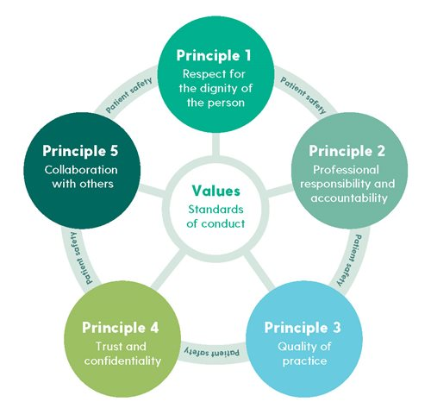

(Nursing and Midwifery Board of Ireland 2021)

* Where available the Clinical Skills Facilitator or Nurse Practice Development Coordinator will support the PHN in achieving the skills outlined below.

|  |  |  |
| --- | --- | --- |
| **Principle 1: Respect for dignity of the person** | **Self-Assessed Achieved Yes/No** | **Comment** |
| Develop an understanding of the community setting and person’s home as a work environment |  |  |
| Communicate with patients about their care and give them information in a manner they can understand |  |  |
| Understand responsibility for seeking the patient’s consent to nursing treatment and care |  |  |
| Knowledge is up to date re the use of advance healthcare directives |  |  |
| Demonstrate the ability to support the person to die with dignity and comfort. This extends to ensuring respect for the patient in the period after their death, taking into consideration the cultural norms and values of the patient and their family. |  |  |
| Develop an understanding of a person’s capacity (capacity Act) and dignity at work to make decisions and the provision of time and support for people to make decisions for themselves. Know when to refer for capacity assessment. |  |  |
| **Principle 2: Professional responsibility and accountability** | **Self-Assessed Achieved Yes/No** | **Comment** |
| Identify the support available to you as a PHN whilst using this toolkit |  |  |
| Consider the management of a caseload |  |  |
| Identify strategies to ensure appropriate time management |  |  |
| Consider your own personal safety when working in the community as a lone worker |  |  |
| Discuss the relevance of Scope of Professional Practice to your role as a PHN |  |  |
| Appropriate delegation and supervision of tasks to colleagues and healthcare assistants |  |  |
| Consider continuous professional development and further education |  |  |
| Consider your own personal/professional development plan <https://healthservice.hse.ie/about-us/onmsd/cpd-for-nurses-and-midwives/pd-planning-framework.html> |  |  |
| Complete the Clinical Leadership Competency Framework <https://clcf.hseland.ie/> |  |  |
| Reflect upon the experience of community nursing so far |  |  |
| Ensure reflective diary is up to date |  |  |
| **Principle 3: Quality of Practice** | **Self-Assessed Achieved Yes/No** | **Comment** |
| Define Chronic Disease and the impact on the patient |  |  |
| Consider the role of the PHN when caring for patients with Chronic Disease and Palliative care |  |  |
| Develop an understanding of integrated approaches to care in the community setting and the resources and networks available for this group |  |  |
| Demonstrate the use of the ‘InterRai’ |  |  |
| Demonstrate competence in compression bandaging therapy |  |  |
| Demonstrate completion of the following documentation and processes:   * Public Health Nursing Service Community Nursing Record * Home Nursing Record * Care Planning * Application for Home Care Assistant / Home Care Package * Review of Home Care Assistant Form * Review of Home Care Package * Home Care Assistant Careplan * Monthly review of Continence Database and follow up re changes * Continence Database Management Plan * Wound care assessment * Medication request and administration record (MRAR) * Discharge Planning * Archiving Process for files in Health Centre * Referral process to 2nd tier clinic * New-born blood spot screening policy * National Childcare Scheme |  |  |
| Demonstrate the process for ordering:   * Pharmacy * Aids and appliance * Stores * Beds/Mattresses |  |  |
| Discuss the following referral processes:   * Referral to Senior Case Worker for Older Person * Referral to Multidisciplinary Team * Referral to Primary Care Team Clinical Meetings * Referral to Respite Services * Referral process to Leg Ulcer Clinics * Referral for adult Safeguarding concerns * Application for Long Term Care * Referral to Tusla |  |  |
| Re-visit additional skills that you may need to achieve in order to work in the community setting and list below: |  |  |
| Consider Sláintecare and explore some of the impact these changes will have on practice e.g. Enhanced Community Care, Chronic Disease Management and Integrated Care Programme Older Person |  |  |
| Competent in venepuncture | Yes / No / NA |  |
| Competent in cannulation | Yes / No / NA |  |
| Competent in male catheterisation |  |  |
| Competent in management of supra-pubic catheter care |  |  |
| Competent in urinary catheter washouts |  |  |
| Competent in use of glucometer |  |  |
| Competent in use of syringe driver |  |  |
| Completion of Quality Care Metrics collection |  |  |
| Completion of monthly nursing returns and primary care metrics |  |  |
| Participate in clinical audit |  |  |
| **Principle 4: Trust and Confidentiality** | **Self-Assessed Achieved Yes/No** | **Comment** |
| Define vulnerability and consider groups at risk Identify various forms of abuse |  |  |
| Awareness of systems that protect vulnerable people and how to ‘raise concerns’ |  |  |
| Understand your role in safeguarding confidentiality extends to all forms of record management including appropriate use of information technology and social media. |  |  |
| **Principle 5: Collaboration with others** | **Self-Assessed Achieved Yes/No** | **Comment** |
| Consider the role of the carer and the impact that carers have in the community |  |  |
| Explore nurses relationship to carers and partnership caring |  |  |
| Look at ways to enhance the carer experience |  |  |
| Explore the benefits of working as a team member in the community nursing and primary care teams |  |  |
| Recognise the importance of working with other professionals in the community |  |  |
| Understand the importance of various forms of communication in the community setting for effective patient care - Ensuring we have the right staff, with the right skills in the right place |  |  |

|  |  |  |  |  |  |  |  |  |  |  |  |  |  |  |
| --- | --- | --- | --- | --- | --- | --- | --- | --- | --- | --- | --- | --- | --- | --- |
| **Section 5: Certificate of Receipt of Induction**  All New Employees on completion of the Induction Programme are requested to complete the following section as proof that induction was received and return same to Line Manager.  ________________________________________  I wish to certify that, on commencement of employment I received formal induction and an Employee Induction Pack.   |  |  | | --- | --- | | Signed: | Date: | | Name PHN: | Location: | | Employment Status: Perm/ Temp/ Part-time |  | |  |  | | ADPHN Signature: | Date: | |  |  | |  |  | |

**Appendix 1: Buddy Nurse System**

The Buddy Nurse system is an informal support system where a newly recruited PHN is assigned a buddy from the existing nursing team. Starting a new job can be daunting for any nurse. Being assigned a “Buddy” may help newly appointed PHNs to understand workplace culture and answer any questions that staff might otherwise be reluctant to ask.

Buddy systems encourages informal learning; developing skills through social interaction and observation. Communicating with and observing another individual is an effective way to learn. This is an opportunity to develop skills and - equally important - confidence. The buddy system is designed to support the PHN to integrate as a new member of the team and become increasingly effective in their work

The buddy system provides a supportive relationship where staff can openly discuss their progress and gain constructive criticism and recognition. We are all required to demonstrate continuous professional development (CPD) in our roles. A buddy system offers an opportunity to reflect on practice and experience. This reflection can be utilised as evidence for professional development.

A buddy nurse can be any registered nurse ( PHN) working as part of the community nursing team for more than 1 year.

**Working together**

At the first meeting with the Buddy Nurse, the newly appointed PHN should be clear what their needs are, and what they want to get out of the transition to community nursing programme. This will depend on previous experience and prior knowledge of community nursing. These needs may change over time, and the relationship will adapt to meet those needs.

The focus of the work together is about the newly appointed PHN’s work. It is not about the work of the buddy nurse. Therefore you need to set the boundaries of the working relationship and to recognise each other's limitations, as well as expertise.

Questions to consider:

* What does the newly appointed PHN wish to focus on?
* What are the newly appointed PHN's strengths and what are the areas they wish to improve upon?
* How often do we wish to meet and how realistic is this?
* What is the minimum/maximum time we can safely allocate to this relationship?
* What can I expect from you and you from me?
* If I don't feel comfortable with anything, how can we address that together?
* How can we create an environment where we both feel able to be negative as well as positive about things?
* Would setting our own ground rules help?

**The working relationship**

It is important that time is spent developing and working on the relationship between the buddy nurse and the newly appointed PHN. This is unlike most supervisory relationships - it is not hierarchical in nature. The newly appointed PHN and buddy nurse’s working relationship can be seen as:

* a resource
* a working ‘observe and engage’ relationship that offers a safe environment to test out new behaviours with the aim of development and growth
* working in partnership
* offering mutual support
* developing trust and openness in communication

**Expectations of Buddy Nurse**

|  |  |
| --- | --- |
| **A buddy nurse** | **A buddy nurse does not** |
| * Provides support and guidance to the newly appointed PHN in the community * Acts as a role model * Facilitates introductions and promoting good working relationships * Provides guidance on local culture and ways of working * Support in navigating the new work environment * Reflection on practice * Informal learning support | * Replace your line-manager / formal managerial structure, or replace the appraisal process. * Provide support outside of working hours |

**The frequency and location of meetings**

Once you have agreed how often, for how long and where you are to meet, try to stick to these. It is best to choose somewhere that will allow minimal disruption.

**Confidentiality**

You will need to discuss confidentiality and whether anonymous principles can be shared outside the relationship for the purposes of learning or taking action.

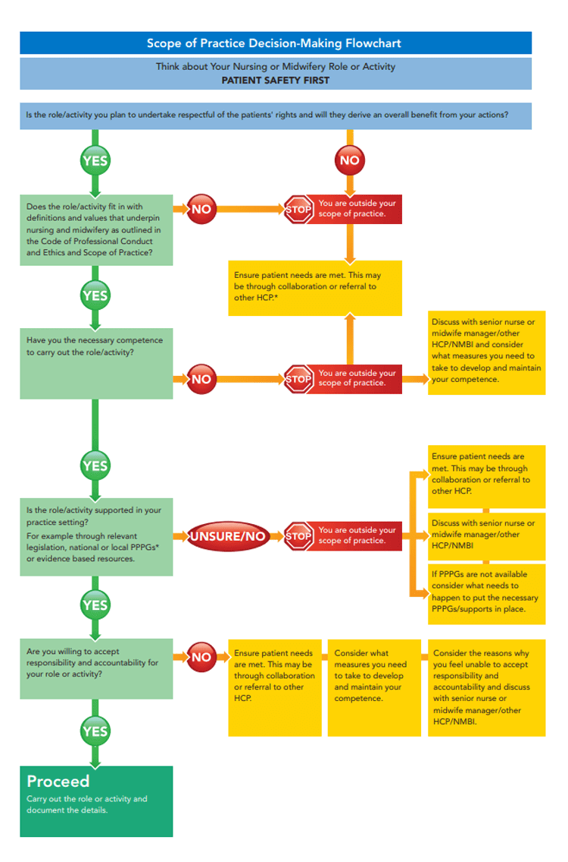

**Appendix 2: Scope of Practice Decision Making Framework** (NMBI, 2015)

**Appendix 3**

The original document (for RGNS) was commissioned, developed and approved by the ECC Workforce Planning Working Group in collaboration with the Nursing and Midwifery Planning and Development representatives. Feedback was received from all grades of Public Health Nurses.

This amended Version for use by PHNs was developed by: (Sept 2022)

|  |  |
| --- | --- |
| **Member** | **Title** |
| Virginia Pye | National Lead for Public Health Nursing |
| Sinead Lawlor | National Practice Development Co Ordinator for PHN Service |
| Anne Marie Mc Dermott | DPHN Mayo CHO 2 |
| Olivia O Connor | PDC CHO 2 |
| Sharon Boyle | Assistant Director of Public Health Nursing |
| Pauline Keogh | Assistant Director of Public Health Nursing |
| Edel Marken | Assistant Director of Public Health Nursing |
| Suzanne Kenny | Public Health Nurse |
| Grainne Kavanagh | Public Health Nurse |
| Paula Luck | Public Health Nurse INMO REP |

**Membership of the original ECC Workforce Planning Working Group April 2022**

|  |  |
| --- | --- |
| **Member** | **Title** |
| Anne Lynott | Director of Public Health Nursing |
| Deirdre Mulligan | Area Director NMPD Dublin North East |
| Edel Mc Aweeney | Director of Public Health Nursing |
| Esther Butler | Director of Public Health Nursing |
| Georgina Bassett | Deputy Chief Nursing Officer- Department of Health |
| Gillian Whyte | ADON NMPD HSE North East |
| Gráinne Keena | ADON NMPD Midlands- HSE Dublin Mid Leinster |
| Grainne Ryan | Director of Public Health Nursing |
| Helen Sweeney | Director of Public Health Nursing |
| Jackie Austin | Director of Public Health Nursing |
| Jan Flanagan | Director of Public Health Nursing |
| Maeve Smyth | Director of Public Health Nursing |
| Margaret Nally | Director of Public Health Nursing |
| Neil Dunne | Director of Public Health Nursing |
| Richard Walsh | ONMSD National Lead- Integrated Care Programme Chronic Disease |
| Virginia Pye | ONMSD National Lead PHN Services |