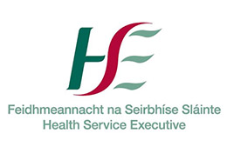
This form is not required to be sent to ICT. The following relates to Line
Manager’s responsibilities when new or amended access is requested and should be completed, signed and filed by your department.
User Declaration
I have read and understood the applicable Health Service Executive policies at governing the use of its ICT resources at
https://www.hse.ie/eng/services/publications/pp/ict/

I agree to be bound by the terms therein.
I understand that I may be subject to the HSE’s disciplinary procedures should I fail to comply with said policies.

Tick to denote agreement:

Note: This form must be retained by the user’s line manager for audit and
control purposes

