Candidate Information
Consultant Radiologist
Cavan Monaghan Hospital (37 hours per week)

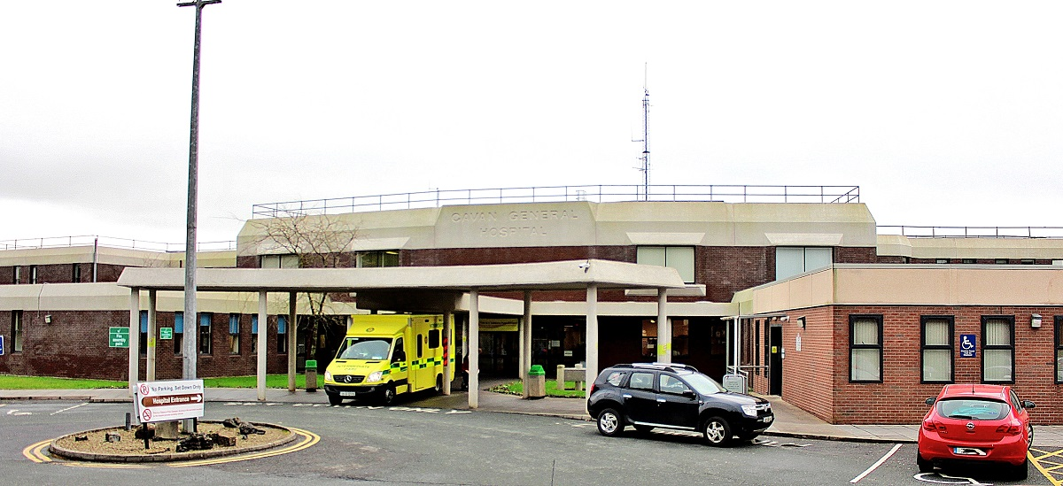

Job Title: | Consultant Radiologist
Closing date for applications: | Tuesday, 21st May 2024 @ 12noon
Contract duration: | Permanent
Contract Type: | Public Only Consultants’ Contract 2023
Hours per week: | 37 hours Cavan General Hospital
Contact Details: | ConsultantHR@beaumont.ie – for application queries only. Apply online at www.beaumont.ie/careers.  Enquiries relating specifically to this post or informal visits should be directed to:  Dr Val Gough, Clinical Director, Consultant Radiologist, Cavan Monaghan Hospital, Tel no: 049 437 6000 or email val.gough@hse.ie

RSCI Hospital Group Profile
The RCSI Hospital Group serves populations in five counties – North Dublin, Meath, Louth, Cavan and Monaghan. The area stretches from the north banks of the River Liffey in Dublin City Centre, north to the border with Northern Ireland, and west to the border with County Donegal. It comprises urban, rural and commuter belt areas, and covers approximately 6,817 square kilometres in total. There is considerable variation in population density from a low of 39 persons per square kilometre in Cavan to a high of 4,137 persons per square kilometre in north Dublin city. Residents of neighbouring areas such as South Dublin and Kildare also access hospitals for secondary care and maternity services. Beaumont Hospital, which is the largest hospital in the group, in addition to providing emergency and acute Secondary Care services to the local community is also a designated Cancer Centre, the Regional Treatment Centre for Ear, Nose and Throat and Gastroenterology and also the National Referral Centre for Neurosurgery and Neurology, Renal Transplantation, and Cochlear Implantation - as such treating patients from all parts of the country.

- The RCSI catchment area has experienced rapid population expansion in recent years, growing from approximately 640,000 in 2002 to 817,522 in 2011.

- This population growth is projected to continue, reaching almost 875,000 by 2021.

- Provisional preliminary data from Census 2016 suggests that the population in the catchment area has now reached approximately 864,000.

- The catchment covers a large area, including urban, rural and commuter areas, each presenting different challenges for service delivery.

- The area includes a relatively young population, with 10% of the population aged 65 and over, compared with 11.7% nationally.

- Some areas within the catchment include higher proportions of older people. In particular, in the area around Beaumont hospital (Dublin North Outer City), 15.4% of the population are aged 65 and over, while Cavan and Monaghan each have approximately 12% of the population aged 65+.
Further information about the RCSI Hospital Group can be found at our website: http://www.rcsihospitals.ie/

Cavan Monaghan Hospital
Cavan Monaghan Hospital is a bi-located site providing services to the population of both counties and its catchment area extends to counties Meath, Longford and Leitrim. It has a total of 421 beds with 286 of these representing acute in-patient beds. All acute inpatient services are based in Cavan Monaghan Hospital; there were approximately 17,000 acute admissions in 2018. Monaghan Hospital's primary role includes the continuing care for medically discharged patients requiring inpatient step-down and rehabilitation care.
Cavan Monaghan Hospital is a teaching hospital with links to the Royal College of Surgeons, Royal College of Physicians and the Dundalk Institute of Technology. Both sites are actively engaged with HIQA (Health Information & Quality Authority) in meeting their standards to ensure they continually strive to provide a high quality service.
Cavan Monaghan Hospital has an Emergency Department, an Acute Medical Admissions Unit, 5 General Medical wards, 1 General Surgery ward, a maternity ward, a paediatric ward, an ICU, a SCBU, and a CCU. It also has 4 operating theatres, a renal dialysis unit, a surgical day ward, an endoscopy / bronchoscopy unit, a haematology / oncology day ward, and an interventional radiology unit. Orthopaedic, vascular, urological and neurological services are provided by visiting consultants with sessional commitments. The hospital provides services for the care of paediatric and adult patients with cystic fibrosis; the paediatric ward has recently been extended and refurbished to include the provision of 2 high specifications, neutral pressure isolation rooms. It is anticipated that an outpatient antimicrobial therapy service will be launched in 2020 following the recruitment of an OPAT co-ordinator.

Radiology Services
The Radiology Department at Cavan Monaghan Hospital is a consultant delivered service with 5.0
W.T.E serving a population base of circa 120000 providing 86000 examinations in 2015. The specialties served by the Radiology Department from both in an out patients include Surgery, Medicine, Paediatrics, Psychiatry, Gynaecology, Obstetrics, Urology, Oncology, Orthopaedic, ENT, Neurology, Haematology and outpatient primary care services.

The Radiology department provides a range of diagnostic and intervention services. There are currently 6 Multidisciplinary team meetings for Medicine, Surgical, Oncology, Pathology, Paediatric & Emergency Medicine.

The Radiology Department provides a range of image guided intervention. The Department has 4 ultrasound rooms (3 in Cavan and 1 in Monaghan), 2 CT scanners (128 Slice in Cavan and 16 Slice in Monaghan), new state of the art interventional suite (Cavan), MRI (Cavan), 3 Radiography rooms (3 Cavan, 1 Monaghan), New DEXA (Monaghan).

The delivery of commitments by the Consultant team across each location covered by the team includes:

- Reporting and interventional duties.
- Reporting includes CT, MRI, contrast studies, fluoroscopy, ultrasound, and plain films in all age groups from neonates onwards.
- Interventional radiology will be provided as per departmental need.
- Each day will have a mixture of above plus non reporting duties such as MDT, consultation support, administration, Quality improvement, teaching, audit and vetting.

The population in this region is approximately 120,000 in Cavan and Monaghan with the regional (i.e. Cavan, Monaghan, Louth and Meath) being approximately 375,000.

Useful Links
Our website: | https://www.hse.ie/eng/services/list/3/acutehospitals/hospitals/cavanmonaghan/cavan-monaghan-hospital.html

Job Description and Responsibilities
Standard Duties and Responsibilities for all Consultant posts are as per Section 4 and Section 10 of the POCC23:
The Employee is hereby employed as a consultant. The Employee will be clinically independent in relation to decisions on the diagnosis, treatment and care of individual patients. This clinical independence derives from the specific relationship between the patient and the Employee. In that relationship, the patient places trust in the consultant who is personally involved in the patient’s care to make clinical decisions in the patient’s best interests and to take continuing responsibility for the consequences of that consultant’s decisions.
The Employee acknowledges that they are subject to statutory and regulatory requirements and corporate policies and procedures including those adopted for implementation by the national clinical programmes.
The Employee has a substantial and direct involvement in the medical diagnosis, treatment and delivery of care to patients.
The Employee may discharge their responsibilities through:
- a direct professional relationship with the patient;
- shared responsibility with other consultants who contribute significantly to patient management; and
- (subject to the following paragraph of this clause) delegation of aspects of the patient’s care to other appropriate members of staff.
The Employee will only delegate responsibility to other doctors or staff members where the delegation is consistent with the continued provision of an appropriate level of diagnosis, treatment and care to the patient in respect of the relevant episode of care. Notwithstanding any such delegation, the Employee will retain a continuing overall responsibility for the care of the patient.
The determination of the range, volume and type of services to be provided and responsibility for the provision of same within available resources rests with the Employer. Services not provided because of a resource limit are the responsibility of the Employer and not the Employee.
The Employee will generally work as part of a consultant team. The primary purpose of consultant teams is to ensure consultant-provided services to patients on a continuing basis. In effect this requires that the Employee will provide diagnosis, treatment and care to patients who are under the care of other consultants on their consultant team and vice versa. This may include discharge and further treatment arrangements, as appropriate.
The membership of the Employee’s consultant team will be determined by the Employer in the context of the local working environment. The team may be defined at specialty/sub-speciality level or under a more broadly based categorisation, such as “general medicine” or “general surgery”.
The work of the Employee will be determined by reference to the Clinical Directorate Service Plan that applies from time to time. The principles underpinning the preparation of the Clinical Directorate Service Plan are set out in Appendix 3 of the POCC23.
The initial scope of this post is as set out in the letter of approval. The main duties of the Employee’s position (as of the Commencement Date) are set out in the job description attached at Appendix 2 of the POCC23. The scope and duties of the post may be changed by the Clinical Director from time to time provided the Clinical Director consults the Employee before making any such change.
In addition to or instead of their normal duties, the Employee may be required to undertake other duties as may be assigned to them provided such other duties are consistent with
      - the role of a consultant having regard to the letter of approval and the duties set out at Appendix 1 and Appendix 2 of the POCC23 respectively and
      - the Employee’s clinical speciality (as recognised in their registration on the Specialist Division or the Register of Dental Specialist).
Any other duties that are assigned further to the preceding paragraph will be discussed between the Employee and their Clinical Director/Executive Clinical Director/line manager and will be incorporated into the Employee’s work plan.
The Employee is required to cooperate with the delivery of national clinical programmes, national health strategies and nationally agreed models of care. If any of these materially change the terms and conditions of this contract, the same will be subject to negotiation. Such cooperation will not impinge on the clinical independence set out in clause 4 of the POCC23.

Clinical Practice:
- The applicant must be able to demonstrate the ability to provide a level of clinical care required by this post, according to agreed standards.

- They must illustrate a high level of verbal and non-verbal communication skills in their ability to relate to patients, parents, families, colleagues, hospital staff and management.

- They must demonstrate a satisfactory level of proficiency, to be able to interact with, and participate in hospital management structures as required.

- They must demonstrate the capacity to supervise and be responsible for the clinical work of junior trainees and auxiliary staff assigned to his/her care, and to ensure that the particulars are duly and properly recorded.

- They must demonstrate skills required for educational training for medical students, junior medical staff, nursing staff and other professions.

- They must demonstrate a proven ability to engage in research relating to their specialty.

- They must participate in CME &CPD.

- They must provide evidence of undertaking and initiating audit and quality assurance exercises.

Educational:
- Supervise and be responsible for the clinical work and the record keeping of all Non-Consultant Hospital Doctors working.

- Undertake undergraduate and postgraduate medical teaching duties.

- Undertake teaching duties if so requested by the Governing Body of the Royal College of Surgeons in Ireland on terms to be agreed between the appointee and the Lead Clinician in Medicine.

Management:
- Support the Lead Clinician and work with other consultants to promote the workings of the Department of Radiology.

- Demonstrate active participation in maximising the safe use of all resources within the service planning and provision of high quality medical care.

- Support/enable critical review and audit systems within the department including the management of identified risks.

Monaghan Hospital
- To share in the acute on-call rota to provide cover for general radiology.
- To maintain responsibility for patients admitted under his/ her care.
- To contribute to the development of R &D and educational commitments to medical students, NCHDs, midwifery/nursing staff and allied health professionals

Skills and Competencies
- Demonstrate evidence of effective planning and organising skills including awareness of resource management and importance of value for money.
- Demonstrate evidence of ability to empathise with and treat patients, relatives and colleagues with dignity and respect.
- Demonstrate an ability to participate fully in audit and clinical governance programmes
The above Job Description is not intended to be a comprehensive list of all duties involved and consequently, the post holder may be required to perform other duties as appropriate to the post which may be assigned to him/her from time to time and to contribute to the development of the post while in office.

