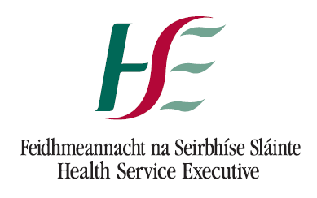 |  | Oifig NaisuintaSlainte Beil,  Fedhmeannacht na Seirbhse Slainte,  31-33 Sráid Caitriona,  Luimneach. | National Oral Health Office,  Health Service Executive,  31-33 Catherine St.,  Limerick.

Each DTSS Contractor

16th March 2020

Dear Dentist,

As you are aware, Ireland is responding to the Covid-19 outbreak through a series of public health measures. Sustained efforts are being made to contain and the delay the spread of the virus, and to support the health services in looking after those with symptoms.

DTSS Contractors have a range of critical clinical skills that the HSE may seek to have deployed in support of Covid-19 services during this time.

While the details of possible roles have yet to be confirmed, the HSE is requesting that DTSS Contractors that are interested in supplementing the HSE’s response to Covid-19 would register their details at this stage.

Your information is requested only for the purpose of supporting the response to Covid-19, and will not be used for other purposes.

The HSE is organising its response on a geographical basis, in Community Hubs, therefore you are asked to indicate which town you practice in, but it is not intended that your practice premises would be used in this initiative.

Please complete and send the information requested below to aoneill@hse.ie

First Name | Surname | Town | Email: contactable outside of practice | Phone: contactable outside of practice | Dentist/Hygienist/Dental Nurse/Ortho Therapist | Dental Council Number | Garda Vetted? (Y/N)

Next steps:

Please do not to contact the HSE at this point, HSE local services will make contact with you when a suitable role has been identified.

Yours sincerely,

___________
Joseph Green,
AND, National Oral Health Lead - Operations

