Recruitment Quality, Standards and Advisory Unit (QSA)

Therefore™ User Guide

Accessing confidential recruitment documents
And information handling

CONTENTS

1. Introduction 2
2. Information handling 4
3. System user guide 4
3.1 System access 4
3.2 How to access confidential recruitment documents 5
3.3 System support 12
3.4 Best practice - system use 12
Document history 13

Introduction
This guide explains to HSE recruiters how to access confidential interview content information via Therefore™ Navigator.
The document outlines the principles and guidelines that aim to safeguard confidential recruitment documentation. The document also details how to maintain the confidentiality of documents, which is integral to a competitive and compliant recruitment process.
Read this document alongside the HSE Information handling & classification policy and HSE ICT Policies & Standards.
Frequently asked questions.
What resources are available in Therefore™ Navigator?
- “Interview Content” for preparing interview guides.
- “Employment Contract Templates”.
Why did you create this resource?
HRSS frequently receive requests for interview guides or interview content. These resources provide a secure and confidential centralised repository of interview content documents to support HSE recruiters.
What is “interview content”?
The interview content documents reflect the skills outlined in sample job specifications on the HR Job Specification Repository.
The interview content is a further development of the skills outlined in the job specification. It details the behavioural indicators related to each skill area to use for assessment and scoring during the interview process; and the key indicators of what successful performance looks like in action in an individual role.
Dependent on the unique requirements of the role, you may wish to amend or add to these skill areas and behavioural indicators.
How do I prepare an interview guide from interview content?
You can download the Interview Guide template from the Recruitment QSA webpages.
We recommend you insert the interview content into an interview guide template for your recruitment campaign.
Are professional/ clinical questions available?
Professional/ clinical questions are available for the following grades: Occupational Therapist Senior, Physiotherapist Senior, Speech, and Language Therapist Senior. These questions are available as part of their respective interview content material.
Professional/ clinical questions are not available for other grades. Add these at local level when preparing an interview guide. Service Managers and relevant others should develop clinical / professional knowledge questions, and related answers, for inclusion in the interview guide before the interview process.
I do not have access to Therefore™ Navigator, how do my delegated Recruitment Manager or I get access?
Download the Therefore™ access request form from the QSA webpage and submit to the National EDRMS Project office @ therefore@hse.ie.
You will also need to submit a software request via Ivanti Self Service [see System Access point 3.1 below for more details].
I need technical support, how to I access it?
If you experience Therefore technical issues log this with therefore@hse.ie or 1800 77 46 45
I have some feedback on the content, to whom do I send it?
Please email QSA.Recruitment@hse.ie We welcome all feedback to assist in further strengthening our resources.

Information handling
There is a requirement to safeguard confidential recruitment documents to ensure the security, confidentiality, access, availability and integrity of the information.
Confidential recruitment documents contain information for use by HSE recruiters in support of a recruitment campaign.
Protecting recruitment documents helps to ensure and maintain the integrity of the recruitment and selection process. This means do not share them publicly, disclose them to any third parties and/or reproduce them in any way. Do not share these with candidates. This applies throughout all stages of the recruitment and selection process.
Interview content documents contain information that is confidential and only for restricted circulation to Interview Board members and recruiters directly involved with the recruitment campaign.
Correct handling of information applies to all HSE staff, students, contractors, sub-contractors, agency personnel and third parties that have access to HSE information as set out in the HSE Information classification & handling policy.

System user guide

3.1 System access
Who can get access?
All recruiters/users involved in handling confidential recruitment documents and/or information as approved by Grade VIII or above.
How can I get access?
Download the access request form from the QSA webpage and submit, for read only access, below with approval by Head of HR and/or Corporate HR Lead and emailed to the National EDRMS Project office @ therefore@hse.ie
Access request approvers are Heads of HR and/or Corporate HR Leads for the relevant areas/groups.
Should a Head of HR and/or Corporate HR Lead wish to add additional approvers (Grade VIII or above) for their area/group they can do so by emailing the National EDRMS Project office @ therefore@hse.ie.
Do I still have to apply for access if I already use Therefore ™ Navigator?
Yes, an access request form is still required to gain access to the Recruitment Quality, Standards & Advisory repository.
How do I get the application installed?
Log a new support ticket/ software request via Ivanti Self Service to request installation of Therefore ™ Navigator on your desktop.
Where do I find Therefore on my desktop?
Once you have access and the software is installed you are ready to start using the system!
You can access the Therefore™ Navigator on your taskbar at the bottom of your screen or desktop, using this icon or, select the search button on the taskbar and type “Therefore”
Click the Therefore™ Navigator icon to start the process
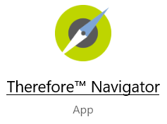

3.2 How to access confidential recruitment documents
- Click on the Therefore™ Navigator icon to start the process. Read the GDPR/Data Protection Declaration and click on “I Agree” in order to proceed.
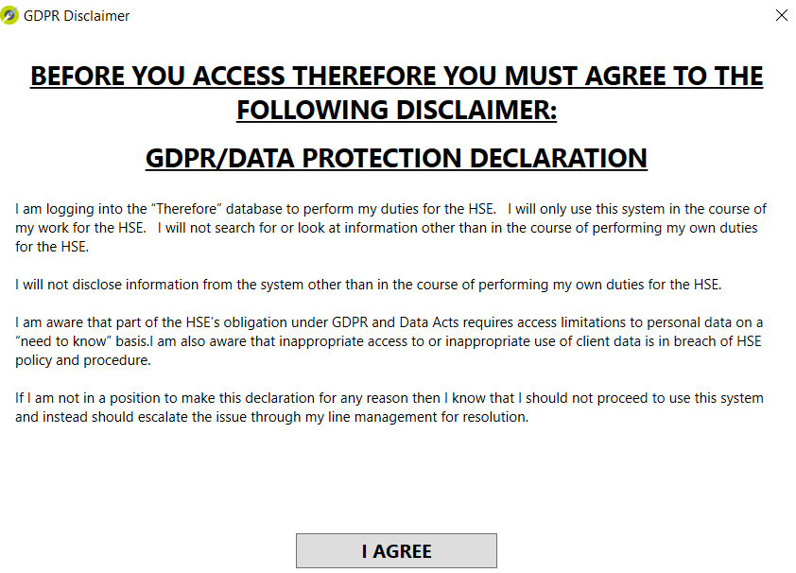
- You will be presented with the Repository screen:
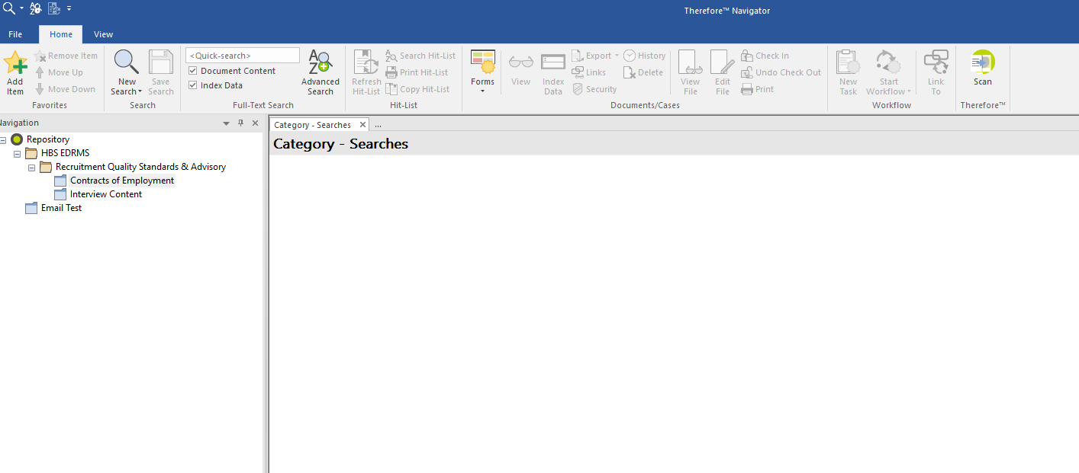
If not already defaulted please select Repository at the bottom left hand corner of Therefore, see below:
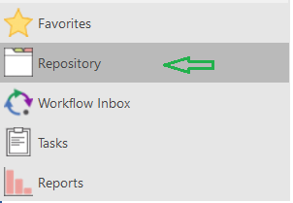
- To access the confidential recruitment documents, navigate the folders at the top left hand side of the screen. The screens below show you how to navigate and access the relevant folders. There are folders for Interview Content documents and Contracts of Employment.
  - Under the Navigation bar, locate the Recruitment Quality, Standards & Advisory folder. See screenshot below. Repository > HBS EDRMS > Recruitment Quality, Standards & Advisory. Click on + to expand the navigation:
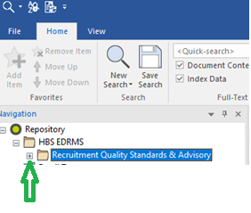
  - Under the Recruitment Quality, Standards & Advisory folder, there are two sub folders: Contracts of Employment and Interview Content:
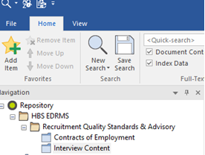
- Click on a folder which will bring you to a unique search index to access the Interview Content documents:
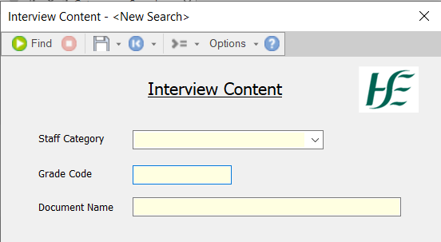
- The Interview Content search index provides 3 options by which to search
  - Staff Category. Select the relevant staff category and click Find or press return on your keyboard.
The results will show interview content documents for all grades of staff in that category.
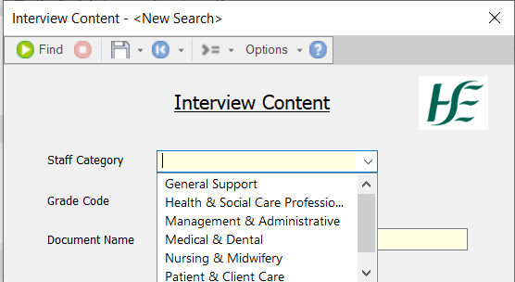
  - Grade Code
If searching for “Physiotherapist Manager 3492 Interview Content”, type 3492 into the Grade Code click Find or press the return button on your keyboard.
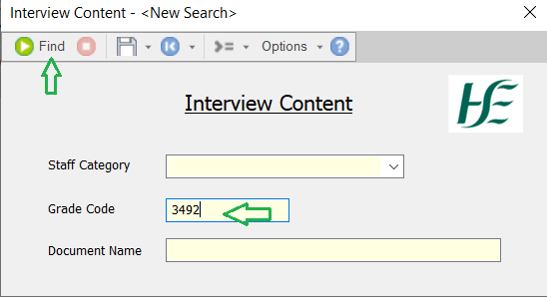
Your search will retrieve the “Physiotherapist Manager 3492 Interview Content” document.
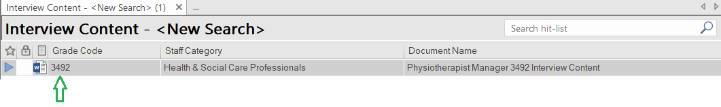
  - Document Name
This option is useful in cases where you do not know the exact name or the grade code related to the document you are looking for. In this case you can use the star key (*) to assist you with your search.
Type * followed by a key word from document title, followed by another *.
For example type *physiotherapist* into Document Name and click on Find, or press the return key. Your search will retrieve all documents that contain the word “Physiotherapist”.
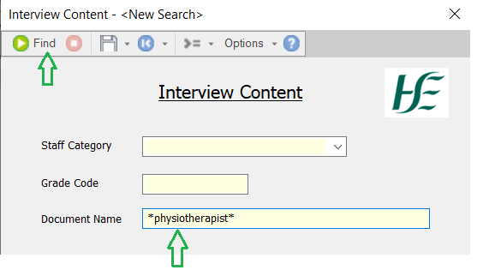
Below are the result of this search. Four documents containing the word “Physiotherapist” in the title.
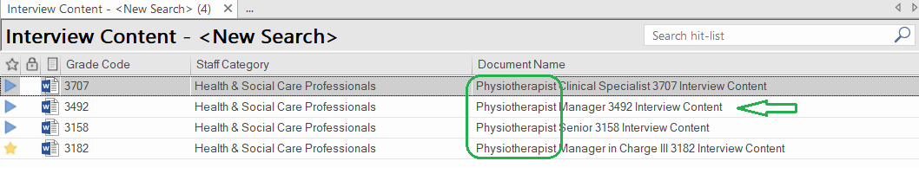
- When you have the search results, select the document you want to access / retrieve. You can do this, three ways.
- Scroll through the listed documents, identify the one you require, highlight it and double click:
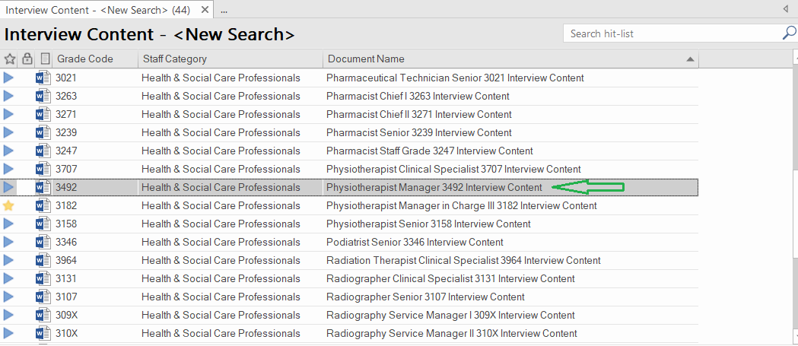
- You can narrow your search by typing a key word or grade code in the box in the top right hand corner of the screen. For example, “manager” or “3492” and hit the return key. Once you have identified the required document, highlight and double click:
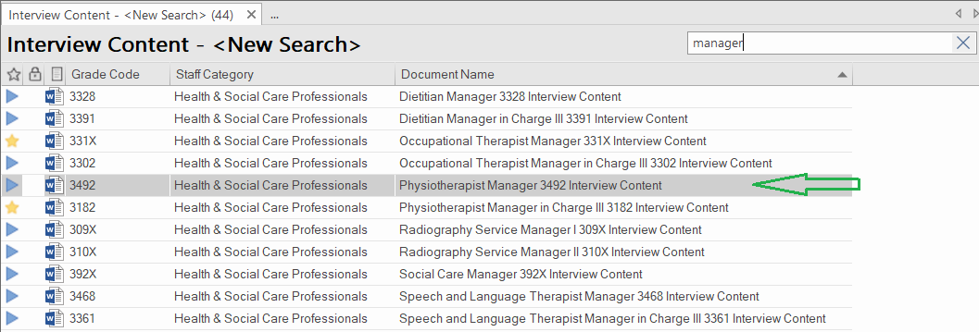
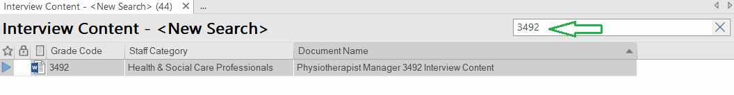
- You can sort the documents to assist you. Under the header bar click on “Document Name”. This will sort the documents by “Document Name” in alphabetical order. Once you have identified the document you need, highlight and double click:
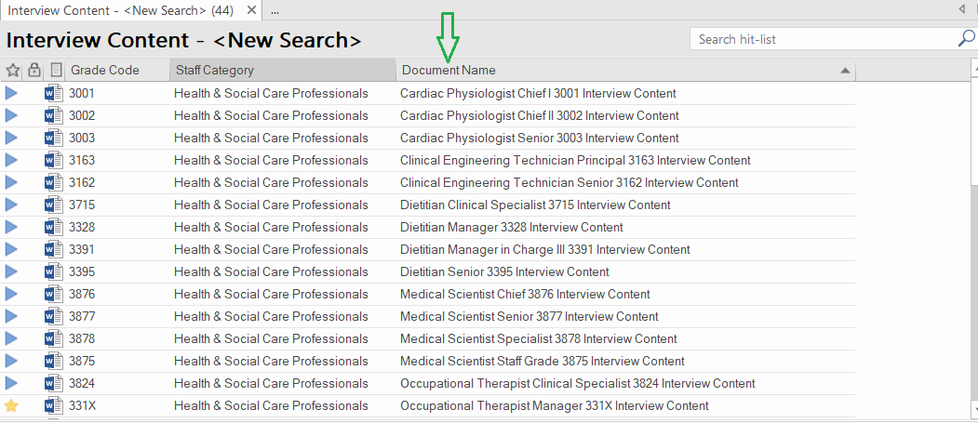

- Once you have selected your document a new window will open. Click on “View File” and the document will now open in MS Word.
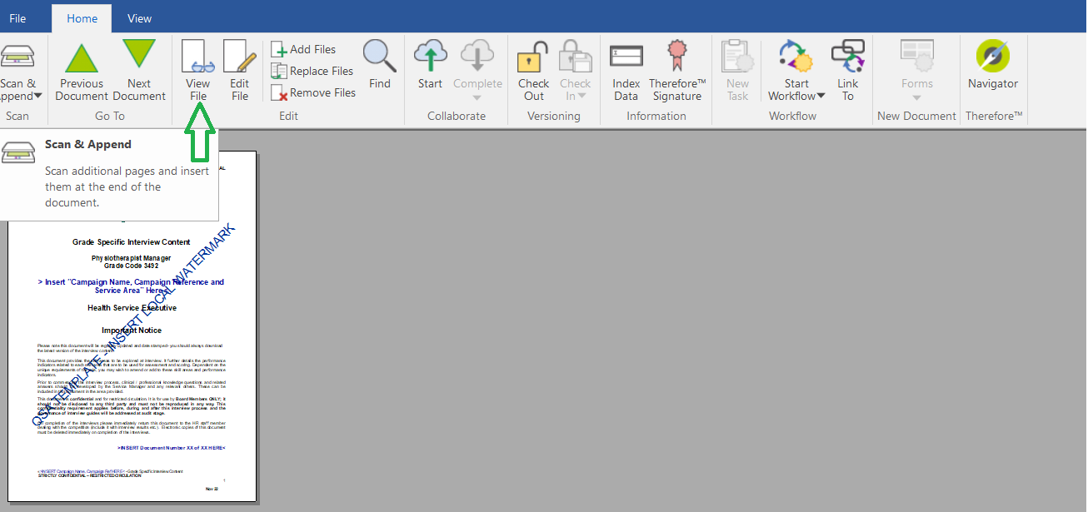
- If the document you are looking for is not available, your search result will show there are no returns available:
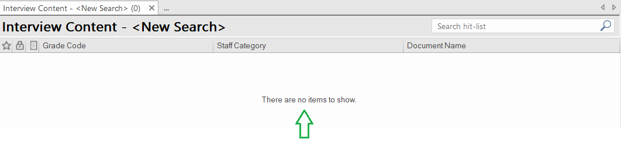
- Professional/ clinical knowledge questions are available for Occupational Therapist Senior, Physiotherapist Senior and Speech and Language Therapist Senior.
For example, if you search for “Physiotherapist Senior 3158 two documents are returned on the left of the screen. You can click on each document as required.
- The first document is the Physiotherapist, Senior interview content document.
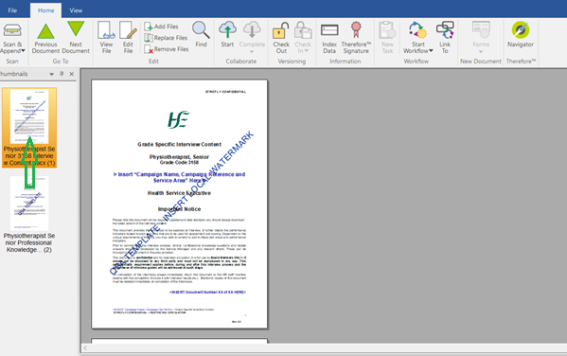
- The second document is the Physiotherapist, Senior professional knowledge question document.
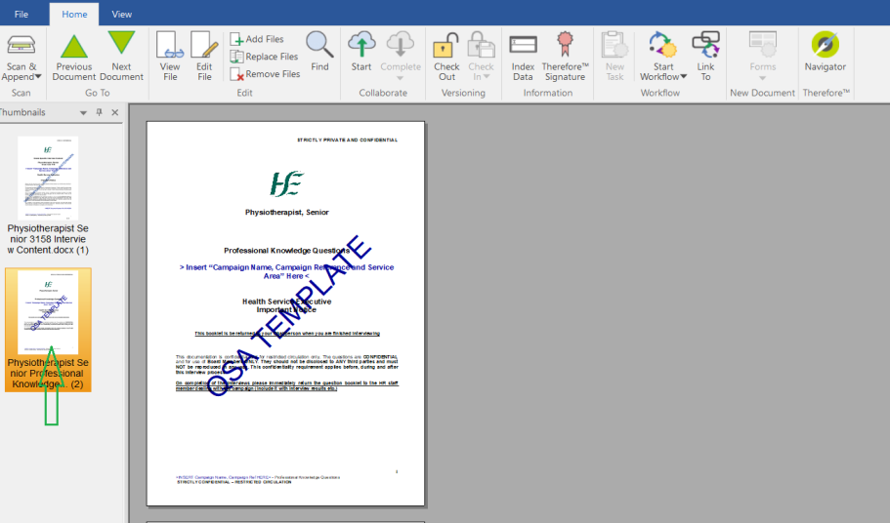
- The same principles apply when retrieving documents in the Contracts of Employment folder. The Contracts of Employment folder has two search options - one drop down and one freeform text.
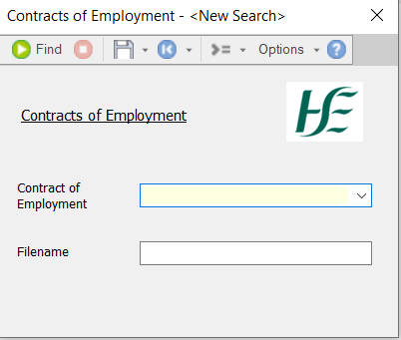
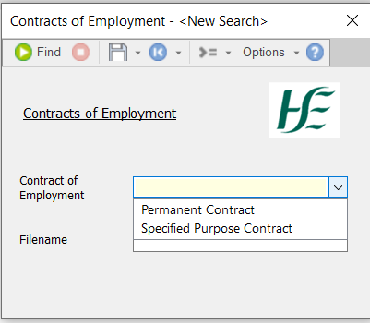
Exiting the System
Once you have completed your search you are now ready to exit Therefore™ Navigator
In the top left had corner click on File and select Exit.
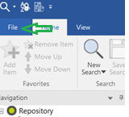
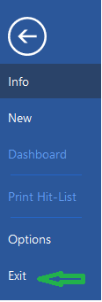

3.3 System support
If you experience technical issues with Therefore log this with therefore@hse.ie or 1800 77 46 45

3.4 Best practice - system use
The system Therefore™ Navigator is crucial for the sharing of confidential recruitment documents in a secure and confidential manner. Consequently download from Therefore™ every time you require a confidential recruitment document.
Apply best practice when using Therefore:
- Do not save a document downloaded from Therefore to any device/ HSE Server in its original format.
- Tailor/edit the documents you download to reflect the specific recruitment campaign. This means, in the case of Interview Content documents remove the QSA watermark, insert campaign name, reference and service area on main page and insert the campaign name and reference in document footer.
- Save / store the tailored/edited document on a HSE Server. Password protect the document to restrict access to authorised users only.
- Delete / dispose (securely) of the tailored documents when no longer required. Retain one master copy (password protected) as part of the recruitment campaign file. Use of the document number on the main page can assist in the sharing/controls e.g. Document number 3 of 4 given to XXX Interview Board Member.

Document history
Version | Owner | Authors | Publish Date
2.0 | Recruitment Quality, Standards and Advisory Unit | Vickie Sharkey & Karen Magarahan | 20/01/2023
1.0 | Recruitment Quality, Standards and Advisory Unit | Karen Magarahan | 11/12/2023

