Seirbhís Aisíoca Príomhchúraim
Bealach amach 5 an M50, Án Bóthar Thuaidh, Fionnghlas, Baile Átha Cliath 11, D11 XKF3
Guthán: 01 8647100

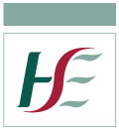
Primary Care Reimbursement Service
Exit 5, M50, North Road, Finglas, Dublin 11, D11 XKF3
Tel: 01- 8647100

Michael McGrath T.D.
Dáil Éireann,
Leinster House,
Kildare Street,
Dublin 2.

05 November 2019

PQ: 43551/19

To ask the Minister for Health the manner in which prize bonds are treated in the means test of capital in the context of the over 70s medical card; if an actual or notional return is used; if a notional rate of return is used, the rate in this regard; and if he will make a statement on the matter. -Michael McGrath

Dear Deputy McGrath,

The Health Service Executive has been requested to reply directly to you in the context of the above Parliamentary Question (Reference 43551/19), which you submitted to the Minister for Health for response.

Details of Prize Bonds should be included in an application for eligibility. The value is treated as savings and investments. The notional rate of 0.425% is currently applied to the value of savings and investments over €36,000 for a single person and €72,000 for a couple.

Yours sincerely,

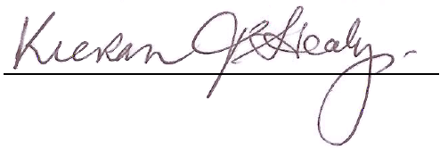

Kieran Healy
Primary Care Eligibility & Reimbursement Service

