**Waiting List Improvement Update – 21 April 2023**

**Outpatient Appointments**

* The number of people waiting greater than 18 months for an appointment has decreased by 39% since last year
* 85% of people are waiting less than 18 months for an appointment

*The NSP target for 2022 is that 98% of people are waiting less than 18 months (100% less than 36 months).*

**Inpatient and Day Case Procedures**

* The number of people waiting greater than 12 months has decreased by 12% since last year
* 83% of people are waiting less than 12 months for an appointment

*The NSP target for 2022 is that is that 98% of people are waiting less than 12 months (100% less than 24 months).*

**GI Scopes**

* The number of people waiting greater than 12 months has decreased by 83% since last year
* 98% of people are waiting less than 12 months for an appointment

*The NSP target for 2022 is that is that 98% of people are waiting less than 12 months (100% less than 24 months).*

We are keen to acknowledge the improvements in the waiting lists across the specialties, hospitals and hospital groups. The table below shows the number of specialties in each hospital group that are meeting the waiting time targets according to the categories listed below.

We recognise that in some cases there are constraints relating to demand and capacity that may be outside the local hospital teams’ control which are impacting on how quickly progress can be made.

**Category 1 - Sláintecare**

The number of specialties achieving the Sláintecare waiting time targets:

* OPD - Specialties that have 100% of patients waiting <10 weeks
* IPDC - Specialties that have 100% of patients waiting <12 weeks
* GI Scopes - Specialties that have 100% of patients waiting <12 weeks

**Category 2**

The number of specialties achieving the following waiting time targets:

* OPD - Specialties that have 100% of patients waiting <12 Months
* IPDC - Specialties that have 100% of patients waiting <9 Months
* GI Scopes - Specialties that have 100% of patients waiting <3 Months

**Category 3**

The number of specialties achieving the following waiting time targets:

* OPD - Specialties that have 100% of patients waiting <18 Months
* IPDC - Specialties that have 100% of patients waiting <12 Months
* GI Scopes - Specialties that have 100% of patients waiting <6 Months

**Category 4 - NSP 2022**

The number of specialties achieving the National Service Plan 2022 targets:

* OPD - Specialties that have 98% of patients waiting less than 18 months and 100% of patients waiting less than 36 months
* IPDC - Specialties that have 98% of patients waiting less than 12 months and 100% of patients waiting less than 24 months
* GI Scopes - Specialties that have 100% of patients waiting less than 12 months

**Number of Specialties Achieving Targets**

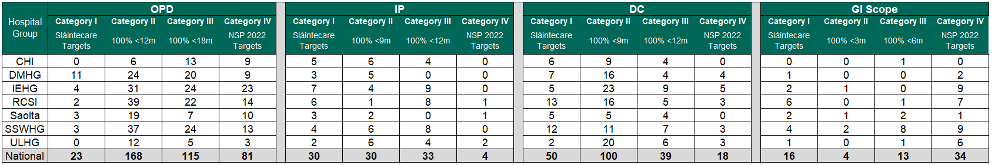

Data capture: 13 April 2023