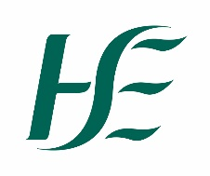

Consent Form for photography/audio/video

I agree for my name and photograph, video footage or audio to be taken by the HSE for use in marketing, PR and publications in connection with the event set out below:

Event: __________________________________

Location: __________________________________

Date: __________________________________

Here are some places the HSE might use it:

Social and Digital Media Twitter, Facebook, YouTube, Instagram and any other HSE accounts
Media National, regional and local media (broadcast, online and print). Publications Annual reports, employee magazine or policy documents

In order to do this we will need to process and store your information in line with our Data Protection policy which you find HSE.ie Search for GDPR Information and click on Data Protection Policy.
You can change your mind and withdraw consent for us to process your photograph, audio or video at any time by contacting _____________________________________________

Your participation is entirely voluntary and there is no obligation on you to give your consent to have your voice or image captured. No fees will be paid to people taking part.

Please indicate your consent (or your consent on behalf of your child if applicable) for this photography/audio/video footage and that you fully understand the proposed use of the photography, audio or video by signing below.

Signature: ________________________________________________________________

Contact Number: _______________________ Email address: ______________________

