NIMS REQUEST FOR DELETION

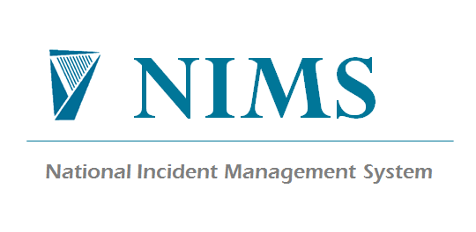

Requested by:
(Liaison manager)
Please print & sign
Agency Name:
Date:

Incident Details:
Incident Id | Name of Person | Reason for Deletion

Comments:

Action taken (SCA):
Form: SCA-F-017-02
Source: Quality Manual
