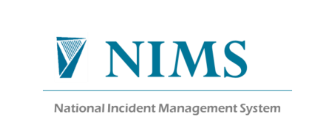

COMPLAINTS MANAGEMENT SYSTEM USER SET UP REQUEST FORM (CMS)

This form is to request the System Administrator to issue the staff member named below with login details to the Complaints Management System with the specified access rights. (Please submit one completed form per user, by email to cmstraining@hse.ie ) Incomplete forms will be returned to sender

First Name and Surname:

Job Title:

Complaints Officer or Support Staff*:

Phone:

Email Address:

Work Address:

CHO/HG:

Division: (i.e.; Mental Health/Primary Care /Other – please specify)

Site name/s: HSE Location(s) where you/the delegated Complaints Officer, investigate complaints.

Please specify the locations that access is required.

Is this access request form for a New User: Yes / No

Or

If a current user please list the location changes you would like to make:

Are you a current NIMS user: Yes/No

*Please ensure you have attached an MOU if Support Staff or a Letter of Appointment if Complaint Officer

NCGLT Liaison Manager Details: Do Not Edit this section
Name, Position, Date: | Anne Danaher, Data Quality Manager NCGLT
Email & Telephone Number: | anne.danaher@hse.ie 086 0498862
Liaison Manager Signature:

Authorisation: Your Line Manager required:
Line Manager: |  | Signature & Date:
Line Manager Phone: |  | Line Manager Email:
Designated Information Owner: | Chris Rudland | Signature & Date:
Form: SCA-F-036-02
Source: Quality Manual
Form: SCA-F-036-02
Source: Quality Manual

