HOME EXERCISE PROGRAMME
Warm up:
Exercise Duration
- Marching on the spot 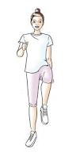 1 minute

- Punches up in the air 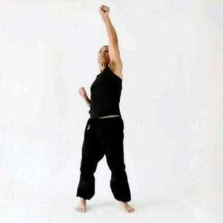 1 minute

- Marching on the spot 1 minute

Circuits
Please see page for time and weekly progression

Sit to Stand 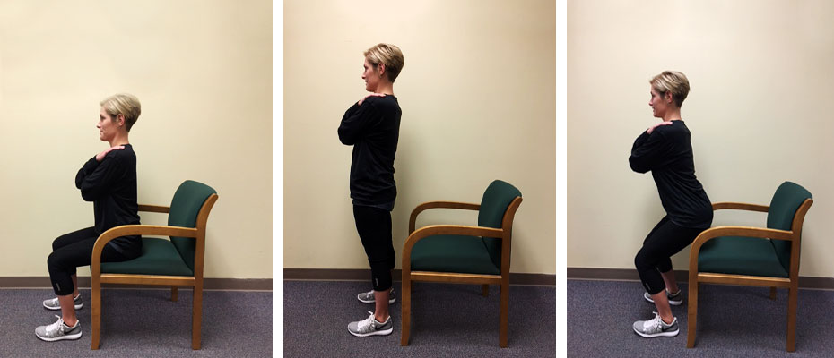

Biceps curl in sitting
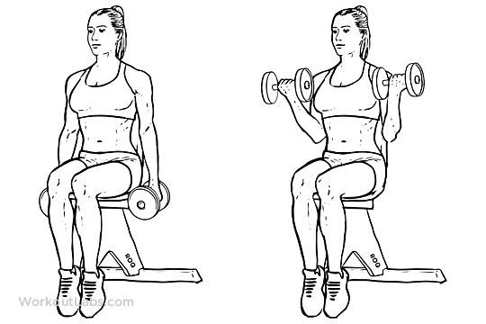
Jumping Jacks

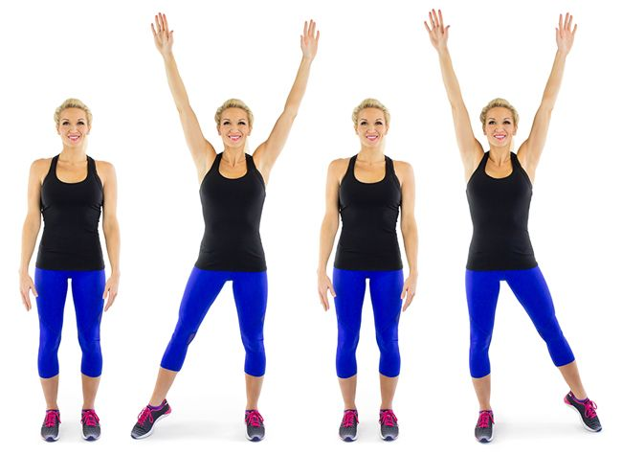

Overhead press in sitting

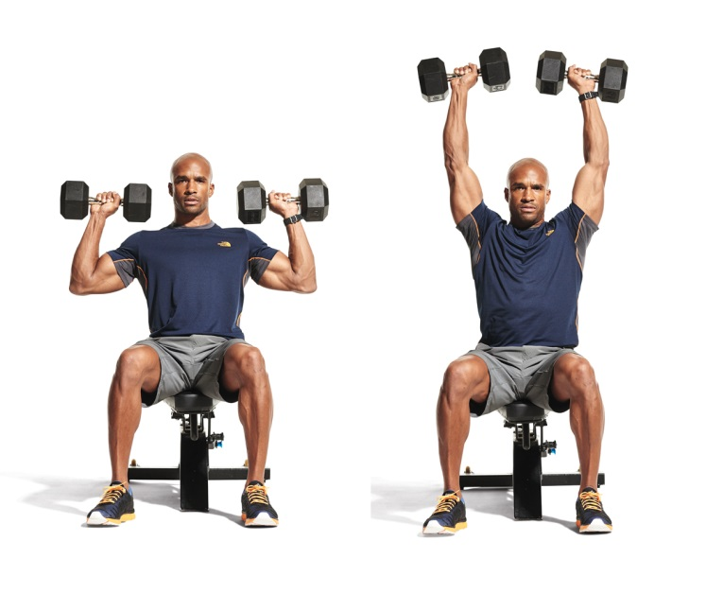
Jog. jog, jog, jog, Jab, Jab Cross, Cross

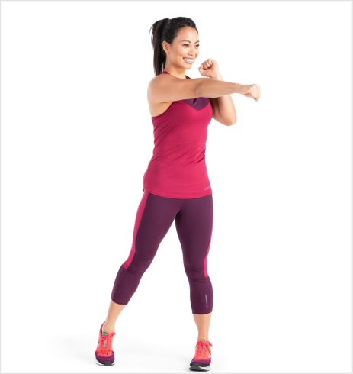

Shoulder Abduction in Sitting
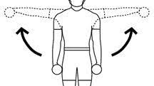

Forward Kicks holding onto chair
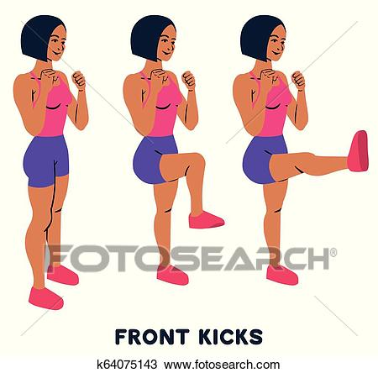
Dead lift
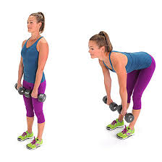
Squats

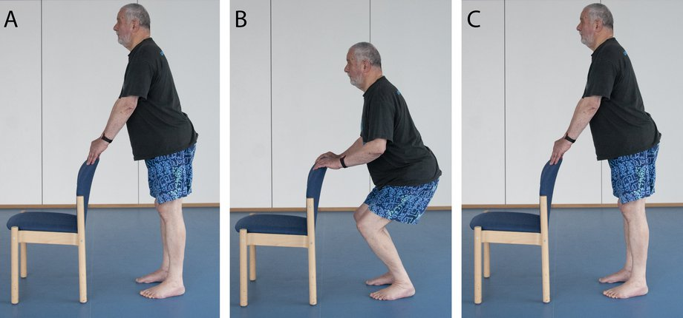

Trunk Twist

Squat, Jab jab

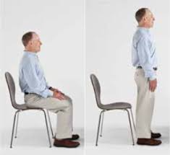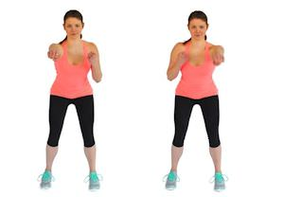

Cool-down
Neck Movements

Arm stretches
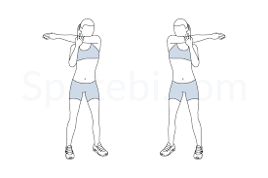
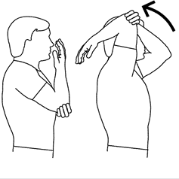
Shoulder circles
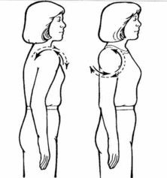
Hip circles
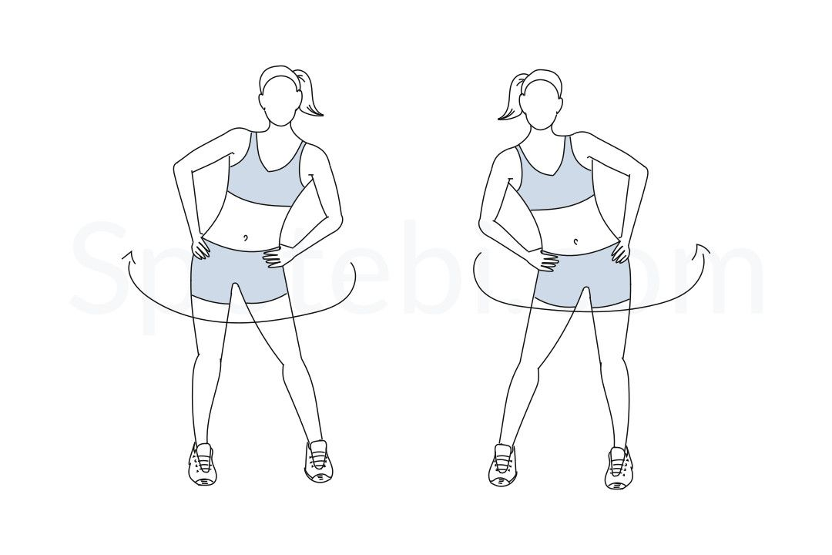

Leg Stretches
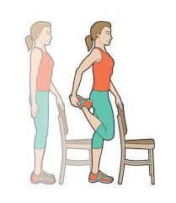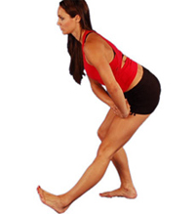

Weekly Progression
Week | Exercise Time | Rest Time | Total Time
1 | 30 seconds | 30 seconds | 4 minutes
2 | 30 seconds | 30 seconds | 5 minutes
3 | 30 seconds | 30 seconds | 6 minutes
4 | 1 minute | 1 minute | 4 minutes
5 | 1 minute | 1 minute | 6 minutes
6 | 1 minute | 1 minute | 8 minutes
7 | 1 minute | 1 minute | 10 minutes

For all exercises with hand weights do 10 repetitions 3 times
For all stretches hold for 20 seconds.

Do this programme at least twice per week.
Please remember to check your Safe Exercise at Home Checklist.

