Modified Borg Dyspnoea Scale

0 Nothing at all
0.5 Very, very slight (just noticeable)
1 Very slight
2 Slight
3 Moderate
4 Somewhat severe
5 Severe
6
7 Very severe
8
9 Very, very severe (almost maximal)
10 Maximal

Patient Instructions for Borg Dyspnoea Scale “This is a scale that asks you to rate the difficulty of your breathing. It starts at number 0 where your breathing is causing you no difficulty at all and progresses through to number 10 where your breathing difficulty is maximal. How much difficulty is your breathing causing you right now?”
Wilson and Jones et al. A comparison of the visual analogue scale and modified Borg scale for the measurement of dyspnoea during exercise: Clinical Science ( 1989) 76,277-282 1989

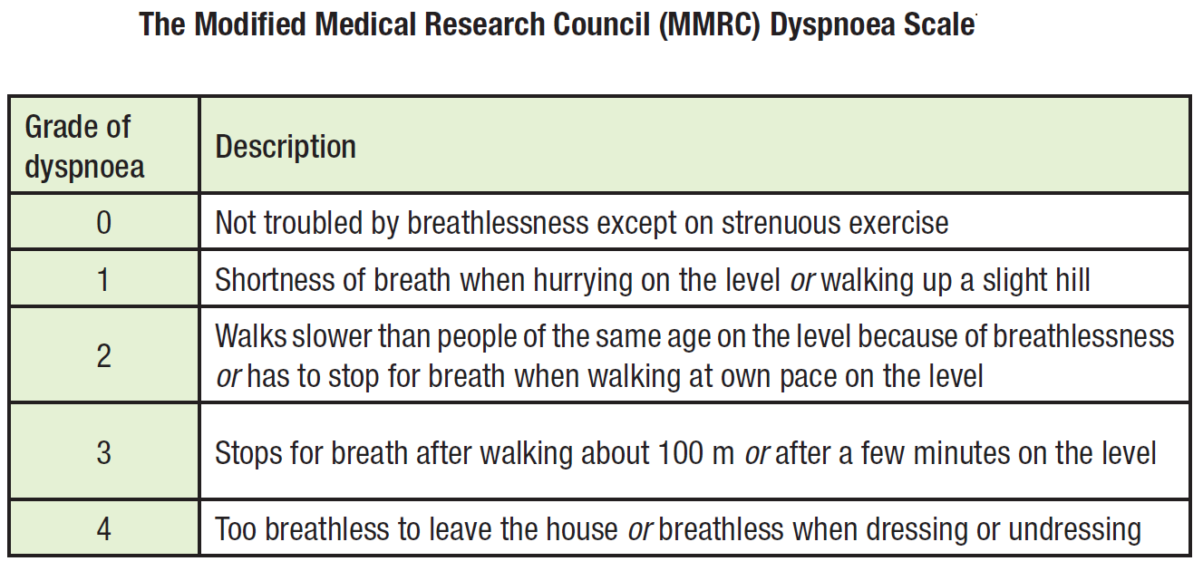
Doherty DE et al. COPD: Consensus Recommendations for early diagnosis and treatment. Journal of Family Practice, Nov 2006

