

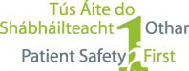

PAEDIATRIC EARLY WARNING SYSTEM (PEWS)

This is to certify that:

attended PEWS Training

Category 1 Approval by Nursing and Midwifery Board of Ireland
for 3.5 CEUs

Signed by: ___________________ Date: _______________
[insert trainer name/title here]
