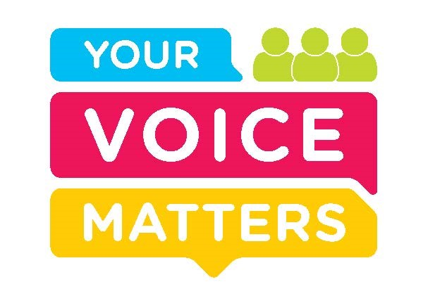

# Your Voice Matters: Paediatric to Adult Healthcare Transitions Survey Report 2023-24

**Survey aim**: To capture the lived experience of young people aged 14-26 years with physical, intellectual, sensory, or mental health difficulties, and their families or carers (18 years or over), during the transition from paediatric to adult services across the Republic of Ireland.

**Survey co-design:** The survey was designed in collaboration with the National Clinical Advisor and Group Lead for Children and Young People and key stakeholders from the Transition of Care Working group, and incorporated insights from the Youth Advisory Council of Ireland.

**Survey analysis:** Sensemaker® software was used to collect and analyse the data.

**Data collection period*:***The survey was live from September 2023 to July 2024. The survey was extended to 14-17 year olds from April - July 2024.

**Who completed the survey?** 76parents and40 young people.

**Survey limitations:** Due to the small number of survey participants the data collected may not represent the full spectrum of experiences, perspectives and views of the wider population. However, the insights gained from the stories, in particular, even though they may not be statistically generalisable, do provide valuable context.

24young people who had transitioned from paediatric to adult services at the time of the survey lived in 14 different counties and accessed 21 different specialties. Therefore, despite the low response rate the survey does represent the experiences of many young people and families.

**Key findings**

1. **The majority of participants described their experience of transitioning from paediatric to adult care as negative.**

The negative stories (67%; n=79) provide valuable insights into how we can improve. While the stories behind positive experiences (17%, n=20) highlight the conditions needed for a positive experience.

Participants who described their experience as positive felt supported by healthcare teams through clear access to relevant information and a strong sense of being cared for.

*“Simply being there for your patient and showing nothing but kindness and warmth is ultimately the most important thing I needed more than any certain facility or plan. I am lucky to say I got that through the nurses, physios and dietitians…”* [Young person]

*“Overall my transition of care was very smooth from the nurse’s standpoint both paediatrics and adults and who continue to show amazing support and care unlike any other.”* [Young person]

*“The nurse spends lots of time with my son - nothing rushed. Lots of information re the future with things we never thought of…”* [Parent/carer]

Young people who described their experience as negative felt unsupported by healthcare teams.

*“I feel let down and forgotten about by the system, and alone in my <REDACTED> management.”* [Young person

*“I was 18 when I transferred and was a very difficult time, felt very alone and clueless at adult service.”* [Young person]

1. **Many participants described a lack of preparation for the transition to adult services.**

*“I’ve had no preparation for moving to adult services, I am confused about what happens. I am nearly 16, autistic and have an intellectual disability I would like to know more about what happens when I’m an adult”.* [Young person]

*“I don’t even know that my child will be transferred soon to adult healthcare services and I am stressed about it now. No preparations at all.”* [Parent/carer]

“*There was no transition, no preparation or reference to same by the paediatric hospitals involved for 18 years in my daughters care, complete discharge with referrals done after discharge and no care pathway secured or created before the complete discharge.”* [Parent/carer]

1. **The majority of participants reported a lack of clear communication from healthcare teams about the transition from paediatric to adult services.**

Communication from healthcare teams about the transition was unclear and difficult to understand (67%; n=68) and insufficient (87% n= 89).

This lack of communication was further emphasised when participants' top tip for others going through the transition was to "ask questions”.

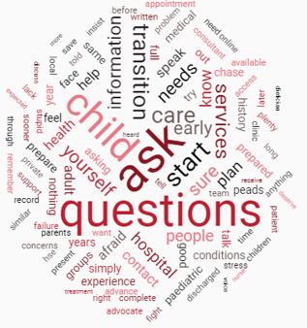

*Figure: word cloud of participant’s top tips*

*“Start questioning your child’s paediatric consultant from the age of 13 at least about transition and have them start making referrals then in order to secure your own child’s transition before discharge.”* [Parent/carer]

*“Don’t be scared, just keep note of questions you want to ask and make sure you get them answered. There’s no need to be ashamed of asking anything or enquiring.”* [Young person]

1. **Almost all participants wanted healthcare teams to provide more information and resources about the transition from paediatric to adult services.**

99% of all survey participants would have liked more information during the transition. On average participants selected at least three topics, see table 1 below.

*“It’s been awful no information about the transition no help no one seems to know anything.”* [Parent/carer]

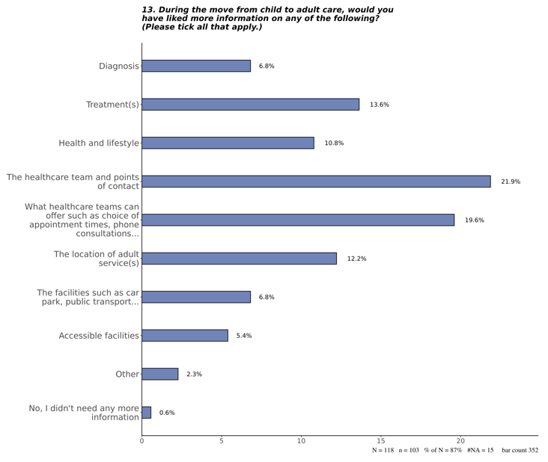Table 1.

40% (n=47) of participants reported that they didn’t know where to find additional information, that the information provided was not given at the right time, or that it was not presented in a format that suited their needs.

*“I have received no guidance preparation or help with this and don’t know where to look for information. I have been asked to have my questions ready for my next appointment as it will be my last. I am anxious about this as I have no idea what I should be asking, yet feel that it is important that I ask the right questions.”* [Young person]

Almost all participants (98% n=116) felt additional resources would have helped their transition. On average participants selected at least three resources, see table 2 below.

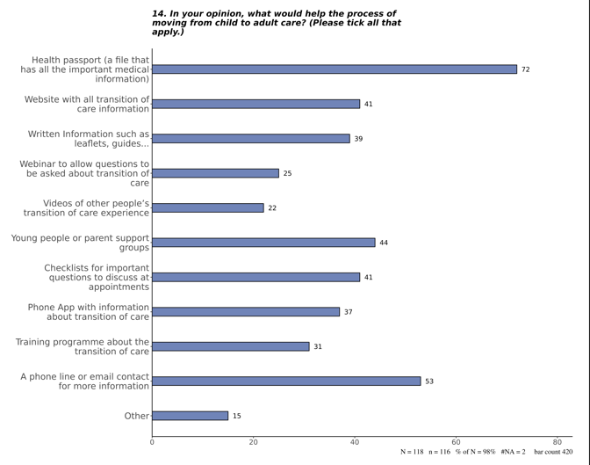Table 2.

1. **Participants highlighted that information and medical documentation were often not transferred between services.**

*“There just seems to be a few gaps in knowledge, between my old clinic and the new one, things that were in my file that I didn’t know or questions I couldn’t answer etc. Perhaps a meeting with the relevant doctors/nurses and the patient at the start of the transition would help get everyone on the same page.”* [Young person]

*“This is a very stressful time for the young person and it’s not made any easier when no one listens or talks to each other in the different departments to get a clear understanding and history of the patient.”* [Parent/carer]

1. **Most survey participants felt unsupported during the transition.**

Participants felt that the transition should be co-ordinated by a dedicated healthcare staff member or multi-disciplinary team but 41% of participants relied on the support of family alone during this critical healthcare juncture.

*“I’m 14 nearly 15. My mam is helping me with a lot from school to all my medical appointments at the hospital and in the disability office. No one has asked mam or me about the future only my teacher in school. Mam says we will have to start the planning now ourselves.”* [Young person]

*“referrals/checkups (cardio, renal, ent) were no longer scheduled by anyone and it is then up to the carer to figure out what needs monitoring and when. Inappropriate as a carer is not a medical professional.”* [Parent/carer]

1. **Where specialised adult services did not exist responsibility fell on the GP and parents to co-ordinate care for young people with complex conditions.**

*“Need a doctor who specialises in Autism for the over 18's, you have a paediatrician under 18 but, once you turn 18 you have nothing only the GP”* [Parent/carer]

*“Transitioning from paediatric care to adult services meant that instead of a “joined up writing” approach to my daughters medical care (led by a Consultant specialising in ID), all services had to be channelled through her GP, who had no specialist training in ID and the complex medical issues that people with ID often have - e.g. the need for closer monitoring of thyroid function than mainstream population.”* [Parent/carer]

1. **Parents felt the need to strongly advocate for their child during the transition to ensure they got access to adult services.**

***“****Speak up for yourself and your child and make sure their voice is heard”* [Parent/carer]

*“Be your child's best advocate as you can slip through the net”.* [Parent/carer]

*“Don't sit back and do nothing if your service has stopped - make plenty noise about it.”* [Parent/carer]

1. **Young People were often not supported to develop the self-management skills necessary to navigate adult healthcare.**

The majority (96% n=23) of young people had transitioned to adult services by 18 years old. However, more than half (n=14) of these young people felt the appropriate age to start in adult services was 19 years old and over. Indicating that most young people surveyed had transitioned before they felt ready.

*“I’m very nervous when my mam can’t ring like she does now to get my care and get me seen when I run into a problem. My brother is moving into adult services for his asthma and he is very nervous.”* [Young person]

1. **Parents and carers worried about being excluded when the young person entered adult services.**

*“I’m worried about dealing with a new team, a new hospital… and a million more things… major concerns about being cut out as we move to adult care… it will be a huge upheaval for us as a family and I’m already worried.”* [Parent/carer]

1. **The adult hospital wards and emergency departments were felt to be challenging environments for young people with complex physical and mental health conditions.**

*“My child is 19 years old… non-verbal and mentally and physically disabled with a rare life limiting condition. Going into an adult hospital A&E with my child who is small and vulnerable has been horrific. My son wears a size 9-10 pyjamas…”* [Parent/carer]

**Conclusion**

Survey participants who reported positive experiences of transition shared the following key elements in their stories:

* Clear and balanced communication from healthcare teams,
* Adequate preparation to ensure readiness for the transition,
* Access to relevant information and resources,
* Being treated with empathy and kindness throughout the process.

To ensure a smooth and supportive transition to adult services, all healthcare teams should:

* **Initiate discussions about the transition early, starting at age 12, with young people and their families.**
* **Support young people to develop self-management and self-advocacy skills,** when appropriate.
* **Support parents and carers to gradually reduce their involvement** in the young person’s care, when appropriate.
* **Begin the transition process early to ensure continuity of care for the young person.**
* **Provide age appropriate information and resources**.
* **Listen to the worries and concerns** of young people and their families with empathy and compassion.

The survey findings align with the recommendations outlined in the Transition of Care Framework, underscoring the need for its implementation to improve outcomes for young people and their families navigating care transitions.

***We extend our sincere gratitude to everyone who provided valuable feedback to inform this report.***