Transition Process Infographic (NICE Guidance)

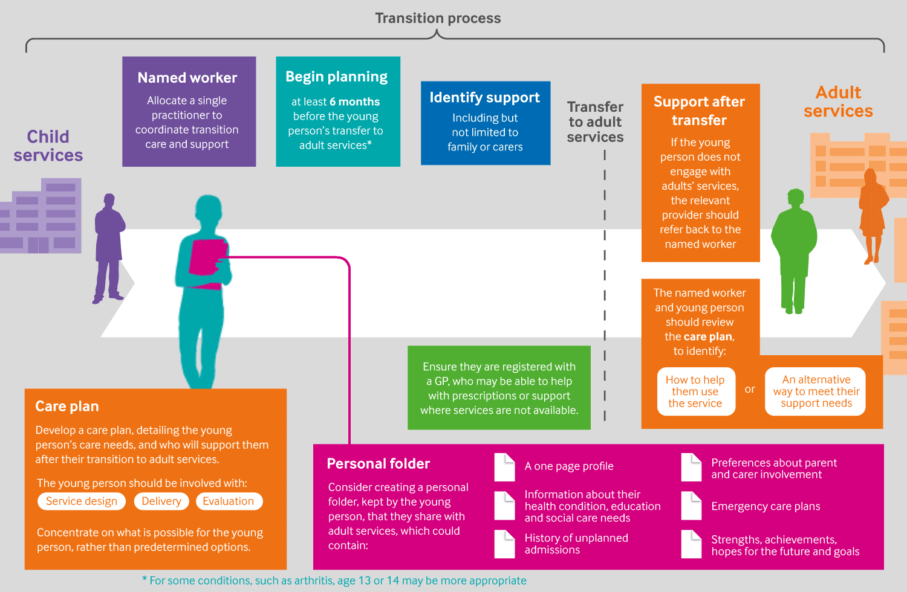
Supporting young people in their transition to adults’ services: summary of NICE guidance- https://www.bmj.com/content/353/bmj.i2225/infographic

