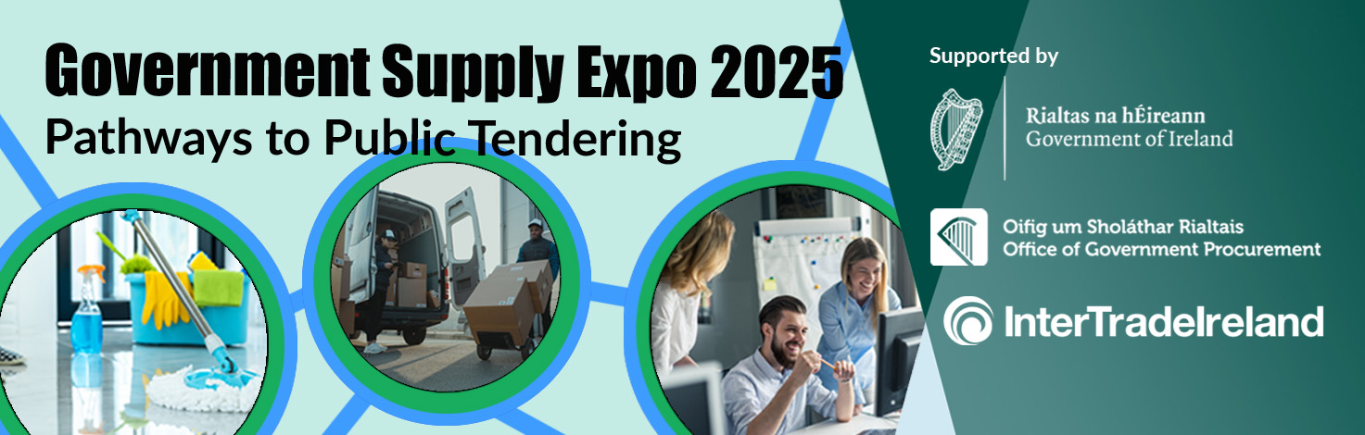

We are delighted to be exhibiting at Ireland’s most important public procurement event of the year, the Government Supply Expo 2025, hosted by the Office of Government Procurement (OGP) in partnership with InterTrade Ireland. This free event taking place in the Aviva Stadium, Dublin, is aimed at businesses currently selling or interested in selling goods, services or construction works to the Health Sector and wider government.
With 1500 attendees, three stages of talks and 40 exhibitors made up of large-scale Government Buyers and business support agencies, its purpose is to give both larger companies and SMEs the chance to engage in face-to-face networking with procurement professionals, government buyers, and peer suppliers.
Exhibitors confirmed include An Post, ESB, Dublin Airport Authority, Dublin City Council, Fingal County Council, Dublin Bus, HSE and many more. For further details and a full list of exhibitors please check
https://www.gov.ie/en/office-of-government-procurement/news/government-supply-expo-2025/
This free event offers unparalleled access to the full scope of public procurement practitioners in Ireland, North and South.
To register for this free event: CLICK HERE
Queries should be directed by email to Government.SupplyExpo@ogp.gov.ie

