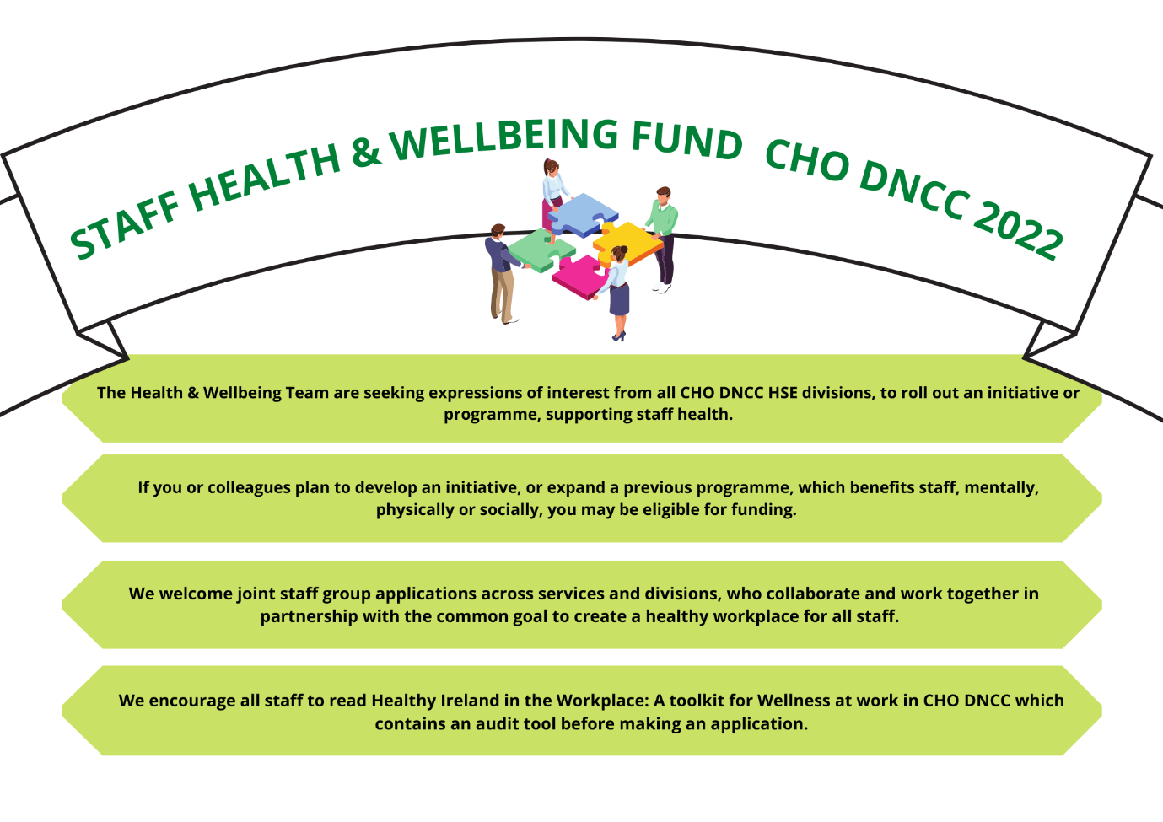
Click here to find Application Form, Toolkit & FAQ’S

Closing date for submission of applications is the 21st of each month January to September 2022 by email to:
hwb.dncc@hse.ie

application process
All initiatives must be Covid-19 compliant and in line with current Government and HSE Covid-19 Guidelines.
- Please refer to Healthy Ireland in the Workplace: A toolkit for Wellness at work in CHO DNCC Click Here when completing this form
- Complete all sections below. Applications with missing details will not be considered
- Tick boxes below, where relevant
- Submit quotes for all initiatives with application
- Ensure line managers are aware of application
- Complete evaluation report for H&W team following successful implementation of initiative
- This is a once-off fund for 2022 and will not include any ongoing costs. All approved funds must be spent within the 2022 financial year
- Applications cannot be considered unless they are fully compliant with HSE procurement and purchasing regulations
- Please note applicants must be willing to seek quotes, organise events, evaluate and report on progress etc.
- Incomplete applications and/or late submissions will not be accepted
- Applicants may use HSE vendors set up already or have the option of setting up a new vendor. Please contact hwb.dncc@hse for a list of vendors who have been used in the past

application deadline
Application form and quotes to be emailed to: hwb.dncc@hse.ie no later than 5pm on the 21st of each month from January to September 2022.

Section 1 – Applicant details
Name of key contact to follow up with:
Role:
Department:
Address:
Email:
Line Manager’s signature:
Date of submission:

Section 2 – Initiative Topic

Which of the following topics below will your initiative focus on? Please refer to Healthy Ireland in the Workplace: A Toolkit for Wellness at Work in CHO DNCC Click Here when completing this section.
Please tick box /boxes
Healthy Eating ☐
Physical Activity ☐
Mental Health ☐
Sexual Health ☐
Stop Smoking ☐
Drugs and Alcohol ☐
Section 3 – Initiative Description

Describe your initiative?

Section 4 – Initiative Aims
What are the aims of your initiative?

Section 5 (a) Staff Benefits
No. of staff who will benefit from this initiative?

Section 5(b) – Staff Benefits
How will this initiative benefit the staff in your Service? Please explain.
NB Your initiative needs to demonstrate the Health & Wellbeing benefits for staff in line with the CHO DNCC Healthy Ireland Implementation Plan which can be found through the link below:
https://www.hse.ie/eng/services/publications/health-and-wellbeing/cho-dncc-healthy-ireland-implementation-plan-2018-2022.pdf

Section 7 – Cost
What is the cost of implementation?

Section 8 - Timeline
What is the timeline for implementation? Please note that all funds are once off and must be spent within 2022.

