**National Office for Human Rights and Equality Policy,**

**National Quality Improvement Team.**

**The Team**

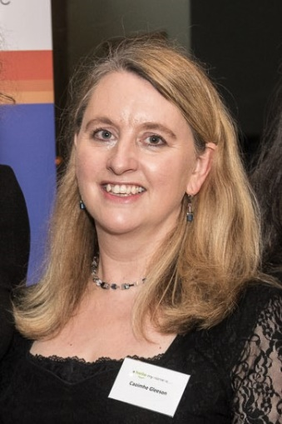

**Caoimhe Gleeson** is the National Programme Manager for the National Office for Human Rights and Equality Policy in the HSE. She has overseen the drafting of the Healthcare Codes of Practice on the Assisted Decision Making (Capacity) Act 2015 on behalf of the Decision Support Service and the Minister for Health. She is a member of the National Disability Authority Technical Group who drafted the non-healthcare Codes of Practice on the 2015 Act on behalf of the Department of Justice. She was a ministerial appointee to the National Research Ethics Committee (NREC) established to expedite ethical approval for research during COVID-19 in 2020. She is also HSE National Specialist in Accessibility and has worked in the area of equality and human rights advocacy, service user partnership, policy and service development for a number of years in Ireland in relation to people with disabilities, the LGBTI Community and other diverse groups.

Before joining the H.S.E. she worked in Community Development with NUI, Galway in partnership with a wide variety of agencies and non-governmental organisations in the North West region of the Republic of Ireland and in Northern Ireland. She has worked and volunteered on programmes relating to gender equality, youth work, intercultural education, conflict transformation and mediation, development of civil society and citizenship rights in El Salvador, Ghana, United States, Mongolia, Croatia and Bosnia-Herzegovina.

She holds a Master’s Degree in Community Development, a Professional Diploma in Equality and Human Rights, is an accredited mediator and qualified psychotherapist. She is currently studying for an LLB.

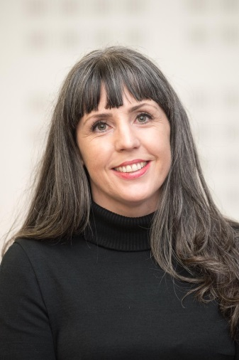`

**Elaine McCaughley** is responsible for the training and education strategy and resources across a number of programmes including the Assisted Decision-Making (Capacity) Act and the National Consent Policy. Elaine has extensive clinical experience as a speech and language therapist, where she gained first-hand experience of the challenges faced by people who are disempowered within health and social care systems. Elaine holds an LLM in Healthcare Ethics and Law from the University of Manchester where she volunteered at the Dementia Legal Advice Clinic. Elaine has a strong interest in ethics education and advocacy, and enjoys collaborating with people using services, and teams within and outside HSE.

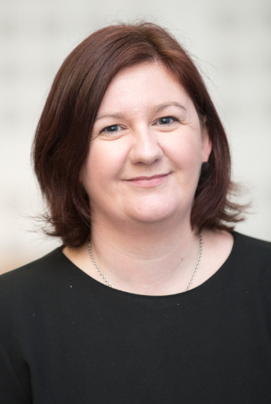

**Jacqueline Grogan**

Jacqueline Grogan is Project Manager in the National Office for Human Rights and Equality Policy. She is responsible for the Assisted Decision-Making (Capacity) Act 2015, Wardship, Public Sector Duty, Transgender and Intersex issues, and Universal Access.

Prior to joining the HSE in 2016, she worked in disability services both in Scotland and Ireland, including Sense Scotland, Momentum Scotland, the Rehab Group, Headway Ireland and the Disability Federation of Ireland, in the areas of service delivery, research, communications, governance and service development. She holds an honours degree in Psychology, a Master’s degree in Social Research, a Certificate in Public Relations, and is a PRINCE II Practitioner. She has recently completed a Professional Diploma in Human Rights and Equality.

Jacqueline strongly advocates for the right for everyone to be supported to make decisions about their care and treatment choices and the need for services and organisations to listen to and learn from the experiences of people who use our services, their families and their advocates.

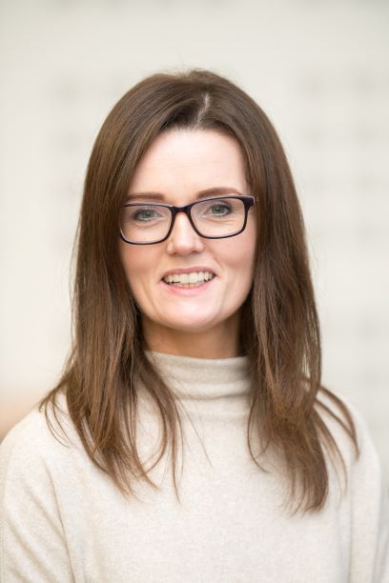

**Orlaith Branagan** is Office Administrator with National Office for Human Rights and Equality Policy. Orlaith is responsible for the management of the website [www.assisteddecisionmaking.ie](http://www.assisteddecisionmaking.ie), co-ordinating the programme of events delivered by the office as well as managing day to day operations.

Orlaith has a strong interest in Person Centredness and putting the rights of the person first.

She is also a qualified Yoga teacher and loves to paint.