Before
you take it…

KNOW
your medicines
and keep a list

CHECK
that you are using
the right medicine the right way

ASK
your healthcare
professional if you’re unsure

What is My Medicines List?
My Medicines List is a list of all the medicines and supplements you take.

Why should I use it?
Keeping an up-to-date list can help you know your medicines. It can also help you when discussing your medicines with a healthcare professional.
My

Information for people who take medicines and their families

How should I fill it in?
To fill out My Medicines List, you need all your medicines in front of you. Another option is to ask your pharmacist to print out a list for you. Make sure you include all prescribed and over-the-counter medicines and supplements.

Medicines
List

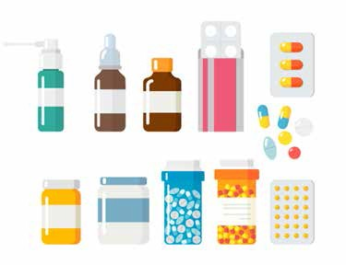
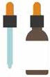

My pharmacy’s name Phone number
My family doctor’s name Phone number
Emergency contact name

Phone number

www.safermeds.ie

How should I use it?
Keep your list up to date. Bring it with you when attending any healthcare appointment. You may find it useful
to keep a photo of this list on your phone.

How can I get another form?
To get another copy, you can print from www.safermeds.ie or ask for a copy at your local pharmacy.

i KNOW
- CHECK
? ASK

My medicines
My allergies and how I react:

Name |  | Date of birth |  | Date I filled  out this form

Name of medicine or supplement | Strength | How much I take each time | I take it | I take it every day (Yes / No) | Why I take it? | My notes
Example: ABC Tablets | 25mg | 2 tablets | Once in the morning | Yes | For my heart | Take with food
This document belongs to the person named above. If taking a copy, return the original to the person.

