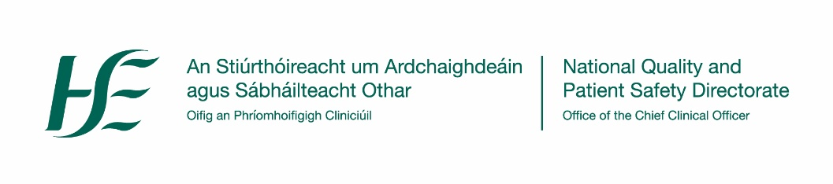 | 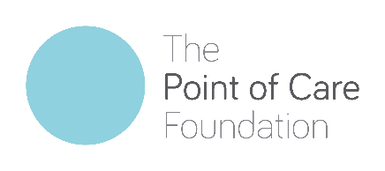
Working in partnership HSE operations, patient representatives and other internal
and external partners to improve patient safety and the quality of care

We are delighted to invite you to join us for a

Schwartz Round
“Title”

Date:
Time:
Location:

Who is invited?
XXXXXXXXXXXXXXXX

What are Schwartz Rounds?

Schwartz Rounds are a forum for all staff. They are designed for us to come together once a month to discuss and reflect on the emotional and social impact of working in healthcare. Rounds provide a confidential space to reflect on and share experiences.

We look forward to welcoming you

National Quality and Patient Safety Directorate│ Caroline Lennon-Nally, Schwartz Rounds Co-ordinator: caroline.lennonnaly@hse.ie Twitter: @NationalQPS Website: https://www.hse.ie/eng/about/who/nqpsd/qps-connect/schwartz-rounds/schwartz-rounds.html

