Project Name:
Project Lead:
- Why?
Run charts can assist in understanding variation. They are used to examine data for trends or other patterns that occur over time. Run charts visually depict the history and patterns of variation in an indicator or measure. Plotting data regularly on a graph shows when shifts and changes occur and can help identify if and when problems appear.

- How?
- Draw Axes
- Plot your data
- Draw a centreline (Median)

A run chart can be created using a pen and paper or excel. See resources for more guidance.

- What is a run?
A run is defined as one or more consecutive data points on the same side of the median.

- Examples of a run chart
This template displays a run chart.
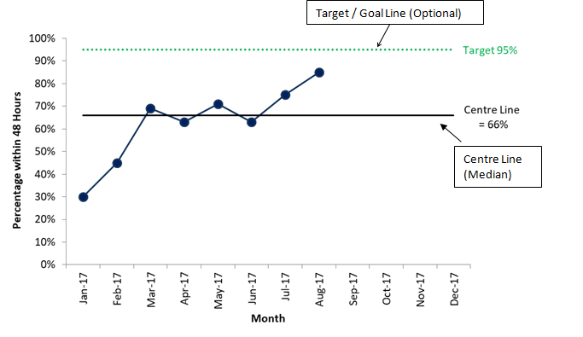

- Interpreting a Run Chart
Four rules are used to help interpret run charts by detecting non-random patterns (i.e. signals) in the data.

- A run of 6 or more consecutive points above or below the centre line (a shift)  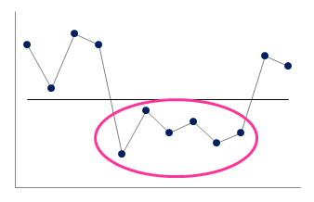 | - A trend of five or more consecutive points all going up or down  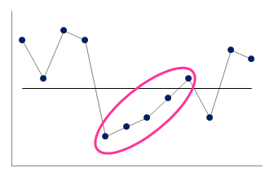
- Too few or too many runs  A run is a series of points in a row on one side of the centre line (median). Too few or too many runs is a signal of a non-random pattern.  To determine the number of runs count the number of times the line connecting the data points crosses the centre line and add one.  Consult Table 1 to determine whether the number of runs is within the expected range, or whether there are too few or too many (indicating a non-random pattern). | - An astronomical data point (an obviously  different value that everyone would agree is highly unusual)  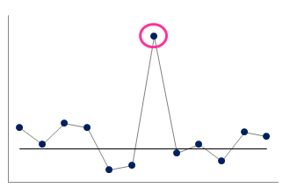
Table 1: Upper & lower limits for number of runs

N  N = Total number of data points on the run chart that do not fall on the centre line  Lower Limit = Lower limit for the number of runs (less than this number of runs is too few)  Upper Limit = Upper limit for the number of runs (more than this number of runs is too many)  Source: Provost L, Murray S. The Healthcare Data Guide: Learning from Data for Improvement. San Francisco: Jossey-Bass, Publication, 2011 | Lower Limit | Upper Limit | N | Lower Limit | Upper Limit | N | Lower Limit | Upper Limit | N | Lower Limit | Upper Limit
10 | 3 | 9 | 23 | 7 | 17 | 36 | 13 | 25 | 49 | 19 | 32
11 | 3 | 10 | 24 | 8 | 18 | 37 | 13 | 25 | 50 | 19 | 33
12 | 3 | 11 | 25 | 8 | 18 | 38 | 14 | 26 | 51 | 20 | 33
13 | 4 | 11 | 26 | 9 | 19 | 39 | 14 | 26 | 52 | 20 | 34
14 | 4 | 12 | 27 | 10 | 19 | 40 | 15 | 27 | 53 | 21 | 34
15 | 5 | 12 | 28 | 10 | 20 | 41 | 15 | 27 | 54 | 21 | 35
16 | 5 | 13 | 29 | 10 | 20 | 42 | 16 | 28 | 55 | 22 | 35
17 | 5 | 13 | 30 | 11 | 21 | 43 | 16 | 28 | 56 | 22 | 36
18 | 6 | 14 | 31 | 11 | 22 | 44 | 17 | 29 | 57 | 23 | 36
19 | 6 | 15 | 32 | 11 | 23 | 45 | 17 | 30 | 58 | 23 | 37
20 | 6 | 16 | 33 | 12 | 23 | 46 | 17 | 31 | 59 | 24 | 38
21 | 7 | 16 | 34 | 12 | 24 | 47 | 18 | 31 | 60 | 24 | 38
22 | 7 | 17 | 35 | 12 | 24 | 48 | 18 | 32

- When should I use a run chart?
Run charts are valuable when:
- You want to look at data over time in a simple way
- You are starting a project with no baseline data and/or have few points of data (less than 12)
- You do not need in depth analysis of the process being charted
- You have limited statistical expertise available.

As you progress with your project, if you have 12+ points of data and some statistical expertise you can use Statistical Process Control (SPC) Charts. SPC charts are like run charts with the addition of upper and lower control limits based on statistical calculations. These limits allow for more robust statistical analysis.

SPC charts are valuable when
- You are starting a project and have baseline data (at least 12 points)
- You have progressed in a project and have 12+ points of data and you would like greater understanding of the process you are charting
- You are interested more robust statistical processes for identifying special cause variation
- You have statistical expertise available.

- Resources
Run Chart Template
A template for creating run charts is available on the National Quality Improvement Team Evidence for Improvement resources page
https://www.hse.ie/eng/about/who/qid/measurementquality/measurementimprovement/mit-resources.html#run

In the Excel template, enter your raw data and optionally labelling information into the grey cells. The chart will update automatically. You can format the chart as you would any excel chart to customise.

Run Chart Video
A video explaining run charts is available on the HSE YouTube channel
https://www.youtube.com/watch?v=ySbhsX-y8zE

Run QI Talktime
A 40 minute talk on run charts is available on the QI Talktime page
http://bit.ly/runchart

