Project Name:
Project Lead:
- Why?
- This tool facilitates a conversation with a MDT so that they agree what work ‘is’ rather than ‘imagined’. This conversation will help Identify a list of opportunities and issues that the team can work on
- Identify value and non-value adding activities e.g. activities that do not add value to the internal or external customer, including: delays; needless storage and transportation; unnecessary work, duplication, and added expense; breakdowns in communication
- Identify points of integration and handover
- Standardise process to minimise variation
- Assist in building a team
- Confirms accountability

- How?
- Observe the process and make transparent the current steps involved in a service user journey
- Make clear which member of a multi-disciplinary team is accountable for which step
- Map and redesign facilitates team working
- A flow chart combined with data exposes waste and delays
- Identify where weak service user handoffs are occurring
- Define requirements for systems and ways of working
- You can collect process measures along the map e.g. wait times, discharge rates and active care time

- Tips for process mapping
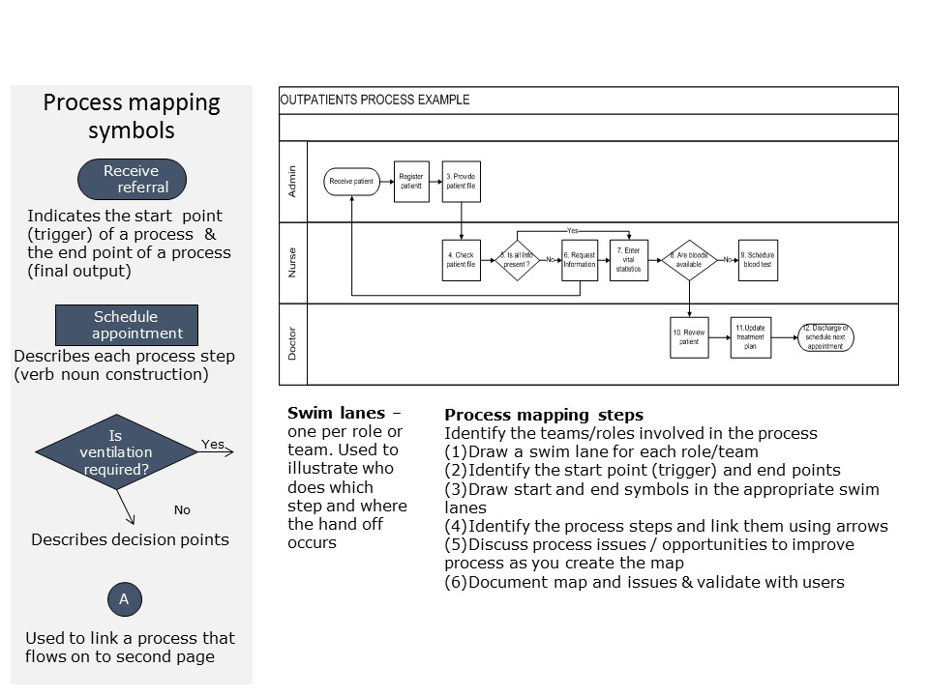

- Sample

You can create a visual process flow on a wall using sticky notes. It is a great way to involve all the team and making it easy to move around if you make mistakes!

