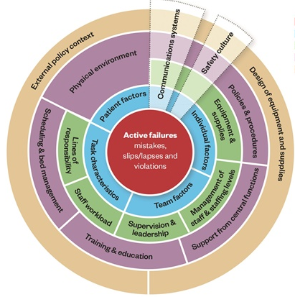
A Framework for Patient Safety Incident Review

Yorkshire Contributory Factors Framework (YCFF)

To support staff in applying the framework in practice it has been adapted to provide a pragmatic 2 page guidance document which suggests a series of prompting questions and examples of contributory factors that may be useful to assist reviewers in formulating questions relating to a review they are undertaking. The questions and examples of contributory factors are illustrative and can be tailored depending on the nature and context of the incident under review.

Prompting Question | Relevant to Incident? | CONTRIBUTORY FACTOR DOMAIN
 |  | Situational Factors
Did the staff involved function as a team? | Yes  Maybe  No | Team Factors – For example:  - Conflicting team goals  - Lack of respect for colleagues  - Poor delegation  - Absence of feedback
On the day of the incident, how did you feel? | Yes  Maybe  No | Individual Staff Factors – For example:  - Fatigue  - Stress  - Rushed  - Distraction  - Inexperience
Did the task features make this incident more likely? | Yes  Maybe  No | Task Characteristics – For example:  - Unfamiliar task  - Difficult task  - Monotonous task
Were there any reasons this incident was more likely to occur to this particular service user? | Yes  Maybe  No | Service User Factors – for example:  - Language barrier  - Uncooperative  - Complex medical history  - Unusual physiology  - Intoxicated
Prompting Question | Relevant to Incident? | CONTRIBUTORY FACTOR DOMAIN
 |  | Local Working Conditions
Did staff provision match the expected workload around the time of the incident? | Yes  Maybe  No | Workload & Staffing issues- For example:  - High unit workload  - Insufficient staff  - Unable to contact staff  - Staff sickness
Did everyone understand their role? | Yes  Maybe  No | Leadership, Supervision & Roles – example:  - Inappropriate delegation  - Unclear responsibilities  - Remote supervision
Were the correct drugs, equipment and supplies available and working properly? | Yes  Maybe  No | Drugs, Equipment & Supplies – example:  - Unavailable Drugs  - Equipment not working  - Inadequate maintenance  - No supplies delivery
Prompting Question | Relevant to Incident? | CONTRIBUTORY FACTOR DOMAIN
 |  | Latent/Organisational Factors
Did the ward environment hinder your work in any way? | Yes  Maybe  No | Physical Environment – For example:  - Poor layout  - Lack of space  - Excessive noise/heat/cold  - Poor visibility (e.g. position of nurses’ station)  - Poor lighting  - Poor access to service user
Were there any problems from other departments? | Yes  Maybe  No | Support from other departments  This includes support from IT, HR, porters, estates of clinical services such as radiology, phlebotomy, pharmacy, biochemistry, blood bank, physiotherapy, medical or surgical subspecialties, theatres, GP, ambulance ….
Did any time of bed pressures play a role in the incident? | Yes  Maybe  No | Scheduling and Bed Management - example:  - Delay in the provision of care  - Transfer to inappropriate ward  - Difficulties finding a bed  - Lack of out-of-hours support
Were there any issues with staff skill or knowledge? | Yes  Maybe  No | Staff Training and Education – For example:  - Inadequate training  - No protected time for teaching  - Training not standardised  - No regular/yearly updates
Did local policies, protocols and Procedures help or hinder? | Yes  Maybe  No | Local Policies, Protocols or Procedures – e.g.  - No protocol exists  - Protocol too complicated  - Lack of standardisation  - Contradictory policies exist
Prompting Question | Relevant to Incident? | CONTRIBUTORY FACTOR DOMAIN
 |  | Latent/External Factors
Is there any characteristic about the equipment, disposables or drugs used that was unhelpful? | Yes  Maybe  No | Design of Equipment, Supplies & Drugs - e.g.  - Confusing equipment design  - Equipment not fit for purpose  - Similar drug names  - Ambiguous labelling and packaging
Have any national policies influenced this incident? | Yes  Maybe  No | National Policies – For example:  - Commissioned resources  - National Screening Policy  - Interference by government organisations  - National medical/nursing standards  - National Performance Targets
Prompting Question | Relevant to Incident? | CONTRIBUTORY FACTOR DOMAIN
 |  | General Factors
How would you describe the culture of you clinical/care areas in relation to service user safety? | Yes  Maybe  No | Safety Culture – For example:  - Service User Safety awareness  - Fear of documenting errors  - Attitude to Risk Management
Were the notes available, accurate and readable?  Did poor or absent verbal communication worsen the situation?  Acknowledgement: Yorkshire and Humberside Improvement Academy. Creative Commons Bradford Teaching Hospitals NHS Foundation Trust. | Yes  Maybe  No | Communication – Written and Verbal e.g.  - Poor communication between staff  - Handover problems  - Lack of communication/notes  - Unable to read notes  - Inappropriate abbreviations used  - Unable to contact correct staff  - Notes availability

