NIMS Data Quality Report

Applies to all Category 1 incidents and SREs
that involved a Service User
Introduction
NIMS is the incident management system used by the HSE and HSE-funded services to record and manage an incident throughout its incident lifecycle.
The benefits of having a national system is that is provides an opportunity for national learning from a rich pool of incident data, therefore benefitting a large population improve patient and staff safety.
To help understand incident trends, ascertain learning from incidents and to help measure compliance it is important to have good engagement with the system and have complete/accurate data.
This report examines one of the key sections of the system, namely the review screens. The review screens contain the information in relation to the management of an incident and are predominantly used for incidents that are a category 1, category 2 or SRE but are not exclusive to such incidents.
The report provides detail as to the completion and accuracy of some of the fields. By taking a global view initially, it is expected to highlight areas where improvements can be made or where misinterpretations around the system requirements exist.
Reporting month:
Extract period:
Date of extraction:
Conditions: Locations as per KPI report, Category [1 OR any if SRE], who was involved is Service User.
Extraction using views.
Total number of records extracted:
Total records with Date Notified Adjusted calculated for reporting period:
Symbols used: Data Quality expected situation and possible issues, Useful info, how current data presents on selected topics
GENERAL SECTION
Date Notified to SAO
In line with the IMF, all Category 1 and Serious Reportable Events have to be notified to the Senior Accountable Officer (SAO) within 24 hours from occurrence. It is acknowledged that in reality a service may only become aware of an incident sometime after the event occurs hence the measure is that the SAO should be informed within 24hours from when a service becomes aware of the incident. The important field here on NIMS is ‘date notified’. The IMF will be updated to reflect this.
The Date Notified filed is entered in the section under ‘specific incident details’ where NIMS also captures who reported the incident. It is an important field for data extraction and measuring KPIs.
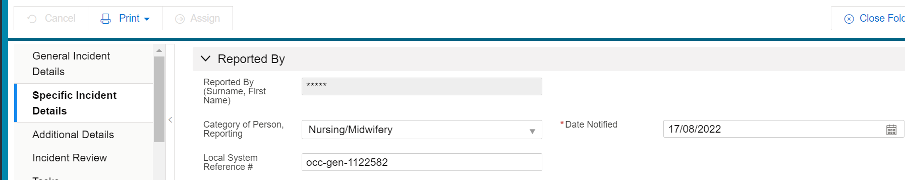

From doing the data analysis on NIMS it is apparent that there can be errors in data entry fields capturing dates on the system, for example staff have inadvertently put a patient’s date of birth in a field before. For this reason, Date Notified Adjusted (DNAdj) is used for determining when a service became aware of the incident. This is then used in conjunction with the field Date Notified to SAO to measure whether or not the SAO was informed within 24 hours.
Calculation of Date Notified Adjusted:
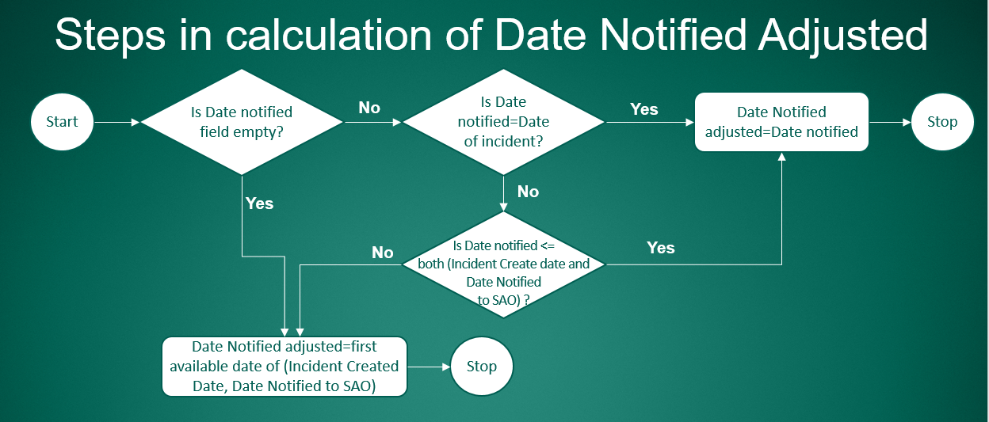
It is expected that the Date Notified to SAO field is not empty.
When the field Date Notified to SAO is populated, then the difference between DNAdj and Date Notified to SAO can be determined and it will be evident if this occurred within one day.
It is also possible to calculate the delays in notifying the SAO based on Date Notified to SAO and DNAdj.

See tab Date Notif SAO – choose tables/ graphs.

Date Notified
It is expected that the ‘Date Notified’ is the first date when a service or healthcare provider becomes aware of the incident.
It is expected DNAdj=Date Notified. This means that when the calculation of DNAdj obtains an earlier date than the recorded Date Notified, it shows that there may have been an incorrect date entered in the Date Notified field or the calculation recognises that an earlier date was entered for Date Notified to SAO or Date Created field.
It is possible to identify where Date Notified and DNAdj are different and how many incidents are affected.
It is also informative to map where these differences appear

See tab DN vs DNAdj– choose tables/ graphs.

Review Dates
It is expected for the review dates to occur in the following sequence:
1. Date Review Decision Made
2. Date Review Started
3. Date Review Accepted by Commissioner
It is expected that the review dates occur on or after DNAdj but not before.
It is considered a Data Quality issue when the review dates are recorded in a different sequence (e.g. review is accepted before it is started) or before DNAdj.
It is possible to map where and when these DQ issues are identified in the extract

See tab wrong dates sequence

QPS Manager Name
It is expected that the QPS Manager Name is recorded for all category 1 incidents and SREs.
An additional test reviewing if the ‘full name’ is recorded in this field is possible and the distribution of the full name recording

See tab QPS manager name

Open Disclosure has happened
It is expected that Open Disclosure occurs in particular where there is a category 1 incident or SRE. The system allows the option ‘No’ to be recorded with an explanation however there are very few exceptions where Open Disclosure would not take place for such incidents, i.e. the patient/service user/relevant other declined open disclosure or they could not be contacted (see HSE Open Disclosure Policy for details).
We aim to have OD completed for all category 1 and SRE incidents (OD has happened =Yes) for as close to 100% as possible.
Analysis can be focused on the entire time period of the data extract and it can focus on the data excluding the most recent 2 months, to determine if the delays in recording are affecting only the most recent incidents or the entire period. Open Disclosure is a process and there are multiple engagements throughout hence staff may not record this as completed early on.
It is possible to map Has OD happened=Yes percentages.

See tab OD Happened

ANALYSIS FOR EACH LEVEL OF REVIEW REQUIRED
Overview of Level of Review Required (LR) recorded
The decision of the level of review for a reported Category 1 incident or an SRE should be made within 72h from the date when a service becomes aware of the incident (DNAdj) and no later than a week. The IMF refers to the date of occurrence but we know that incidents can occur that may not come to light for some time hence we use DNAdj. This will be updated in the next IMF revision.
The field LR has 5 values and can also be empty before a decision for review is made. This field is correlated with the field Approach to Review.
Analysis can be focused on entire period or can exclude the last 2 months, to determine if the delays in recording a value in LR field are affecting only the most recent months or the entire period.

See Tab Level of review BAR

No decision review recorded
It is expected that a decision regarding the appropriate level of review required is to be made for all category 1 incidents and SREs.
It is expected that the decision regarding the level of review required is recorded in NIMS. This should be reached within the timeframe described above, therefore the field LR is not expected to be blank after this timeframe.
It is possible to map where and when the field LR is blank.
The aim is to have the level of review field populated and there should not be any blanks for incidents that are older than a month.

See Tab LR blank

Comprehensive reviews

See tab Level of review Tables

Appendix 1 summarises on column ‘Comprehensive’ the relevant tests.
Overview of all test results is available. Based on test results a decision can be made for inclusion as simple text, tables/ graphs or just in overview.

See tab LR=comprehensive DQ for overview

Date Review Decision Made

It is expected that the Date Review Decision Made is recorded for all category 1 and SREs with the LR field not blank.
It is expected that the Date Review Decision Made is not before DNAdj.
It is expected that Date Review Decision Made is the first review date recorded, therefore it is expected to be on the same date or before the other two review dates (review started and accepted).
It is expected that the Date Review Decision Made is no later than one week after DNAdj.
It is possible to calculate the delays when Date decision-DNAdj>7days and how many incidents are affected.

See tabs
Missing date decision,
Decision in 7days from DNAdj,
review decision bf DNAdj,
DRABC<= decision

Date Review Started
It is expected that the Date Review Started is recorded when the review starts.
Analysis is available for each month and location showing the presence/absence of a start date.
It is expected that the Date Review Started is not before DNAdj.
It is expected that the Date Review Started is on or after Date Decision and before Review Accepted.

See tabs
Missing date started
started bf DNAdj
started bf decision

Date Review Accepted by Commissioner (DRABC)
It is expected that the Date Review Accepted by Commissioner (DRABC) field is populated when the review is completed and accepted by the commissioner
If DRABC is not recorded it may show an under-performance when in fact the review is closed and details have simply not been updated in NIMS.
It is expected that DRABC is not before DNAdj.
It is expected that DRABC is the last of the review dates (after decision and after it started).
It is expected that the DRABC and Status review field correlate. If the field status review is populated with “c.Complete”, but the DRABC is not recorded it points to a data quality issue.

See tabs
DRABC is recorded
DRABC <= DNAdj

Level of Independence
It is expected that the Level of independence is recorded.

See tab level of independence

Name Reviewer
It is expected that the Name Reviewer is recorded for LR Comprehensive.
An additional test for ‘full name’ recorded in this field is possible and the distribution of full name recording

See tab reviewer name

Name Commissioner
It is expected that the Name Commissioner is recorded for LR Comprehensive.
An additional test for ‘full name’ recorded in this field is possible and the distribution of full name recording

See tab commissioner name

Statement of findings, Corrective actions to reduce reoccurrence and Main contributory factors
It is expected that the fields Statement of findings, Corrective actions to reduce reoccurrence and Main contributory factors are completed for reviews that have been accepted by the Commissioner.
Data is available for records with DBRAC, with status complete but without DRABC and as well without DRABC or status c.Complete, therefore with no indication the review is closed.

See tab LR=comprehensive DQ

Concise reviews

See tab Level of review Tables

Appendix 1 summarises on column ‘Concise’ the relevant tests.
Overview of all test results is available. Based on test results a decision can be made for inclusion as simple text, tables/ graphs or just in overview.

See tab LR=concise DQ for overview

Date Review Decision Made

It is expected that the Date Review Decision Made is recorded for all category 1 and SREs with the LR field not blank.
It is expected that the Date Review Decision Made is not before DNAdj.
It is expected that Date Review Decision Made is the first review date recorded, therefore it is expected to be on the same date or before the other two review dates (review started and accepted).
It is expected that the Date Review Decision Made is no later than one week after DNAdj.
It is possible to calculate the delays when Date decision-DNAdj>7days and how many incidents are affected.

See tabs
Missing date decision,
Decision in 7days from DNAdj,
review decision bf DNAdj,
DRABC<= decision

Date Review Started
It is expected that the Date Review Started is recorded when the review starts.
Analysis is available for each month and location showing presence/ absence of start date.
It is expected that the Date Review Started is not before DNAdj.
It is expected that the Date Review Started is on or after Date Decision and before Review Accepted.

See tabs
Missing date started
started bf DNAdj
started bf decision

Date Review Accepted by Commissioner (DRABC)
It is expected that the Date Review Accepted by Commissioner (DRABC) field is populated when the review is completed and accepted by the commissioner
If DRABC is not recorded it may show a poor performance when in fact the review is closed, but details are not updated in NIMS.
It is expected that DRABC is not before DNAdj.
It is expected that DRABC is the last of the review dates (after decision and after started).
It is expected that the DRABC and Status review field correlate. If the field status review is populated with “c.Complete”, but the DRABC is not recorded it points to a data quality issue.

See tabs
DRABC is recorded
DRABC <= DNAdj

Level of Independence
It is expected that the Level of independence is recorded.

See tab level of independence

Name Reviewer
It is expected that the Name Reviewer is recorded for LR Concise.
An additional test for ‘full name’ recorded in this field is possible and the distribution of full name recording

See tab reviewer name

Name Commissioner
It is expected that the Name Commissioner is recorded for LR Concise.
An additional test for ‘full name’ recorded in this field is possible and the distribution of full name recording

See tab commissioner name

Statement of findings, Corrective actions to reduce reoccurrence and Main contributory factors
It is expected the fields Statement of findings, Corrective actions to reduce reoccurrence and Main contributory factors are completed for closed reviews.
Data is available for records with DBRAC, with status complete but without DRABC and as well without DRABC or status c.Complete, therefore with no indication the review is closed.

See tab LR=concise DQ

Aggregate reviews

See tab Level of review Tables

Appendix 1 summarises on column ‘Aggregate’ the relevant tests.
It is expected that Category 1 incidents and SREs are reviewed using a comprehensive or concise review approach. It may be that following this number of reviews are clustered and comprise an aggregate review. This section is included in the unlikely event that a service chooses aggregate review for Category 1 incidents and SREs. Refer to the Incident Management Framework for correct application.
Overview of all tests results is available. Based on tests results a decision can be made for inclusion as simple text, tables/ graphs or just in overview.

See tab LR=aggregate DQ for overview

Date Review Decision Made

It is expected that the Date Review Decision Made is recorded for all category 1 and SREs with the LR field not blank.
It is expected that the Date Review Decision Made is not before DNAdj.
It is expected that Date Review Decision Made is the first review date recorded, therefore it is expected to be on the same date or before the other two review dates (review started and accepted).
It is expected that the Date Review Decision Made is no later than one week after DNAdj.
It is possible to calculate the delays when Date decision-DNAdj>7days and how many incidents are affected.

See tabs
Missing date decision,
Decision in 7days from DNAdj,
review decision bf DNAdj,
DRABC<= decision

Date Review Started
It is expected Date Review Stared is recorded when review starts.
Aggregate is not the expected LR for category 1 incidents and SREs. If there is a decision to use Aggregate for these, all review dates will be recorded although the review screens are not targeted towards LR Aggregate.
Analysis available for each month and location showing presence/ absence of start date.
It is expected that the Date Review Stared is not before DNAdj.
It is expected that the Date Review Stared is on or after Date Decision and before Review Accepted.

See tabs
Missing date started
started bf DNAdj
started bf decision

Date Review Accepted by Commissioner (DRABC)
It is expected that the Date Review Accepted by Commissioner (DRABC) field is populated when the review is completed and accepted by the commissioner
If DRABC is not recorded it may show a poor performance when in fact the review is closed, but details are not updated in NIMS.
It is expected that DRABC is not before DNAdj.
It is expected that DRABC is the last of the review dates (after decision and after started).
It is expected that the DRABC and Status review field correlate. If the field status review is populated with “c.Complete”, but the DRABC is not recorded it points to a data quality issue.

See tabs
DRABC is recorded
DRABC <= DNAdj

Level of Independence
It is expected that the Level of independence is recorded.

See tab level of independence

Reason/Rationale for aggregate/no review
It is expected that the Reason/Rationale for aggregate/no review is recorded.
Detail available in the overview for field empty and most probably empty. Overview may suffice.
See tab LR=aggregate DQ

Name Reviewer
It is expected that the Name Reviewer is recorded for LR Aggregate when used in SIs.
An additional test for ‘full name’ recorded in this field is possible and the distribution of full name recording

See tab reviewer name

Statement of findings, Corrective actions to reduce reoccurrence and Main contributory factors
It is expected the fields Statement of findings, Corrective actions to reduce reoccurrence and Main contributory factors are completed for closed reviews.
Data is available for records with DBRAC, with status complete but without DRABC and as well without DRABC or status c.Complete, therefore with no indication the review is closed.

See tab LR=aggregate DQ

Decision for No further review (local and SIMT)
The table below shows the distribution of incidents where there is a decision for NFR recorded as a percentage of total number of incidents per location and month and the totals and percentage per period and location:
See tabs
NFR
LR=NFR DQ

Date Review Decision Made

It is expected that the Date Review Decision Made is recorded for all category 1 incidents and SREs with the LR field not blank.
It is expected that the Date Review Decision Made is not before DNAdj.
It is expected that the Date Review Decision Made is no later than one week after DNAdj.
It is possible to calculate the delays when Date decision-DNAdj>7days and how many incidents are affected.

See tabs
Missing date decision,
Decision in 7days from DNAdj,
review decision bf DNAdj,
DRABC<= decision

Reason/Rationale for aggregate/no review
It is expected that the Reason/Rationale for aggregate/no review is recorded.
Detail available in the overview for field empty. Additional calculation available for field being probably empty because there are very few characters entered.
See tab LR=NFR DQ

Report prepared by xxx
Sign off xxx
Report approved for internal circulation on xxxx

Appendix 1 Data Quality Checks correlated with Level of Review Required
Level of review -> | blank | Comprehensive | Concise | Aggregate | No further review local or SIMT decision
Fields checked/ Aim | No records with LR field blank* | All quality tests satisfied.
Date decision review |  | Exists. Only report if missing (not likely)  Is after DNAdj  Is no later than 7 days from DNAdj  Is before Date started or same day if Date started recorded  Is before DRABC if this date recorded |  |  | Exists; Is after DNAdj  Is before Date started if a date started is recorded  Is no later than 7 days from DNAdj
Date review started |  | Distribution of date recorded.  Should exist for all records with DNAdj m-2  Is after DNAdj.  Is before DRABC if this date recorded |  |  | Do not check. No value added if NFR.  Separate project to determine if NFR adequate
Date Review Accepted by Commissioner (DRABC) |  | Distribution of date recorded.  Compliance is tested in KPI, do not include here  If recorded is after DNAdj
Level of Independence required |  | Is recorded.  Distribution of recorded  When % recorded improves additional report on distribution of levels can be introduced.
Status review |  | Error if status review recorded c.Complete and no DBRAC.  Distribution of errors | Concise and Aggregate TB clarified.
Rationale |  | Do not check | Do not check | Is not blank | Is not blank
Name QPS | checked in common section
Name reviewer |  | Check for 'full name' similar test to QPS M. name in common section |  |  | Do not check. No value added if NFR.  Separate project to determine if NFR adequate
Name commissioner |  | Check for 'full name' similar test to QPS M. name in common section | Concise and Aggregate TBD.
Statement of findings |  | Is not blank  Quality of data provided not included here, but different report
Corrective actions to reduce reoccurrence |  | Is not blank. Percentage usage
Main contributory factors HSE |  | Is not blank. Percentage usage
*Entire period and period-2months distribution of these records.

