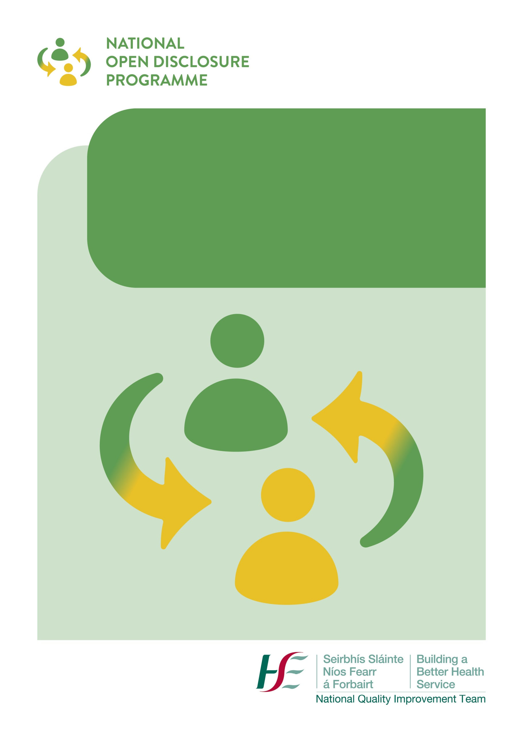
N

National Open Disclosure Programme

Pre, During and Post Meeting Checklists

OPEN DISCLOSURE: PRE-MEETING CHECKLIST

Action | Completed Y/N
Ensure continued clinical care to the patient to prevent further harm and provide other supports, as required
Assess patient safety incident for severity and level of open disclosure required (high level or low level)
Offer / provide support for staff involved in or affected by patient safety incident
Notify appropriate personnel / agencies
Update patient record and ensure the incident is reported on NIMS
Agree team to meet the patient or relevant person
- Lead Discloser
- Deputy Discloser
- Designated Person(Key contact person)
Consider if the protections of Part 4 of the Civil Liability Amendment Act 2017 are being sought (optional). If yes, prepare the relevant documentation and ensure process is followed – process and forms are available here.

Agree staff member to act as Designated Person (key contact person)
- Confirm name, telephone number and email address of the Designated Person

Designated Person to contact the patient or relevant person to:
- Arrange and agree meeting date and time
- Provide an overview of what to expect at the meeting and who will be attending
- Communication with the relevant person following the death of a patient must take into consideration and be led by the grieving process of the relevant person/family.
- Discuss any venue requirements such as off site or access requirements
- Encourage them to have a support person present with them at the meeting (discuss the number of people attending). Offer the services of an independent advocate, if required.
- Consider need for interpreter services
- Ask about any specific questions or concerns the patient/relevant person may have
- Provide information re transport to venue and car parking arrangements
- Send patient information leaflet

Book suitable venue based on the needs of the patient or relevant person

Arrange a pre-meeting of the Open Disclosure Team
- Agree the flow, content and structure of the open disclosure meeting
- Identify a note taker
- Consider any concerns/questions raised by the patient or relevant person to the Designated Person
- Establish the facts and discuss any anticipated questions
- Consider the timeframe involved in any review or other processes that are on-going as a result of the incident so that realistic timescales may be provided to the patient/relevant person.
- Consider and agree the wording of the apology/expression of regret to be provided at the meeting
- Consider any other additional requirements such as PPE
Action | Completed Y/N
Prepare room for meeting
- “Do not disturb" sign on door
- Refreshments available
- Tissues available (discreetly)
- Room set up in a non-confrontational, relaxed style
- Bathroom facilities nearby and checked

Additional Notes/Considerations

Checklist completed by:
Date:

Disclaimer: Please note this is a general guidance checklist to help staff prepare for and manage open disclosure meetings in an informed, empathic, compassionate and effective manner. Each case must be assessed on an individual basis and managed in accordance with the specific needs of the patient and family affected. This checklist does not form part of the clinical record.
OPEN DISCLOSURE: MEETING CHECKLIST

 | Action | Complete Y/N
Introductions | - Designated person to meet, greet, and welcome patient/relevant person and their support person at agreed location and time and accompany them to the meeting room  - On arrival at meeting room the patient/relevant person and support person are welcomed and thanked for attending this meeting  - Introductions must include the names, job title and role of all persons present
Housekeeping | - Offer refreshments, ensure comfort  - Provide information regarding facilities, toilets etc.  - Offer breaks – e.g. “If at any stage you feel that you need a break / refreshments or need time out to discuss anything we have said please let us know and we will facilitate that for you”  - Explain note taking e.g. “We will be recording the key points discussed in this meeting today in writing and a copy of these meeting notes will be sent to you after the meeting”
Using the ASSIST model to structure the meeting
Acknowledgment | - Acknowledge what has happened and the impact on the patient/relevant person  - Demonstrate understanding e.g. “I know that this has been a very difficult time for you”.
Sorry | - Provide a sincere and meaningful apology/expression of regret  e.g. “I would like to express my sincere apologies to you for what has happened and for how this has affected you.”
Story | - Encourage them to talk about what has happened from their perspective and how it has affected them  - Listen attentively and actively without interruption  - Summarise their story with empathy and understanding
Inquire | - Pause regularly to check understanding and provide clarification e.g. “If at any stage you are unsure about anything or don’t understand anything we have said please stop us and ask for clarification”  - Encourage questions and provide factual answers e.g. “What questions do you have?”
Solutions | - Agree next steps and the proposed plan for their on-going care – involve the patient/relevant person in decisions made and ensure understanding.  - Provide information about appropriate supports available to them.
Travel | - Provide reassurance to the patient/relevant person in relation to the on-going communication process - agree communication arrangements via the designated person – confirm contact details  - Offer further meetings, if required.  - Agree the action points.  - Ensure that adequate time is provided for the closure of the meeting.  - Check if the patient/relevant person has any further questions.  - The Designated Person accompanies the patient/relevant person to the exit of the premises. They check in with them immediately following the meeting and confirm a follow up call.
Documentation | - The salient points of the open disclosure meeting will be documented in the healthcare record including the names of persons present, information and apology provided, agreed care/treatment plan and any actions agreed.
After meeting review | - The team should discuss the meeting and reflect on the outcome, what went well, any unanticipated matters that arose and reflect how they are feeling following the meeting.

Checklist completed by:
Date:

Disclaimer: Please note this is a general guidance checklist to help staff prepare for and manage open disclosure meetings in an informed, empathic, compassionate and effective manner. Each case must be assessed on an individual basis and managed in accordance with the specific needs of the patient and family affected. This checklist does not form part of the clinical record.

OPEN DISCLOSURE: POST-MEETING CHECKLIST

Actions | Completed Y/N
- Follow up call by the Designated Person to

- Establish the patient/relevant person’s experience of the open disclosure meeting using the Patient Experience Questionnaire (attached)
- Provide an update on any actions taken since the meeting
(C) Check if any further assistance is required
- Circulate the minutes of the meeting to all relevant parties for timely verification
- Send final meeting record to the patient/relevant person and keep a copy of the record in the open disclosure/incident management file.

- Document actions pertaining to the continued care/treatment of the patient in the patient’s healthcare record.
- Follow up on/complete agreed actions

- Send the outcome of the investigation or review to the patient/relevant person and offer them the opportunity to discuss

- Provide relevant updates to the patient’s GP

- Organise further meetings as required using above process

- File the minutes of the meeting, details of follow up actions and the meeting checklist in the Open Disclosure record
- Record the Open Disclosure meeting on the NIMS system

Checklist completed by:
Date:

Disclaimer: Please note this is a general guidance checklist to help staff prepare for and manage open disclosure meetings in an informed, empathic, compassionate and effective manner. Each case must be assessed on an individual basis and managed in accordance with the specific needs of the patient and family affected. This checklist does not form part of the clinical record.

