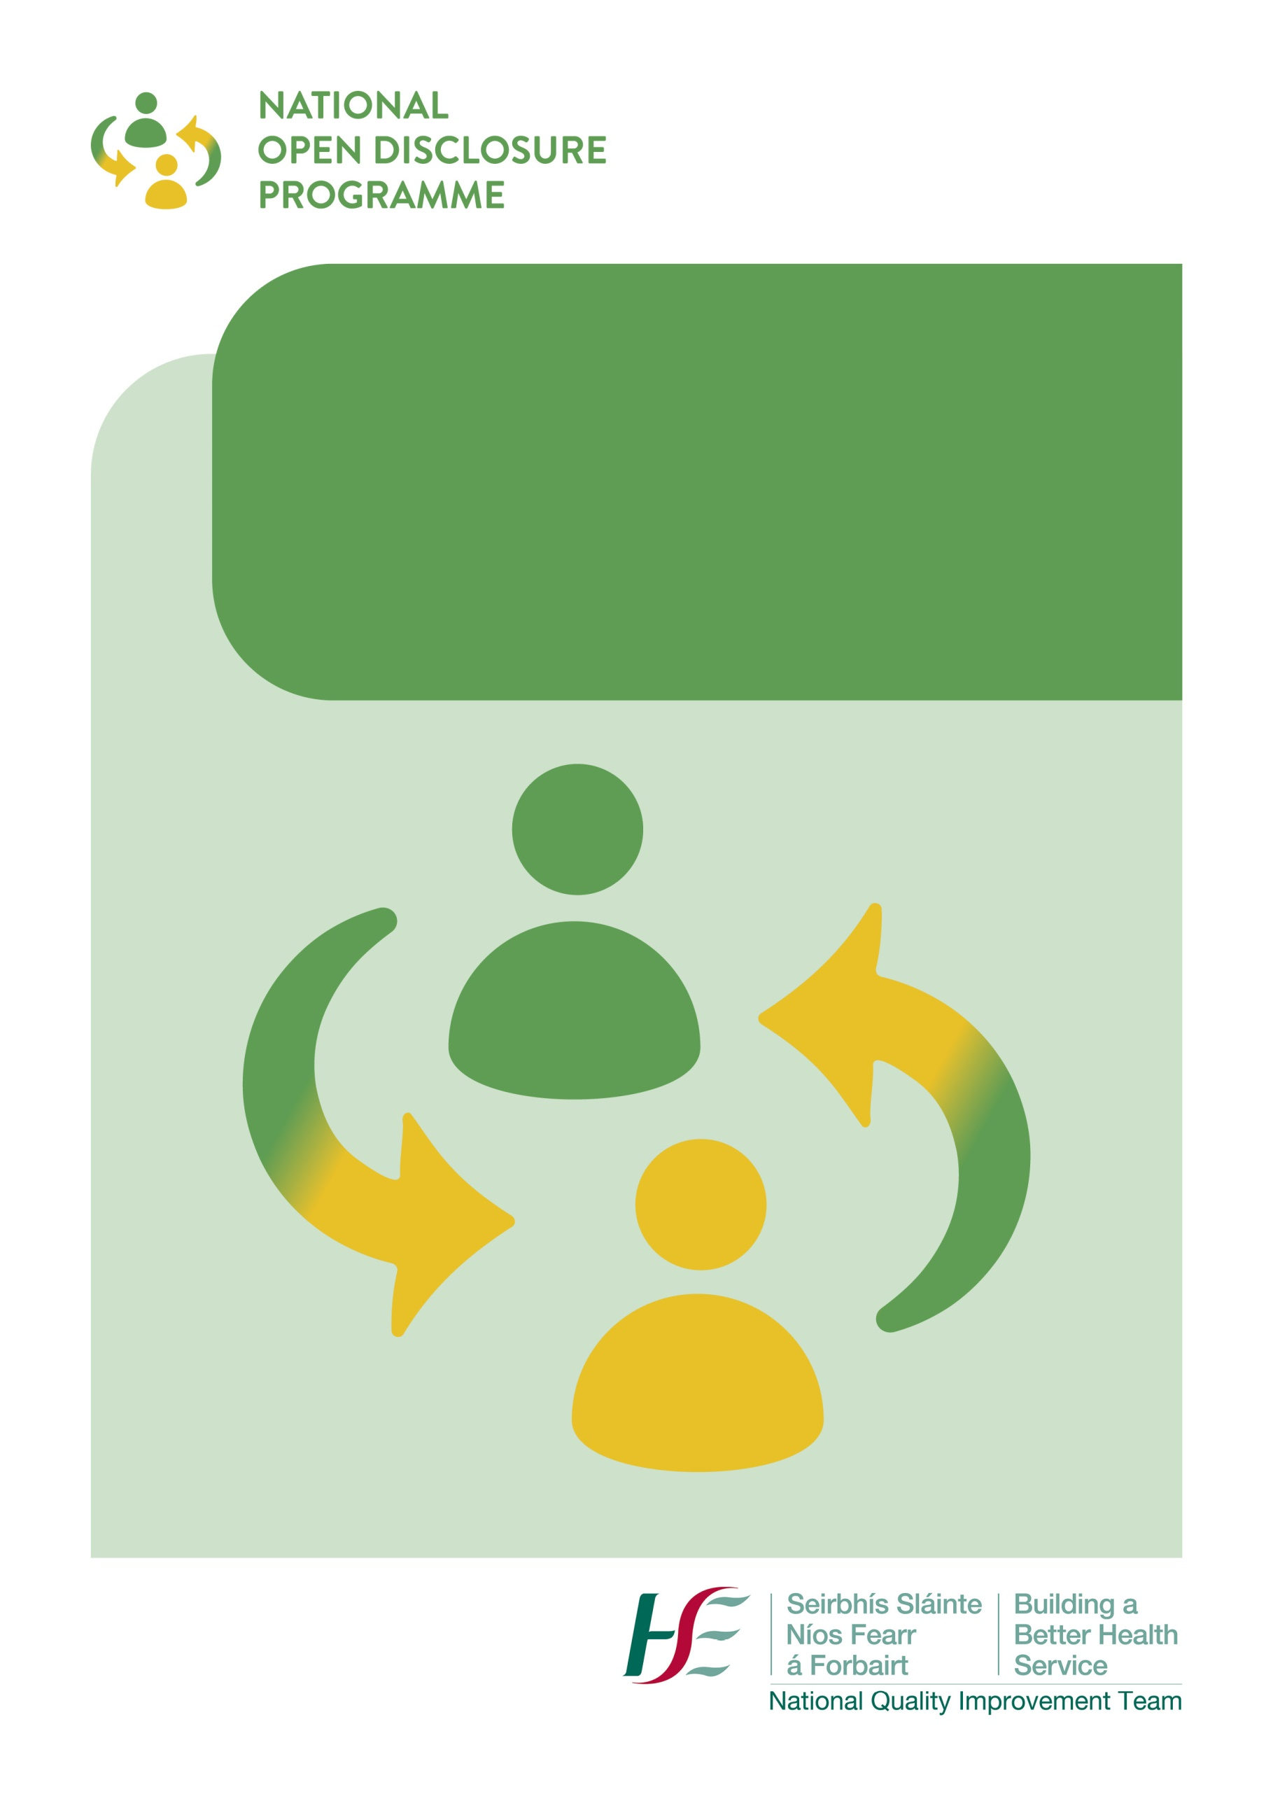

National Open Disclosure Programme

Management of an Open Disclosure Meeting: Quick Reference Guide and Tool Kit

CONTENTS

Section | Title | Page
Part A | Introduction | 3
Part B | The Principles of Open Disclosure | 4
Part C | Managing the Open Disclosure Process  - Assessing the Level of Response required to the Patient Safety Incident  - Preparing for an Open Disclosure meeting  - Managing an Open Disclosure Meeting  - Documentation of the Open Disclosure Meeting  - Providing Follow-Up | 6
Part D | Further Information and Support | 8
References |  | 8
Appendices  - Pre Meeting Checklist  - Open Disclosure Meeting Checklist  - Template for recording the Open Disclosure Meeting  - Post Meeting Checklist  - Sample Language to Assist in Open Disclosure Discussions |  | 9  11  13  16  17

PART A: INTRODUCTION
Open disclosure discussions are often complex and sensitive and may involve many uncertainties. Guidance, training and support for staff is necessary to address the challenges that can arise and to consider the communication skills required to engage in effective open disclosure with patients/service users and/or their relevant person(s).

The National Open Disclosure Office, in consultation with the National Open Disclosure Steering Committee and staff, has prepared this Quick Reference Guide and Tool Kit which provides easily accessible information to assist staff when preparing for and managing an open disclosure meeting. This resource will be of particular benefit to staff during the current Covid-19 pandemic and associated restrictions when many services have had to suspend face to face training. The National Open Disclosure Office recognises that additional practical resources and support may be required at this time.
This resource will support staff in managing incidents in line with the provisions of the HSE Incident Management Framework (2020) and the HSE National Open Disclosure policy (2019). It includes a number of resources which are also available on the Open Disclosure website www.hse.ie/opendisclosure.
Please note that this resource should not be used as an alternative to attending training. Additional support is available by contacting the Open Disclosure Trainers and Leads in your area.

Please note the meaning of Designated Person, Relevant Person and Patient as referred to in this document.
Designated Person - A person to liaise with the health services provider and the patient or relevant person (or both of them) in relation to the open disclosure of the patient safety incident. (Civil Liability (Amendment) Act 2017)

Relevant Person- this means a person who is (1) a parent, guardian, son or daughter; spouse/ civil partner, cohabiting with the patient or (2) whom the patient has nominated in writing to the health services provider as a person whom clinical information in relation to them may be disclosed.

Patient – “Patient” means, in relation to a health services provider, a person to whom a health service is, or has been provided. Note: Please note that the term “patient” as used throughout this document includes patients, service users and clients of the HSE and of services funded by the HSE.

PART B: THE PRINCIPLES OF OPEN DISCLOSURE
There are ten principles designed to assist health and social care services to create and embed a culture of open disclosure.
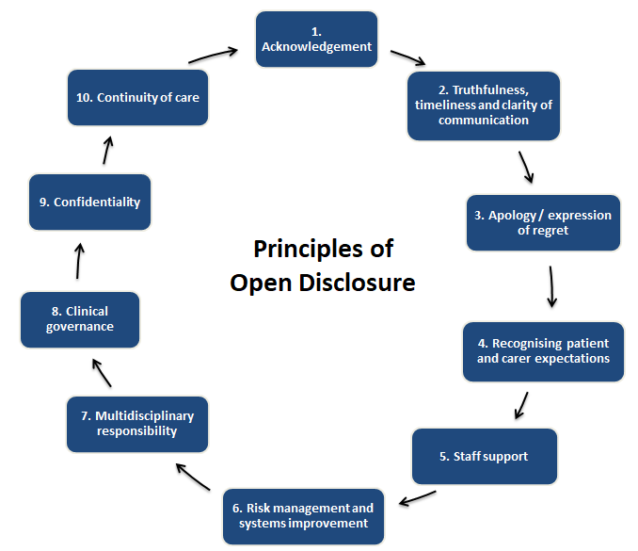

An Overview of the 10 Principles of Open Disclosure

Diagram 1: The Principles of Open Disclosure - Adapted from the UK National Patient Safety Agency

1) Acknowledgement | Acknowledge what has happened (i.e. the patient safety incident) and the impact on the patient/relevant person.
2) Truthfulness, Timeliness and Clarity of Communication | Truthfulness  Stick to the facts available – do not speculate – it is not necessary to know all the facts to initiate the communication process – further information can be provided as it becomes available at a later date.  Timeliness  Open disclosure must occur as soon as possible (ideally within 24 – 48 hours of the incident occurring or becoming known to the health services provider) and may be influenced by a number of factors such as the condition of the patient, availability of the patient, agreement of the patient, availability of the relevant person and availability of the most responsible person caring for the patient.  Clarity of Communication  - Use simple language and avoid medical jargon – provide small chunks of information at a time and check for understanding before moving on.  - Encourage questions and provide factual answers – remember that you may not have all the answers. Use the services of an interpreter, if required.
3) The Apology | - Apologise / express regret for what happened and for the impact on the patient.  - An apology must be personal to the individual and the given situation.  - It must be provided by the most appropriate person and include the words “I am sorry”.  - The apology must be sincere and delivered with empathy. For more information on managing the apology and sample language click here.
4) Recognising Patient and Carer Expectations | Be guided by what patients want and expect: Patients want an acknowledgement of what has happened, an explanation as to how or why it happened, a sincere and meaningful apology, reassurance in relation to their on-going care and treatment and in relation to the steps being taken by the health services provider to try to prevent a recurrence of the same incident to them or to others.
5) Staff Support | It is important to identify the staff involved in and/or affected by the patient safety incident and to ensure that they are being supported in the immediate aftermath of the incident and on an on-going basis for as long as is required.
6) Risk management and System Improvement | Incidents are identified, managed, reported, disclosed and reviewed and learning is derived from them. Actions are then taken to try to prevent a recurrence of the incident.  Keep the patient and relevant person involved – their story and perspective is an important part of the incident management and review process.
7) Multidisciplinary Responsibility | Open disclosure involves multidisciplinary accountability and response.
8) Clinical Governance | Health and social care services are required to have appropriate accountability structures in place which ensure that open disclosure occurs and that it is integrated with other clinical governance systems and processes including clinical incident reporting and management procedures, systems analysis reviews, complaints management and privacy and confidentiality procedures.
9) Confidentiality | The information collated following a patient safety incident is often of a sensitive nature and therefore patient confidentiality is paramount. Disclosure to the relevant person of an adult patient should be with the consent of the patient, where this is possible.
10) Continuity of Care | - Maintain communication with the patient.  - Follow through on actions agreed.  - Provide or direct to relevant support services via the Designated Person.

PART C: MANAGING THE OPEN DISCLOSURE PROCESS
- Assessing the Level of Response required to the Patient Safety Incident
The first step in the process is to assess the level of response required in consideration of the level of harm that has occurred as per the HSE Incident Management Framework 2020 and HSE Risk Impact Table.

Low Level Response

This will involve a face to face meeting with the patient when there is no harm to the patient or the level of harm is minimal.
(i) Acknowledge what happened and the impact on the patient (if any).
(ii) Provide a factual explanation, a meaningful apology and reassurance in relation to on-going care and treatment.
(iii) Document the salient points of the discussion in the patient’s clinical /care record.
(iv) Assess the need for follow up including if a further meeting is required.
High Level Response

A high level response will be required when a patient has suffered a moderate or greater level of harm – i.e. following Category 1 and Category 2 incidents.

This will generally involve an initial discussion with the patient and/ or their relevant person to acknowledge that a patient safety incident has occurred followed by a further meeting(s) to update the patient and/or relevant person as additional information becomes available.

Occasionally patients/their relevant person may request a high level response to a low level event.

Once more detailed facts are established, such as following the review of the incident, a formal open disclosure meeting will be offered to the patient / relevant person. Ideally this will be a face to face meeting.

Covid 19
National Guidelines on the Management of Open Disclosure during Covid 19 have been developed. These guidelines address the requirement for open disclosure of incidents relating to exposure to Covid 19, how to manage an open disclosure meeting via telephone or video call and how to manage an open disclosure meeting effectively when using PPE. The guideline may be accessed here.
- Preparing for a Formal Open Disclosure Meeting
- The importance of preparation for this meeting cannot be underestimated as open disclosure can be a highly charged and emotional process for all involved. Use the Open Disclosure Pre Meeting Checklist (Appendix 1-pages 9 and 10) to guide you in the preparation for the meeting and to ensure compliance with the HSE Open Disclosure policy.
- Identify the Open Disclosure Team. Ideally the Lead Discloser will be the principal healthcare practitioner involved in the care of the patient or a healthcare practitioner deemed appropriate by the health services provider. A deputy discloser will also be appointed to assist the lead discloser.
- Identify the Designated Person (Key Contact Person) who has a critical role in maintaining personal contact between the patient/relevant person and the health services provider and in providing support to the patient/relevant person at all stages in the open disclosure process. More information on the Role of the Designated Person is available here and the Designated Person Checklist is available here.
- Use the Sample Language Guidance Document (Appendix 5, page 17 to 21) to support and guide you in the open disclosure discussion.

3. Managing the Formal Open Disclosure Meeting
Patients /relevant persons generally appreciate the opportunity to meet with the healthcare team to discuss what has happened. It is important for them to have an opportunity to tell their story, to be heard and be able to convey their thoughts/perceptions in relation to what has happened. Participating in open disclosure meetings requires the open disclosure team to demonstrate empathy and compassion towards all those involved in/affected by what has happened including the patient, relevant person(s) and staff.
An Open Disclosure Meeting Checklist (Appendix 2-page 11) has been developed which outlines all of the components involved in managing the meeting effectively whilst ensuring compliance with the HSE Open Disclosure Policy.
It is recommended that the ASSIST model of communication is used to guide the open disclosure discussion and to ensure that all the key components of open disclosure are included.

 | THE ASSIST MODEL OF COMMUNICATION
A: | ACKNOWLEDGE | Acknowledge what happened and the impact.
S: | SORRY | Provide a sincere apology / expression of regret.
S: | STORY | Listen to the patient/relevant persons story without interruption and acknowledge your understanding of what they have said.
I: | INQUIRE | Encourage questions and provide factual answers, as available.
S: | SOLUTIONS | Discuss and agree solutions and next steps.
T: | TRAVEL | Maintain communication and continue to provide support. Follow through on actions agreed.
Table 1: The ASSIST Model of Communication developed by the Medical Protection Society

4. Documentation of the Formal Open Disclosure Meeting: The Documentation Template for recording the formal open disclosure meeting (Appendix 3, page 13 to 15) will assist you in meeting the policy requirements. Actions pertaining to the continued care/treatment of the patient will be documented in the patient’s healthcare record. A copy of the formal meeting record will be agreed and sent to the patient/relevant person in a timely manner following the formal open disclosure meeting and a copy of this will be maintained in the Open Disclosure/Incident Management file.

5. Follow-Up after a Formal Open Disclosure Meeting
Follow-up after an open disclosure meeting is important and may continue over a considerable period of time. This will be coordinated by the designated person who will continue to liaise between the open disclosure team and the patient/ relevant person.
It is important to ensure that the patient / relevant person are afforded an opportunity to ask further questions, request further information and seek clarification, as required. It is also imperative that an on-going treatment/care plan is discussed and agreed. The attached Open Disclosure Post Meeting Checklist (Appendix 4- page 16) has been developed to ensure that there is comprehensive follow up after an open disclosure meeting which is compliant with the HSE Open Disclosure Policy.

PART D: FURTHER INFORMATION AND SUPPORT FOR STAFF
As part of the Open Disclosure Process it is recognised that staff require support during this process.
- The ASSIST ME Booklet has been developed to provide practical information for health and social care managers and staff in relation to:
(a) Understanding the potential impact of patient safety incidents on staff
(b) Recognising and managing the associated signs and symptoms
(c) Supporting staff following patient safety incidents on an immediate an on-going basis
(d) Providing information on the support services available to staff.

This booklet is available here.

E-Learning: Open Disclosure modules on HSELanD have been developed and will assist staff in preparing for a formal open disclosure meeting. Module 1 “Communicating effectively through Open Disclosure” provides the theoretical components of open disclosure. Module 2 “Open Disclosure: Applying Principles to Practice” focuses on how to prepare for and manage an open disclosure meeting and some of the complexities that may arise.

Contact the Open Disclosure Lead for your area. The list of Open Disclosure Leads is available here.

Further information and resources for patients, staff and services are available on the Open Disclosure Website www.hse.ie/opendisclosure.

If you require any additional assistance or guidance please email the National Open Disclosure Office: OpenDisclosure.Office@hse.ie

REFERENCES
- The HSE National Open Disclosure Policy 06/2019.
- The HSE Open Disclosure website and resources www.hse.ie/opendisclosure.
- The HSE Incident Management Framework and Guidance 2020.
- Australian Commission on Safety and Quality in Health Care (2013), Open disclosure: Just-in-time information for clinicians.

APPENDIX 1: Pre Meeting Checklist
OPEN DISCLOSURE: PRE-MEETING CHECKLIST

Action | Completed Y/N
Ensure continued clinical care to the patient to prevent further harm and provide other supports, as required.
Assess patient safety incident for severity and level of open disclosure required (high level or low level).
Offer / provide support for staff involved in or affected by patient safety incident.
Notify appropriate personnel / agencies.
Update patient record and ensure the incident is reported on NIMS.
Agree team to meet the patient or relevant person
- Lead Discloser
- Deputy Discloser
- Designated Person(Key contact person)
Consider if the protections of Part 4 of the Civil Liability Amendment Act 2017 are being sought (optional). If yes, prepare the relevant documentation and ensure process is followed – process and forms are available here.

Agree staff member to act as Designated Person (key contact person).
- Confirm name, telephone number and email address of the Designated Person.

Designated Person to contact the patient or relevant person to:
- Arrange and agree meeting date and time.
- Provide an overview of what to expect at the meeting and who will be attending.
- Communication with the relevant person following the death of a patient must take into consideration and be led by the grieving process of the relevant person/family.
- Discuss any venue requirements such as off site or access requirements.
- Encourage them to have a support person present with them at the meeting (discuss the number of people attending). Offer the services of an independent advocate, if required.
- Consider the need for interpreter services.
- Ask about any specific questions or concerns the patient/relevant person may have.
- Provide information re transport to venue and car parking arrangements.
- Send patient information leaflet.

Book suitable venue based on the needs of the patient or relevant person
Arrange a pre-meeting of the Open Disclosure Team.
- Agree the flow, content and structure of the open disclosure meeting.
- Identify a note taker.
- Consider any concerns/questions raised by the patient or relevant person to the Designated Person.
- Establish the facts and discuss any anticipated questions.
- Consider the timeframe involved in any review or other processes that are on-going as a result of the incident so that realistic timescales may be provided to the patient/relevant person.
- Consider and agree the wording of the apology/expression of regret to be provided at the meeting.
- Consider any other additional requirements such as PPE.
Action | Completed Y/N
Prepare room for meeting
- “Do not disturb" sign on door.
- Refreshments available.
- Tissues available (discreetly).
- Room set up in a non-confrontational, relaxed style.
- Bathroom facilities nearby and checked.

Additional Notes/Considerations

Checklist completed by:
Date:

APPENDIX 2: OPEN DISCLOSURE MEETING CHECKLIST

OPEN DISCLOSURE: MEETING CHECKLIST

 | Action | Complete Y/N
Introductions | - Designated person to meet, greet, and welcome patient/relevant person and their support person at agreed location and time and accompany them to the meeting room.  - On arrival at meeting room the patient/relevant person and support person are welcomed and thanked for attending this meeting.  - Introductions must include the names, job title and role of all persons present.
Housekeeping | - Offer refreshments, ensure comfort.  - Provide information regarding facilities, toilets etc.  - Offer breaks – e.g. “If at any stage you feel that you need a break / refreshments or you need time out to discuss anything we have said please let us know and we will facilitate that for you”.  - Explain note taking e.g. “We will be recording the key points discussed in this meeting today in writing and a copy of these meeting notes will be sent to you after the meeting”.
Using the ASSIST model to structure the meeting
Acknowledgment | - Acknowledge what has happened and the impact on the patient/relevant person.  - Demonstrate understanding e.g. “I know that this has been a very difficult time for you”.
Sorry | - Provide a sincere and meaningful apology/expression of regret.  e.g. “I would like to express my sincere apologies to you for what has happened and for how this has affected you”.
Story | - Encourage them to talk about what has happened from their perspective and how it has affected them.  - Listen attentively and actively without interruption.  - Summarise their story with empathy and understanding.
Inquire | - Pause regularly to check understanding and provide clarification e.g. “If at any stage you are unsure about anything or don’t understand anything we have said please stop us and ask for clarification”  - Encourage questions and provide factual answers e.g. “What questions do you have?”
Solutions | - Agree next steps and the proposed plan for their on-going care – involve the patient/relevant person in decisions made and ensure their understanding.  - Provide information about appropriate supports available to them.
Travel | - Provide reassurance to the patient/relevant person in relation to the on-going communication process - agree communication arrangements via the designated person – confirm contact details.  - Offer further meetings, if required.  - Agree the action points.  - Ensure that adequate time is provided for the closure of the meeting.  - Check if the patient/relevant person has any further questions.  - The Designated Person accompanies the patient/relevant person to the exit of the premises. They check in with them immediately following the meeting and confirm a follow up call.
Documentation | - The salient points of the open disclosure meeting will be documented in the healthcare record including the names of persons present, information and apology provided, agreed care/treatment plan and any actions agreed.
After meeting review | - The team should discuss the meeting and reflect on the outcome, what went well, any unanticipated matters that arose and reflect how they are feeling following the meeting.

Checklist completed by:
Date:

APPENDIX 3 TEMPLATE FOR RECORDING THE OPEN DISCLOSURE MEETING
DOCUMENTATION TEMPLATE
Formal Open Disclosure Meeting

This is a confidential document which may be used to formally record the open disclosure meeting and if used must be kept in the open disclosure / incident management file
Patient’s full name |  | Patient Identification Number (if applicable)
Date of birth |  | Venue for Meeting
Date of Meeting |  | Time of Meeting
Type of Meeting (Face to Face / Telephone / Other)

Date incident occurred |  | Date incident became known to the service
How incident became known |  | Date of initial discussion with the patient/relevant person
Meeting Attended By:

Staff | Lead Discloser (Name and Role):  ______________________________________________________________________________  Other staff attending (Name and Role)  1.  2.  3.
Patient/Relevant person | Patient attended Yes / No (please circle as appropriate)  Details of persons attending with or on behalf of the patient (state names and relationship to patient).  1.  2.  3.
Information provided at the Open Disclosure Meeting

Information Provided | Details
- Description of the incident:
- Physical and psychological consequences of the incident for the patient: (known or potential)
- Treatment and care plan for the patient in relation to any consequences of the incident.
- Actions taken or planned by the health services provider to address the incident: (include procedures or processes to be implemented)
- Apology/expression of regret provided: | Yes / No
- Details of the apology/expression of regret made by the health services provider:
- Patient story – the patient/relevant person’s perception of the incident and how it has impacted them:
- Questions asked and responses provided:

Information provided at the Open Disclosure Meeting
Health service contact person (Designated contact person assigned as point of contact for patient and support persons). | Name:  Position:  Contact Telephone No:  Email address:
Actions agreed and next steps:

Plans for follow-up:
Details of supports offered and agreed:
Date of next meeting (if applicable):
Further comments/patient feedback:

Signature of Principal Healthcare Practitioner: __________________________________________
Print name: __________________________________________
Date: __________________________________________

Please Note: This template has been adapted from the Australian Open Disclosure Framework Open disclosure documentation and is aligned with the provisions of the HSE National Open Disclosure Policy 2019. This is a template document which may be adapted for local use.

APPENDIX 4 POST-MEETING CHECKLIST
OPEN DISCLOSURE: POST-MEETING CHECKLIST

Actions | Completed Y/N
- Follow up call by the Designated Person to
- Establish the patient/relevant person’s experience of the open disclosure meeting using the Patient Experience Questionnaire available here.
- Provide an update on any actions taken since the meeting.
(C) Check if any further assistance is required.
- Circulate the minutes of the meeting to all relevant parties for timely verification.
- Send final meeting record to the patient/relevant person and keep a copy of the record in the open disclosure/incident management file.

- Document actions pertaining to the continued care/treatment of the patient in the patient’s healthcare record.
- Follow up on/complete agreed actions.

- Send the outcome of the investigation or review to the patient/relevant person and offer them the opportunity to discuss.

- Provide relevant updates to the patient’s GP.

- Organise further meetings as required using above process.

- File the minutes of the meeting, details of follow up actions and the meeting checklist in the Open Disclosure record.
- Record the Open Disclosure meeting on the NIMS system.

Checklist completed by:
Date:

Disclaimer: Please note this is a general guidance checklist to help staff prepare for and manage open disclosure meetings in an informed, empathic, compassionate and effective manner. Each case must be assessed on an individual basis and managed in accordance with the specific needs of the patient and family affected.

APPENDIX 5: Sample Language to Assist in Open Disclosure Discussions
SAMPLE LANGUAGE TO ASSIST IN OPEN DISCLOSURE DISCUSSIONS
using the MPS ASSIST Model of Communication

Stage of Discussion | Sample Phrases
Acknowledgement  Discussing what has happened and the impact | “We are here to discuss the harm that you have experienced/the complications with your surgery/treatment”  “I realise that this has caused you great pain/distress/anxiety/worry”  “I can only imagine how upset you must be”  “ I appreciate that you are anxious and upset about what happened during your procedure – this must have come as a big shock for you”  “I understand that you are angry/disappointed about what has happened”
Sorry  Saying Sorry /  Expressing Regret  Managing the Apology | “ I am so sorry that this has happened to you”  “ I am very sorry that the procedure was not as straightforward as we expected and that you will have to stay in hospital for an extra few days for observation”  “I truly regret that you have suffered xxx which is a recognised complication associated with the xxx procedure/treatment”. “I am so sorry about the anxiety that this has caused for you”  “ A review of your care has indicated that an error occurred – I am truly sorry about this”  “A review of this event has indicated that there were certain failings in the care provided to you. (List failings identified)… I am so sorry about this and I would like to offer you my sincere apologies on behalf of myself and my team. We are planning the following actions to try to prevent this happening again in the future…”
Story  Listening to the patient’s/relevant person’s story and summarising | Establishing their Story  “How are you since we last met?”  “Tell me about your understanding of your condition”  “Can you tell me what has been happening to you?”  “Can you tell me your understanding of what has happened?”  Demonstrating your understanding of their Story: (Summarising)  “I understand from what you have said that you are very upset and angry about this” “You think that …… Is this correct?” (I.e. summarise their story and acknowledge any emotions/concerns demonstrated)  “Am I right in saying that you …?”  “From what you have told me it is your understanding that ..., is this correct, have I missed anything?”  Relating your understanding of the story to date  “Is it ok for me to explain to you the facts known to us at this stage in relation to what has happened and hopefully address some of the concerns you have mentioned?”  “Do you mind if I tell you what we have been able to establish at this stage?”  “We have been able to determine at this stage that …”  “We are not sure at this stage about exactly what happened but we have established that … We will remain in contact with you as more information unfolds”  “You may at a later stage experience xx - if this happens you should …”
Inquire  Encouraging questions and providing factual answers | “What questions do you have in relation to what we just discussed?”  “We may not be able to answer all of your questions until we have completed our review of the incident.”  “How do you feel about this?”  “Is there anything we talked about that is not clear to you?”  “Do you understand what has happened?”  “Do you understand what is happening in relation to your care now?”  “Have we addressed all of your questions and concerns?”  “Is there anything that you would like me to explain again?”  “You will likely think of other questions following this discussion. Please write them down and I can try to answer them for you when we meet next or you can contact your designated person who will let me know.”
Solutions  Establishing and agreeing the plan of care together | “What do you think should happen now?”  “What is important to you?”  “Do you mind if I talk you through what I think we could do and you can let me know if you are happy with this? “  “I have reviewed your condition and this is what I think we need to do next … What do you think about that?”  “These are your options now in relation to managing your condition, do you want to have a think about it and I will come back later to talk about it with you?”  “I have discussed your condition with my colleague Dr X. We both think that you would benefit from xx. What do you think about that?”
Travel  Moving forward with the patient/relevant person. Providing reassurance and on-going support | “It is important to us that we find out why this happened. We have already commenced a review of the incident to establish the facts.”  “We expect the review to take xx time.”  “We will keep you up to date on what is happening.”  “We will be taking steps to learn from this incident so that we can try to prevent it happening again in the future”  “I will be with you every step of the way and this is what I think we need to do now -”  “We will keep you up to date in relation to our progress with the review of the incident and you will receive a report in relation to the findings and recommendations of the review team”.  “Would you like us to contact you to set up another meeting to discuss our progress with the review?  “I will be seeing you regularly and will see you next in ….. days/weeks.  “You will see me at each appointment”  “Please do not hesitate to contact me at any time if you have any questions or if there are further concerns – you can contact me by …”  “XX your designated person will be in contact with you and continue to support you during this time. Please let them know if you need any assistance or have any further questions for us”  “If you think of any questions write them down and bring them with you to your next appointment.”  “Here are some information leaflets regarding the support services we discussed – we can assist you if you wish to access any of these services.”

Language to avoid when apologising/expressing regret to the patient/relevant person

Certain phrases should be avoided during an apology or expression of regret. This is to ensure that only known facts are communicated to the patient/relevant person and also to ensure that the apology is sincere and meaningful. Hearing the word ‘sorry’ in an apology or expression of regret is very important to the patient who has been harmed and also to their relevant persons/support persons. However, any insincerity, real or perceived, can have the opposite effect. It is important to realise that people harmed during care are likely to have a heightened emotional sensitivity.
Some examples of wording to be avoided:
- So-called apologies that are vague, passive or conditional:
  - ‘I apologise for whatever it is that happened’
  - ‘Mistakes were made … mistakes happen’
  - ‘These things happen to the best of people…”
  - ‘If I did anything wrong, I’m sorry’
  - “We are sorry …but the mistake certainly didn’t change the outcome…”
  - “I know that this is awful for you.... but believe me, for me it is shattering’
- Any speculative statements and apportioning of blame:
  - ‘I would say that the night staff probably neglected to write down that you were given this medication…’
  - I am sorry that this has happened – I don’t know what they were doing/how they could have missed this at xx Hospital
  - “I don’t really know what happened …… it was probably due to ……”
- Try to avoid the words “but” and “however” as they often negate the first part of the sentence and can come across as defensive
  - “I am sorry that you feel that way but…….”
  - “I am sorry if you feel that X was rude to you, however…….
- Avoid the use of legal terminology:
  - “It is all my fault – I am liable”
  - I made a mistake – I was negligent in my actions”

NOTE: Negligence and liability are matters that are established in a court of law and therefore these terms should be avoided when communicating with patients/relevant person(s).

Disclaimer: Please note this is a guidance document which contains sample language which may assist staff when communicating with patients/relevant persons during open disclosure meetings. Each case must be assessed on an individual basis and managed in accordance with the specific needs of the patient/relevant person affected.
