National Quality & Patient Safety Directorate
Self-Evaluation Workbook

August 2019 V1.0

About National Quality and Patient Safety Directorate
The National Quality and Patient Safety Directorate (NQPSD) was established in mid-2021 as a result of the HSE Central Reform Review. The NQPSD is part of the HSE Office of the Chief Clinical Officer, and is led by Dr Orla Healy, National Clinical Director, Quality and Patient Safety.

Purpose

The NQPSD works in partnership with HSE operations, patient representatives and other internal and external partners to improve patient safety and the quality of care by:

- building quality and patient safety capacity and capability in practice
- using data to inform improvements
- developing and monitoring the incident management framework and open disclosure policy and guidance
- providing a platform for sharing and learning; reducing common causes of harm and enabling safe systems of care and sustainable improvements.

Teams

In line with the “Patient Safety Strategy 2019-2024”, the NQPSD delivers on its purpose through the following teams:

- Patient Safety Programme: Oversee and monitor the implementation of the HSE Patient Safety Strategy.
- QPS Improvement: Use of improvement methodologies to address common causes of harm.
- QPS Intelligence: Using data to inform improvements in quality and patient safety.
- QPS Incident Management: developing and monitoring the Incident Management Framework, Open Disclosure Policy and National Incident Management System.
- QPS Education: Enabling QPS capacity and capability in practice.
- QPS Connect: Communicating, sharing learning, making connections.
- Establishment and operation of the National Centre for Clinical Audit.

Connect With Us

Email address: NQPS@hse.ie
Twitter: @NationalQPS
Telephone: (021) 4921501
Website: https://www.hse.ie/eng/about/who/nqpsd/

Is self-evaluation appropriate?
There are different ways you can evaluate your work and the following decision tree will help you to decide whether self-evaluation is appropriate for your project.
Is learning from my project a strategic priority for the NQPSD team?
Yes

No

Conduct evaluation – but what type?
- Is an independent perspective required for the evaluation to be accepted and used system-wide?
- Is the budget and/or capacity likely to be made available for commissioning and managing an external evaluation team?
- The necessary skills and capacity to conduct the evaluation are not available internally?
Are most of your responses ‘No’?

Are most of your responses ‘Yes’?

Consult with HSE PMO re. potential for internal evaluation
Conduct self-evaluation
Do I want to know if and/or how my project worked?

Yes

No

Are the QI project measures/other available measures enough to tell me what I want to know?
No additional self-evaluation required
No

Yes

Commission independent evaluation
Commission independent evaluation

You have decided to complete a self-evaluation.
Describe the aim of the project that is being evaluated, please refer to your Driver Diagram to help you complete Table 1.
Table 1: Aim of the project to be evaluated

It is important that you are clear from the beginning what the overall timeframe for your evaluation project is. For example, do you need to complete your evaluation within a certain timeframe to inform decision-making; does the project have particular start and finish dates outside of which it is not feasible to conduct an evaluation; is there a funding opportunity that you wish avail off? Provide details of the project’s timeframes here:
Project start date:
Project end date:
Evaluation timeframe:

The Evaluation Cycle

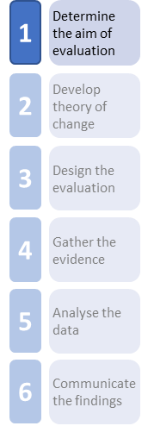
1. Determine the Aim of the Evaluation

Who is the evaluation for?

Identify your evaluation stakeholders, their interests, how they can/may use the evaluation findings, and their level of priority as a stakeholder. These are stakeholders in the evaluation, e.g. end-users of the evaluation findings, not all stakeholders for the innovation.

High priority evaluation stakeholders should be involved in the design of the evaluation.

You may wish to use post-its and a flip chart to brainstorm your ideas and fill in the workbook when finished.
Table 2: Identifying evaluation stakeholders and their evaluation interests
Who are your key stakeholders? | What are their interests? | How will they use the evaluation? | Priority – High / Medium / Low

What is the aim of my evaluation?
Start by thinking about the overall aim of your evaluation and fill this box in.
The overall aim of my evaluation is to:

Building on this and the work done in Table 2 to clarify stakeholders’ interests, identify the aim(s) of your evaluation and the high-level evaluation questions you want to answer, using the following four headings as a guide. For example, if the aim of your evaluation is to establish if outcomes are achieved for a prescribing quality improvement initiative, an evaluation question may be ‘Did the proportion of inappropriate prescribing reduce?’ Whilst an evaluation can’t answer every possible question that you may have, an evaluation may have up to 4-5 high-level evaluation questions.
Note that the aim(s) may fall under only one heading or multiple headings.
Table 3: Aim of evaluation and evaluation questions
 | The aim(s) of my evaluation is/are: | My high-level evaluation questions are:
PROCESS/APPROACH
e.g. did the approach work?
OUTCOMES
e.g. were the outcomes achieved?
VALUE
e.g. was it worth the investment?
RELEVANCE
e.g. is it still needed?
Unintended consequences
e.g. were there unexpected effects from implementing the innovation?

Do my evaluation questions need to change after consultation with my stakeholders?
This section is for documenting any changes to your evaluation questions, following engagement with the key evaluation stakeholders identified in Table 2.
Table 4: Evaluation questions - revised
Key stakeholders | Suggested revision to evaluation questions

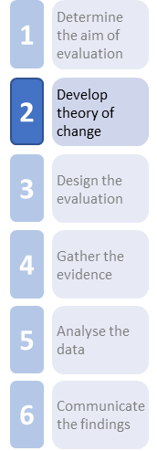
2. Develop Logic Model/Theory of Change for Initiative
If you have a Driver Diagram for your project, include that here. It should help you to populate your logic model, the template for which is provided overleaf.

Evidence
Monitoring and evaluation (not to be completed until finished workbook)

Inputs

Situation Analysis
Activities / Outputs

Long-term Outcomes
Vision:

Short-term Outcomes

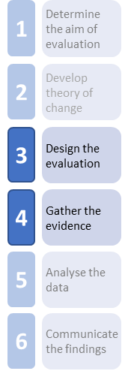
3 and 4. Design your Evaluation and Gather your Evidence
Complete the following data collection planning tool for each evaluation question. Data collected as part of your normal monitoring and reporting processes can be used for the evaluation and you can include them in Table 5. You should complete one data collection per high-level evaluation question.
Table 5a: Data collection plan 1
The aim of my evaluation is to:
My high-level evaluation question is:

What do I want to measure? | Who from? | When, how often? | Method | Who will collect the data?

Table 5b: Data collection plan 2
The aim of my evaluation is to:
My high-level evaluation question is:

What do I want to measure? | Who from? | When, how often? | Method | Who will collect the data?

Table 5c: Data collection plan 3
The aim of my evaluation is to:
My high-level evaluation question is:

What do I want to measure? | Who from? | When, how often? | Method | Who will collect the data?

Table 5d: Data collection plan 4
The aim of my evaluation is to:
My high-level evaluation question is:

What do I want to measure? | Who from? | When, how often? | Method | Who will collect the data?

Ethical issues & data management issues
Consider and record any potential ethical and data management issues associated with the data collection tools and methods you have selected for your evaluation.
Table 6: Consideration of ethical and data management issues
Data collection tools | Potential ethical issues

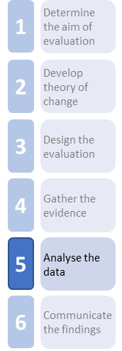
5. Analyse the Data
When you have agreed your data collection plan, you need to design and develop your data collection tools, e.g. surveys and questionnaires; and interview and focus group guides.
Use the template below to develop a high-level data management plan. This plan sets out how you will manage your data, including information on who will collect the data, who will enter it into analysis software, who will complete the data analysis, the software and hardware required, and any staff training/ orientation requirements needed to analyse the data. This is a high-level plan and it may be necessary to update this data management plan as you develop and refine your data collection tools further.
Table 7: Data management plan
Type of Data Collected (Table 5) | Data Collected By (Table 5) | Data Entry/Write-up By: | Data Analysis By: | Software/ Hardware? | Staff Training / Orientation

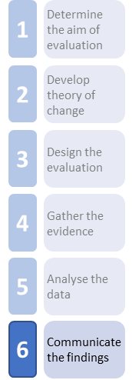
6. Communicate the Evaluation Findings
Document the plan for how you will communicate your evaluation findings in the following communication plan template. Don’t forget to include any baseline or interim reports or outputs in your communication plan.
Table 8: Communication plan
Stakeholder | What do you want stakeholders to do with the findings? | What findings do you need to communicate? | Communication channels / activities | Timeline

If you are producing a detailed evaluation report, the following is an example of typical headings to include.
- Abstract: This is a short paragraph which tells the reader what was evaluated, how it was evaluated, how many participants took part and what the main results were.
- Executive Summary: This should provide the reader with a short, plain language summary of the main results observed, the conclusions and the recommendations.
- Introduction: This section should outline the aims, objectives and motivations for the evaluation and a review of the literature in the area (if appropriate). It should also include a description of the initiative and the context in which it is delivered.
- Methodology/Design: This section should describe the methods used to collect data, the participants who took part, and how data were analysed.
- Results: This section should outline the results observed, without explanations for them, which you discuss in the following section.
- Discussion: This section should discuss possible reasons and explanations for the results observed in the evaluation and any other evidence to support these findings.
- Conclusion: This final section should summarise the main findings observed, and contain recommendations for policy, practice and future research and initiatives.
- Appendices: This section should include copies of any measurement tools used, such as surveys/questionnaires, topic guides or questions for focus groups and interviews, and observation frameworks.
- References: Include the authors, titles and publication details of any publications or websites drawn on for the report should be included. When referencing a website, include the URL address and the date it was accessed.

Evaluation Project Plan
Below is a sample evaluation project plan; a project plan can be as detailed or high-level as is appropriate for your evaluation project.
Evaluation project plans are dynamic tools, that is they are updated as and when circumstances change. Depending on the type and complexity of your evaluation project, you may wish to develop your evaluation plan using weekly, monthly or quarterly timeframes. The example below includes a range of activities that may or may not be relevant to your particular evaluation project, the purpose of 9 is to illustrate the types of activities that you may wish to include in your evaluation project plan, in order provide an outline timeframe for your evaluation.
Table 9: Sample Evaluation Project Plan
Evaluation Activities | Start date | Weekly/ Monthly/ Quarterly | Weekly/ Monthly/ Quarterly | Weekly/ Monthly/ Quarterly | Weekly/ Monthly/ Quarterly | Weekly/ Monthly/ Quarterly | Weekly/ Monthly/ Quarterly | Weekly/ Monthly/ Quarterly | Weekly/ Monthly/ Quarterly | Weekly/ Monthly/ Quarterly | Weekly/ Monthly/ Quarterly | End date
Identify stakeholder interests
Define the aim of the evaluation
Specify evaluation questions
Consult with evaluation stakeholders
Revise evaluation questions
Develop/refine logic model
Agree evaluation methods
Design data collection tools, e.g. surveys, focus groups or interviews
Define & identify sample and agree sample size
Prepare ethics application and/or consent and information materials
Pilot data collection tools
Revise data collection tools
Fieldwork e.g. issue surveys, conduct interviews or focus groups (include baseline, post and follow-up periods if appropriate)
Review documents/ documentary evidence
Data entry/transcription
Data analysis
Draft interim report
Draft final report
Finalise final report
Preparation of other evaluation outputs

