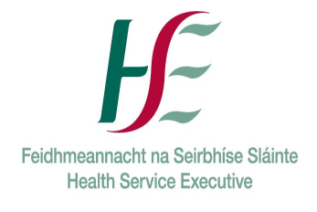 Request for SAOR© 1 Day Training 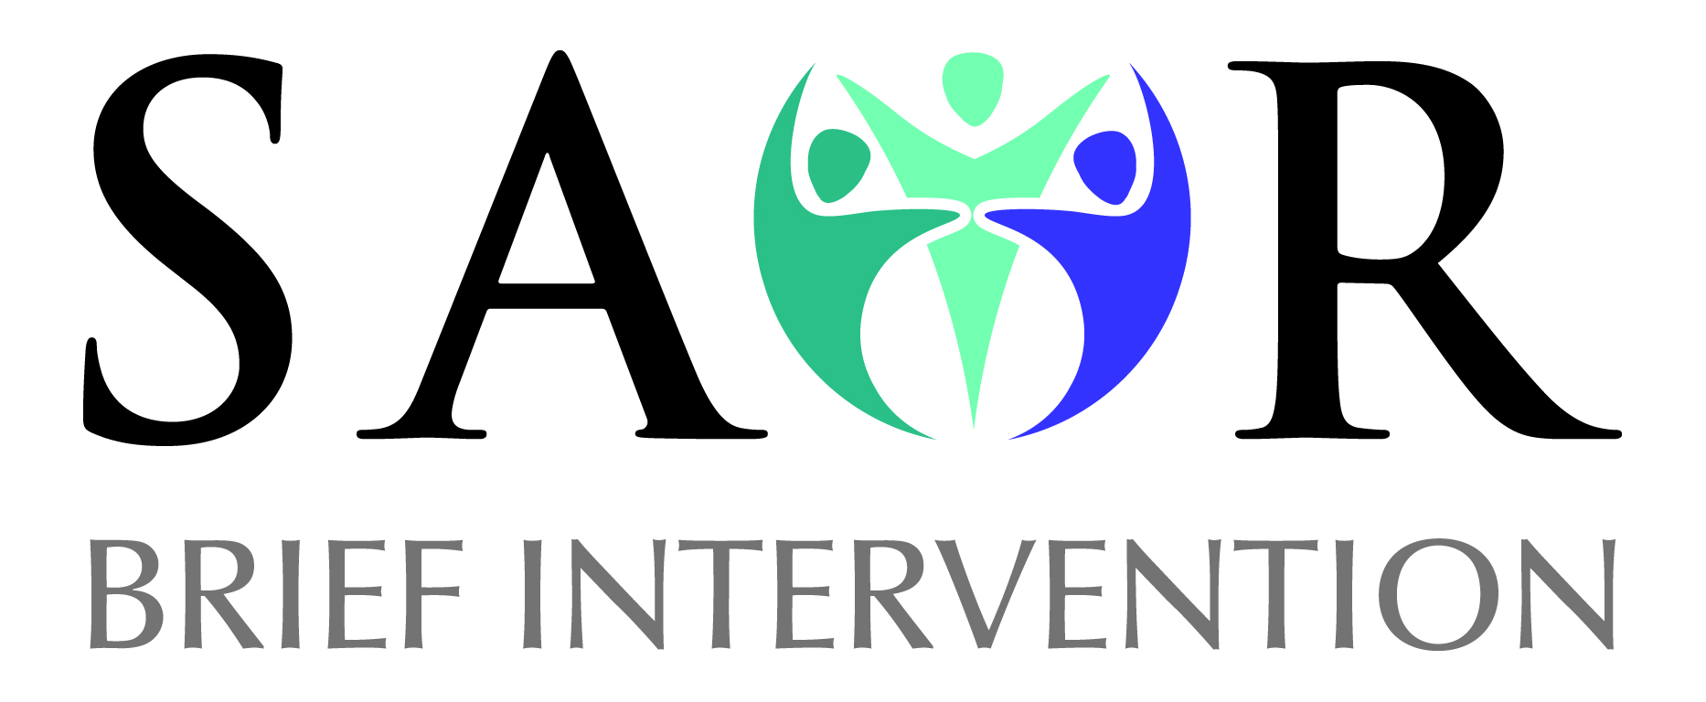
Thank you for your interest in running a 1 Day SAOR: Screening and Brief Intervention for Problem Alcohol and Substance Use. Please complete the details below and return
Name of Organisation:
Address:
Phone No:
Email:
Contact Person:
Training Request Information
Participants/audience:
(Staff/volunteers etc.)
Size of group: (max 18)
Preferred dates for training to take place:
Address of training venue
Location of training room
What do you hope to achieve by running this course?
Training requirements:  Are you in a position to provide the following in your venue/service?  Please tick | - Room that is 30' X 30' minimum.
 | - Table at the top for equipment that is 3' X 4' minimum.
 | - Screen or light coloured wall to project on to.
 | - U-shape of chairs (max 18).
 | - Power outlets and extension leads at top table.
 | - Tea/coffee on site.
 | - Lunch on site if possible (or options locally for participants at their own expense)
 | - Parking for trainers onsite/nearby
The trainer(s) will | - Provide you with information on the training course  - Participant Packs – these will be emailed to you to circulate to participants in advance of the training  - Sign In Sheet
Completed by: | Name:  Position in Organisation:  Date completed:
Any Other Comment/Info
Please return booking form to:
socialinclusion@hse.ie

