Correct hand washing techniques
For Adult hand washing - Please see link:
https://public.3.basecamp.com/p/RTp3RcZS2T1iTAscFkmmqucu

For Children’s hand washing – please see link: https://www.youtube.com/watch?v=EfQvLT0sKNc&feature=youtube

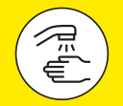
Wash your hands properly and often:
✔ After coughing or sneezing 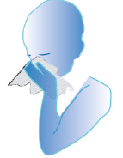

✔ Before and after eating

✔ Before and after preparing food
✔ After toilet use

✔ If your hands are dirty 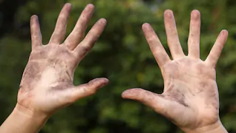

✔ Before having a cigarette or vaping 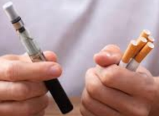
✔ If you have touched animals 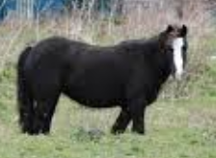

✔ When you arrive and leave buildings, your home or someone else’s home
✔ Before and after being on public transport

Useful tips:
✔ Use hand sanizitser if you do not have access to warm running water
✔ Clean surfaces regularly with anti-bacterial wipes
✔ When shopping use the alcohol gel that is provided at the entrances

