Symptoms of COVID-19
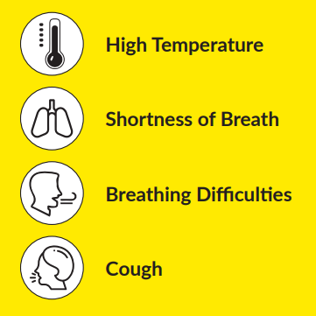

If you have symptoms:
Stay away from other people / self-isolate 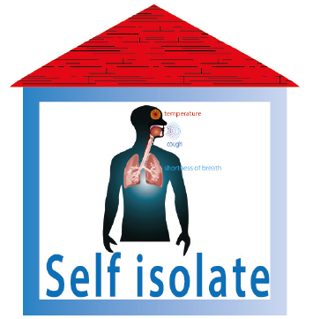

Phone your GP 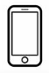 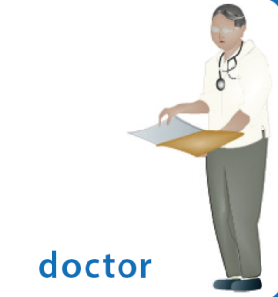

Do not go to your GP, Health Centre, Pharmacy or A&E

