What is social distancing?
Keeping a space of 6.5feet/2metres between you and other people 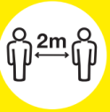

Reducing contact with people outside the workplace and home

Reducing the number of people you meet every day
Keeping in contact by phone, social media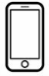

No hand shakes

No hugging

No crowded places 