

**Guidelines for Data Returns 2022**

corporate information facility

**Operational Performance and Integration**

**Business Information Unit**

**Community Healthcare**

Table of Contents

Corporate Information Facility (CIF) 3

Corporate Information Facility Templates 3

2022 CIF template Heading Colours 3

Opening a CIF Template 3

Saving a CIF Template 4

Completing a CIF template 4

Cover sheet 4

Activity Sheet 5

Sending and Submission of a CIF template 5

Late, Retrospective and/or resubmitted data 6

Non Returns 6

NBIU Information Officers – Contact Details 6

Appendix 1: 2022 CIF Template Names 7

Population Health and Wellbeing 7

National Services 7

National Screening Services 7

Primary Care 8

Palliative Care 9

Social Inclusion 9

Older persons 9

Disability Services 10

Mental Health 10

Appendix 2: National/CHO/LHO codes 11

Appendix 3 : Month Reference Codes 13

Appendix 4: Mental Health Team Codes 14

Adding a new Mental Health Team 14

CAMHS Teams – use this table for individual team returns: 15

Adult Psychiatry (General) Teams 17

Psychiatry of Later Life Teams 20

Mental Health Homeless Team 21

MHID Adult Teams 22

MHID CAMHS Teams 22

Psychiatry of Later Life Liaison Service 23

Appendix 5: Primary Care Codes 24

GP Out of Hours Co-Operatives 24

Community Intervention Teams 25

Orthodontic Service 26

Appendix 6: Enable macros in excel 2007 27

Appendix 7: Example of no service in month/quarter 29

# Corporate Information Facility (CIF)

Under the governance of the Office of the Chief Information Officer the **C**orporate **I**nformation **F**acility Project was established in 2011 to give a standardised approach and automate the manual processes of the National Business Information Unit in order for reasonable, timely, and quality assured data to be readily available to meet current/future performance measurement and reporting requirements.

It is an in-house data management facility for Community Healthcare, National Services, National Screening Services activity Data.

# Corporate Information Facility Templates

Corporate Information Facility (CIF) Templates (MS excel format) have been designed to collect data on the metrics set out in the National Service Plan & Delivery Plan KPI suite.

Data is available to view on Community Healthcare DataMart dashboard on Qlikview.

# 2022 CIF template Heading Colours

Each year the colours on the CIF templates will change, this is a quick visual reference to ensure you are completing the current, most up to date CIF template.

# Opening a CIF Template

**First reporting month for which the new template is in use:**

Open the original template (e.g. PC_Occupational_Therapy_00_month). This file uses macros to ensure no structural changes are made to the template and you may need to enable macros on your computer. This is a once off exercise and there should be no further problems opening templates once this is done. *(See Appendix 6 on how to enable macros)*

If macros are enabled on your computer and you get a message saying 'Macros are required for this template', click on **'Enable Macros'** and the document should open normally after that.

If this doesn't work, the macro security settings on your computer may be too high. Use the following steps to reduce the macro security settings: In Excel, click on Tools on menu bar, scroll down to **Macro** and then to **Security**, select **Medium** and **OK**. Try to open the document again.

# Saving a CIF Template

Left click on '**file**', **'save as**' and save the new document replacing the '00' in the file name with the relevant CHO / LHO / service provider number *(Appendix 2: reference code tables)* and 'month' with the relevant 3-letter month in lower case *(Appendix 3: monthly reference code).*

For example: Dublin South West Occupational Therapy return in January would be named: **PC_Occupational_Therapy_04_jan**

*Appendix 4 below lists codes specific to Mental Health Teams*

*Appendix 5 lists codes specific to Primary Care*

# Completing a CIF template

## Cover sheet

Use the drop down menus to complete the year, month, CHO and LHO fields. With the exception of January please use the previous month’s completed template, change the month on the coversheet and leave the CHO and LHO numbers unchanged. Complete the data entry in the relevant (month) column. Save the template appropriately for the relevant reporting month.

The cover sheet has an empty cells alert message to show the number of empty cells in a template activity sheet. This is calculated based on the month selected on the cover sheet and then the corresponding cells in the activity sheets *(for example, if March is selected in the month field, then the empty cell alert will count all cells for Jan, Feb and Mar in this calculation.)*

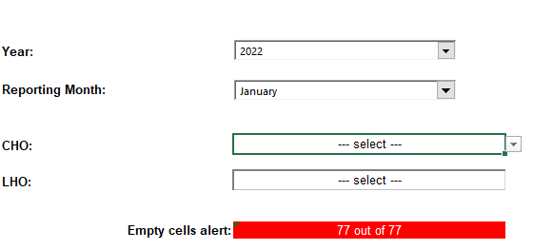

## Activity Sheet

**Please follow the steps carefully**

**Step 1:** No text or symbols permitted in cells, numeric values only.

**Step 2:** Data to be entered in the month/quarterly column when the activity took place.

**Step 3:** If nobody waiting during month/quarter, Please enter ‘0’ in the required field.

*OR*

If no activity in the month/quarter, Please enter ‘0’ in the required field.

**Step 4:** If no service provided in this location – Please leave blank.

If no return/figure not known – please leave blank and provide explanation in covering mail.

If no service provided in the month/quarter – See example in Appendix 2.

All Steps must be completed each month. The Count of Blank Cells alert at the bottom of the activity sheet will display in red if one or more cells remain blank. Blank cell occurrences, not due to any reason outlined under Step 4 above and with no explanation provided, may result in the template being returned to the data contact for completion

The activity sheet is restricted to numerical values only so no other character such as text, comma instead of a decimal point, or a space, can be entered in the Jan-Dec columns. If anything other than a number is entered, an error message will pop up as shown here

# Sending and Submission of a CIF template

* Data provided in the CIF templates must be validated for accuracy, completeness and month on month comparison before submission to the Business Information Unit.
* Each CHO Office must approve CIF Template content before submission, as NBIU are not authorised to make any changes to submitted CIF templates.
* **CIF Template returns received by the BIU are understood to have been approved by the CHO Office.**

## Late, Retrospective and/or resubmitted data

Should late or retrospective data for previous month(s)/quarter(s) require loading, please ensure to return a correctly labelled individual CIF template for each month(s)/quarter(s) to which the late or retrospective data relates.  This is essential so that the Corporate Information Facility (CIF) loading system can recognise that late /retrospective data needs to be captured and loaded to the database.

**Note:** HSE Leadership Team sign off on all report content, including data, in advance of publication. Published reports cannot be changed but Qlikview (data presentation tool) will report the most up to date figures including late and retrospective data uploaded.

***You must advise your assigned BIU HUB Information Officer by email, of the inclusion of late and/or retrospective data in the template attachments***

## Non Returns

If a non-return of any Template(s) or part of any template is anticipated when due for reporting, please state the name of the template, the period it relates to and reason why the template is not being returned. This must be notified by email to the Business Information Unit via your assigned HUB Information Officer.

# NBIU Information Officers – Contact Details

Please forward completed templates to the generic emails as below. If there is a designated data coordinator assigned to your CHO, please forward your completed templates to your CHO Data Coordinator who will forward them to the BIU HUB. If you have any queries re the above, please contact your assigned HUB Information Officer at the number below.

|  |  |  |  |
| --- | --- | --- | --- |
| **CHO** | **Name** | **Contact Number** | **Email Address** |
| CHOs 1, 2 & 3 | Denise O’Reilly | Mobile: 087 7071868 | Communityhealth.data123@hse.ie |
| CHOs 4 & 5 | Deirdre Devin | Mobile: 087 1891797 | [Communityhealth.data45@hse.ie](mailto:Communityhealth.data45@hse.ie) |
| CHOs 6, 7, & 8 | Jarlath Conefrey | Mobile: 0876197351 | [Communityhealth.data678@hse.ie](mailto:Communityhealth.data678@hse.ie) |
| CHO 9 | Miriam Byrne | Mobile: 0877878563 | [Communityhealth.data45@hse.ie](mailto:Communityhealth.data45@hse.ie) |

# Appendix 1: 2022 CIF Template Names

## Population Health and Wellbeing

|  |  |
| --- | --- |
| **2022 CIF Template Title** | **Frequency** |
| HWB_HPI_Tobacco_99_month | Q & Q-1Q |
| HWB_HEAL_Dietetics_99_month | Q |
| HWB_Immunisation_uptake_12_months_99_month | Q-1Q |
| HWB_Immunisation_uptake_24_months_99_month | Q-1Q |
| HWB_Public_Health_99_month | Q & Q-1Q |
| HWB_MECC_99_month | Q |
| HWB_Immunisations_Schools_annual_99_year_month | A |
| HWB_Immunisations_FluVaccine(65+_&2-12yrs)99_year | A |
| HWB_Immunisations_FluVaccine_99_year | A |

## National Services

|  |  |
| --- | --- |
| **2022 CIF Template Title** | **Frequency** |
| NS_Environmental_Health_99_month | Q & BiA |
| NS_PCRS_99_month | M |

## National Screening Services

|  |  |
| --- | --- |
| **2022 CIF Template Title** | **Frequency** |
| NSS_National_Screening_99_yyyy_mm | M, M-1M, Q, Q-1Q & BiA-1Q |

## Primary Care

|  |  |
| --- | --- |
| **2022 CIF Template Title** | **Frequency** |
| PC_Audiology_00_month | M |
| PC_CIT_00_month | M |
| PC_CIT_OPAT_Readmissions_99_month | M |
| PC_Dietetics_00_month | M |
| PC_GP_OOH_00_month | M |
| PC_Occupational_Therapy_00_month | M |
| PC_Ophthalmology_00_month | M |
| PC_Oral_Health_00_month | M |
| PC_Orthodontics_00_month | Q |
| PC_Primary_Care_Teams_00_month | M |
| PC_PHN_00_month | M-1M |
| PC_Physiotherapy_00_month | M |
| PC_Podiatry_00_month | M |
| PC_Psychology_00_month | M |
| PC_SLT_00_month | M |
| PC_Consumption_of_Antibiotics_99_month | Q-1Q |
| PC_Health_Amendment_Act_99_month | Q |
| PC_Child_Health_Developmental_Assessment_00_month | M-1M |
| PC_Child_Health_Quarterly_00_month | Q |
| PC_Community_Diagnostics_99_month | M |
| PC_National_Hepatitis_C_Treatment_Programme_99_month | M |
| PC_National_Newborn_Hearing_Screening_99_month | Q-1Q |
| PC_GP_Trainees_99_month | A |
| PC_National_Virus_Reference_Laboratory_99_month | M |
| PC_Chronic_Disease_Structured_Management_Programme | Bi-A |
| PC_Paediatric_Home_Care_Packages_99_month | M |

## Palliative Care

|  |  |
| --- | --- |
| **2022 CIF Template Title** | **Frequency** |
| PALLCARE_Specialist_00_month | M |
| PALLCARE_Intermediate_00_month | M |
| PALLCARE_Community_Services_00_month | M |
| PALLCARE_Daycare_00_month | M |
| PALLCARE_Bereavement_00_month | M |
| PALLCARE_Children_LHO_00_month | M |
| PALLCARE_Children_Acute_00_month | M |
| PALLCARE_Adult_Acute_00_month | M |
| PALLCARE_LauraLynn_99_month | M |

## Social Inclusion

|  |  |
| --- | --- |
| **2022 CIF Template Title** | **Frequency** |
| SI_Alcohol_Addiction_00_month | Q |
| SI_Homeless_00_month | Q |
| SI_Substance_Misuse_00_month | Q-1Q |
| SI_Needle_Exchange_99_month | Q |
| SI_Traveller_Health_99_month | Q |
| SI_Opioid_Substitution_99_month | M-1M |

## Older persons

|  |  |
| --- | --- |
| **2022 CIF Template Title** | **Frequency** |
| OP_Home_Support_00_month | M |
| OP_Home_Support_Pilot_99_month | M |
| OP_Intensive_Home_Care_Packages_00_month | M |
| OP_Public_Beds_99_month | M |
| OP_NHSS_99_month | M |
| SC_Safeguarding_99_month | Q-1M |
| OP_Quality_99_month | Q |
| OP_Transitional_Care_Beds_99_month | M-1M |
| OP_InterRAI_Ireland_Assessment_99_month | M |

## Disability Services

|  |  |
| --- | --- |
| **2022 CIF Template Title** | **Frequency** |
| DIS_Day_Res_Respite_00_month | Q-1M |
| DIS_Childrens_Disability_Network’s_00_month | M |
| DIS_Rehab_Training_99_month | M |
| DIS_Rehab_Training_Places_99_month | M |
| DIS_New_Emergency_Places_99_month | M |
| DIS_Residential_Places_99_month | M |
| DIS_AIM_99_month | M-1M |
| DIS_Assessment_of_Need_99_month | Q |
| DIS_Congregated_Settings_99_month | Q |
| DIS_Personalised_Budgets_99_month | Q |
| DIS_HIQA_Inspections_99_month | Q-2Q |
| DIS_School_Leavers_99_month | A |
| DIS_Day_Services_99_month | BiA |

## Mental Health

|  |  |
| --- | --- |
| 2022 CIF Template Title | Frequency |
| MH_Adult_ Psychiatry_General_00_month | M |
| MH_Adult_Psychiatry_Inpatient_99_month | Q |
| MH_Adult_Psychiatry_Inpatient_Child_and_Adolescent_99_month | M |
| MH_CAMHS_Community_00_month | M |
| MH_CAMHS_Inpatient_00_month | M |
| MH_Homeless_00_month | M |
| MH_Psychiatry_of_Old_Age_00_month | M |
| MH_Bed_Days_99_month | M |
| MH_POA_Liaison_00_month | M |
| MH_MHID_CAMHS_00_month | M & Q |
| MH_MHID_Adult_00_month | M & Q |

# Appendix 2: National/CHO/LHO codes

If the return is at National or CHO level return (i.e. LHO breakdown not available) use this reference table:

|  |  |
| --- | --- |
| **CHO Name** | **CHO No** |
| CHO 1 | 1 |
| CHO 2 | 2 |
| CHO 3 | 3 |
| CHO 4 | 4 |
| CHO 5 | 5 |
| CHO 6 | 6 |
| CHO 7 | 7 |
| CHO 8 | 8 |
| CHO 9 | 9 |
| National | 99 |

If the return is an LHO level return (i.e. data provided by each LHO), use this reference table:

| **LHO No** | **LHO Name** | **CHO Area** |
| --- | --- | --- |
| 1 | Dun Laoghaire | 6 |
| 2 | Dublin South East | 6 |
| 3 | Dublin South City | 7 |
| 4 | Dublin South West | 7 |
| 5 | Dublin West | 7 |
| 6 | Dublin North West | 9 |
| 7 | Dublin North Central | 9 |
| 8 | Dublin North | 9 |
| 9 | Kildare West Wicklow | 7 |
| 10 | Wicklow | 6 |
| 11 | Carlow Kilkenny | 5 |
| 12 | South Tipperary | 5 |
| 13 | Waterford | 5 |
| 14 | Wexford | 5 |
| 15 | North Lee | 4 |
| 16 | South Lee | 4 |
| 17 | North Cork | 4 |
| 18 | West Cork | 4 |
| 19 | Kerry | 4 |
| 20 | Limerick | 3 |
| 21 | North Tipperary East Limerick | 3 |
| 22 | Clare | 3 |
| 23 | Galway | 2 |
| 24 | Mayo | 2 |
| 25 | Roscommon | 2 |
| 26 | Donegal | 1 |
| 27 | Sligo Leitrim | 1 |
| 28 | Cavan Monaghan | 1 |
| 29 | Louth | 8 |
| 30 | Meath | 8 |
| 31 | Laois Offaly | 8 |
| 32 | Longford Westmeath | 8 |
| 34 | Unallocated CHO1 | 1(pall care only) |
| 35 | Unallocated CHO2 | 2 (pall care only) |
| 36 | Unallocated CHO3 | 3 (pall care only) |
| 37 | Unallocated CHO4 | 4 (pall care only) |
| 38 | Unallocated CHO5 | 5 (pall care only) |
| 39 | Unallocated CHO6 | 6 (pall care only) |
| 40 | Unallocated CHO7 | 7 (pall care only) |
| 41 | Unallocated CHO8 | 8 (pall care only) |
| 42 | Unallocated CHO9 | 9 (pall care only) |
| 43 | Home Schooled | 10 (HWB only) |

# Appendix 3 : Month Reference Codes

|  |  |
| --- | --- |
| **Month** | **Month_ref** |
| January | jan |
| February | feb |
| March | mar |
| April | apr |
| May | may |
| June | jun |
| July | jul |
| August | aug |
| September | sep |
| October | oct |
| November | nov |
| December | dec |

# Appendix 4: Mental Health Team Codes

## Adding a new Mental Health Team

To add a new team to the existing list above, so that the new team can submit monthly stat returns, please email a request directly to the Mental Health Analyst [Diane.Duignan@hse.ie](mailto:Diane.Duignan@hse.ie) with the following information:

* The name of the new team
* DED codes of the area the new team will cover (Please contact the service or [Ellen.Cranley@hse.ie](mailto:Ellen.Cranley@hse.ie) for CAMHS to confirm DED codes)
* Date from when the new team will start making returns.
* Contact details of the data collector who will submit the returns.

Once the request is received with all relevant information, the team will be setup with a team code and included in the drop down menu on the cover sheet of the CIF template. You will be notified by us when the process is complete.

Please also notify both [*diane.duignan@hse.ie*](mailto:diane.duignan@hse.ie) (and [*ellen.cranley@hse.ie*](mailto:ellen.cranley@hse.ie) for CAMHS) if there is a change to the DED codes of existing teams.

## CAMHS Teams – use this table for individual team returns:

| **CHO No** | **CAMHs Teams Code** | **CAMHTs** |
| --- | --- | --- |
| 1 | 49 | Donegal North Team |
| 1 | 50 | Donegal South Team |
| 1 | 57 | Cavan CAMHS 1 |
| 1 | 58 | Monaghan CAMHS 2 |
| 1 | 64 | West Cavan/Leitrim/East Sligo |
| 1 | 65 | Sligo (excluding East Sligo) |
| 1 | 78 | South Cavan/South Monaghan CAMHS 3 |
| 1 | 84 | Inishowen |
| 2 | 43 | Mayo South |
| 2 | 44 | Mayo North |
| 2 | 45 | North Galway |
| 2 | 46 | South Galway |
| 2 | 47 | West Galway |
| 2 | 48 | Roscommon / East Galway |
| 3 | 52 | North Tipperary |
| 3 | 53 | East Limerick |
| 3 | 54 | West Limerick |
| 3 | 56 | Limerick Central |
| 3 | 75 | Clare East |
| 3 | 76 | Clare West |
| 4 | 36 | North Cork |
| 4 | 37 | North Lee East |
| 4 | 38 | North Lee West |
| 4 | 39 | South Lee 1 |
| 4 | 40 | South Lee 2 |
| 4 | 41 | South Lee / West Cork |
| 4 | 59 | South Lee 3 |
| 4 | 60 | Kerry Team 1 |
| 4 | 61 | Kerry Team 2 |
| 4 | 66 | Cork North Central |
| 5 | 30 | Carlow / Kilkenny 1 |
| 5 | 31 | Carlow / Kilkenny 2 |
| 5 | 32 | Waterford |
| 5 | 33 | Wexford South |
| 5 | 34 | Wexford North |
| 5 | 35 | South Tipperary |
| 5 | 69 | South Tipperary Team 2 |
| 6 | 10 | Marine 56 |
| 6 | 13 | Lucena Team A (Dub. 6 14 16) |
| 6 | 14 | Lucena Team C (Dub. 2 4 12) |
| 6 | 15 | Lucena Wicklow - Bray |
| 6 | 16 | Lucena Wicklow - Arklow |
| 6 | 79 | Century Court Team |
| 7 | 2 | Linn Dara Clondalkin |
| 7 | 3 | Linn Dara Ballyfermot/St. James |
| 7 | 4 | Linn Dara Lucan |
| 7 | 5 | Linn Dara North Kildare (Celbridge) |
| 7 | 6 | Linn Dara East Kildare/West Wicklow |
| 7 | 7 | Linn Dara South Kildare (Athy) |
| 7 | 11 | Lucena Tallaght Team 1 |
| 7 | 12 | Lucena Tallaght Team 2 |
| 7 | 68 | Linn Dara West Kildare |
| 7 | 81 | Linn Dara South Kildare/West Wicklow |
| 7 | 82 | Linn Dara Community Eating Disorder Service |
| 7 | 83 | Linn Dara Admire ADHD Pathway Team |
| 8 | 18 | Laois |
| 8 | 19 | Offaly |
| 8 | 27 | Meath North |
| 8 | 28 | Meath South |
| 8 | 62 | Louth North |
| 8 | 63 | Louth South |
| 8 | 67 | Laois/Offaly CAMHS team 3 (16-17yrs) |
| 8 | 70 | Longford/North Westmeath |
| 8 | 71 | South Westmeath |
| 8 | 72 | Meath South Ashbourne |
| 8 | 73 | Longford Westmeath YAMHS |
| 8 | 80 | South Louth/East Meath |
| 9 | 20 | Blanchardstown |
| 9 | 21 | Castleknock |
| 9 | 22 | North Inner City |
| 9 | 23 | Ballymun |
| 9 | 24 | North East City |
| 9 | 25 | Swords |
| 9 | 74 | Balbriggan |
| 9 | 77 | Darndale |

## Adult Psychiatry (General) Teams

| **CHO No** | **General Adult Psychiatry Team Code** | **General Adult Psychiatry Team** |
| --- | --- | --- |
| 1 | 38 | Monaghan |
| 1 | 39 | East & West Cavan |
| 1 | 107 | Donegal Central |
| 1 | 108 | Donegal South West |
| 1 | 109 | Donegal North West |
| 1 | 110 | Inishowen |
| 1 | 111 | Sligo |
| 1 | 112 | Leitrim/South Donegal/West Cavan |
| 1 | 113 | South Sligo - DELETED |
| 1 | 114 | West Sligo - DELETED |
| 1 | 115 | South Leitrim - DELETED |
| 2 | 73 | Sector C Ballinasloe/Mountbellew |
| 2 | 74 | Sector B/C Tuam Hedford |
| 2 | 75 | Sector B Loughrea/Athenry |
| 2 | 76 | Sector A Portumna/Gort |
| 2 | 77 | Moycullen/Oughterard |
| 2 | 78 | South Connemara |
| 2 | 79 | Oranmore/Aran Islands/Galway City |
| 2 | 80 | Clifden/Galway City |
| 2 | 81 | Roscommon/Athlone |
| 2 | 82 | Roscommon (Ros Na Suan PCCC) |
| 2 | 83 | Castlerea/Ballaghaderreen |
| 2 | 84 | Boyle |
| 2 | 102 | Castlebar |
| 2 | 103 | Ballina |
| 2 | 104 | Westport |
| 2 | 105 | Claremorris |
| 2 | 106 | Belmullet |
| 2 | 137 | GR1 Connemara-City West |
| 3 | 116 | Nenagh |
| 3 | 117 | Thurles |
| 3 | 124 | Clare South |
| 4 | 53 | Mallow |
| 4 | 54 | Fermoy |
| 4 | 55 | Kanturk |
| 4 | 56 | Cobh Glenville |
| 4 | 57 | Midleton Youghal |
| 4 | 58 | City North West |
| 4 | 59 | City North East |
| 4 | 60 | Macroom Blarney |
| 4 | 61 | North Lee Homeless |
| 4 | 62 | Bandon/Kinsale |
| 4 | 63 | Bishopstown/Ballincollig |
| 4 | 64 | Douglas/Carrigaline |
| 4 | 65 | City South West |
| 4 | 66 | City South East |
| 4 | 67 | West Cork |
| 4 | 68 | Listowel |
| 4 | 69 | Killorglin/Iveragh |
| 4 | 70 | Killarney |
| 4 | 71 | Castleisland/Dingle |
| 4 | 72 | Tralee |
| 5 | 40 | Carlow North |
| 5 | 41 | Carlow South |
| 5 | 42 | Kilkenny North |
| 5 | 43 | Kilkenny West |
| 5 | 44 | Kilkenny East |
| 5 | 45 | South Kilkenny |
| 5 | 46 | Waterford City |
| 5 | 47 | Waterford West |
| 5 | 48 | Wexford South |
| 5 | 49 | Wexford North |
| 5 | 50 | Clonmel West (changed to South Tipperary) |
| 5 | 51 | Clonmel East (changed to South Tipperary) |
| 5 | 52 | Tipperary-Cashel sector (changed to South Tipperary) |
| 6 | 1 | SJOG Team A Cluain Mhuire |
| 6 | 2 | SJOG Team B Cluain Mhuire |
| 6 | 3 | SJOG Team C Cluain Mhuire |
| 6 | 4 | North Wicklow |
| 6 | 5 | South Wicklow |
| 6 | 92 | Glenmalure A |
| 6 | 93 | Churchtown A |
| 6 | 94 | Glenmalure B |
| 6 | 95 | Vergemount |
| 6 | 146 | Churchtown B |
| 7 | 85 | Camac |
| 7 | 86 | Drimnagh |
| 7 | 87 | Owendoher |
| 7 | 88 | Tallaght |
| 7 | 89 | Clondalkin |
| 7 | 90 | Crumlin |
| 7 | 91 | Ballyfermot |
| 7 | 96 | Kildare Mid East |
| 7 | 97 | Kildare Mid West |
| 7 | 98 | South Kildare |
| 7 | 99 | Kildare North East |
| 7 | 100 | Kildare North West |
| 8 | 6 | Mullingar |
| 8 | 7 | Longford |
| 8 | 8 | Birr |
| 8 | 9 | Birr TF - DELETED |
| 8 | 10 | Tullamore West |
| 8 | 30 | South Louth East Meath |
| 8 | 34 | North Meath |
| 8 | 36 | South Meath |
| 8 | 101 | Athlone |
| 8 | 143 | South Louth |
| 8 | 144 | North Louth |
| 8 | 145 | South East Meath |
| 9 | 11 | Cabra |
| 9 | 12 | Blanchardstown East Team 1 |
| 9 | 13 | Blanchardstown East Team 2 |
| 9 | 14 | Finglas Team 1 |
| 9 | 15 | Finglas Team 2 |
| 9 | 16 | Ballymun |
| 9 | 17 | Marino/Clontarf |
| 9 | 18 | Marino Tolka |
| 9 | 19 | Mater |
| 9 | 20 | Millmount |
| 9 | 21 | North Strand |
| 9 | 22 | Coolock |
| 9 | 23 | Kilbarrack East |
| 9 | 24 | Kilbarrack West |
| 9 | 25 | Hampton Balbriggan |
| 9 | 26 | Darndale OPD |
| 9 | 27 | Killester OPD |
| 9 | 28 | Curam Clinic Swords |

## Psychiatry of Later Life Teams

|  |  |  |
| --- | --- | --- |
| **CHO No** | **Psychiatry of Later Life Team Code** | **Psychiatry of Later Life Team Name** |
| 1 | 7 | Cavan Monaghan |
| 1 | 15 | Sligo/Leitrim |
| 1 | 18 | Donegal |
| 2 | 13 | West Galway Later Life UHG |
| 2 | 14 | East Galway |
| 2 | 23 | Mayo POA |
| 2 | 26 | Roscommon/North Galway POLL |
| 2 | 29 | Mayo POA2 |
| 3 | 16 | Psychiatry Old Age Limerick |
| 3 | 17 | Psychiatry Old Age Co. Clare |
| 3 | 34 | North Tipperary POA |
| 4 | 12 | Old Age South Lee |
| 4 | 30 | North Lee POA |
| 4 | 32 | Kerry POA |
| 4 | 33 | West Cork POA |
| 5 | 8 | Carlow Kilkenny |
| 5 | 9 | Waterford |
| 5 | 10 | Wexford |
| 5 | 11 | Tipperary South |
| 5 | 31 | Waterford Wexford POA |
| 6 | 21 | Dun Laoghaire POA |
| 6 | 27 | Wicklow POA |
| 7 | 19 | Dublin South City POA |
| 7 | 20 | Dublin South West POA |
| 7 | 28 | Kildare West Wicklow POLL |
| 8 | 1 | Longford/Westmeath POLL |
| 8 | 2 | Laois/Offaly POLL |
| 8 | 6 | Meath |
| 8 | 24 | Louth POA |
| 8 | 25 | Louth-Meath POA |
| 9 | 3 | Mater |
| 9 | 4 | Dublin North POA |

## Mental Health Homeless Team

|  |  |  |
| --- | --- | --- |
| **CHO No** | **Mental Health Homeless Team Code** | **Mental Health Homeless Team Name** |
| 4 | 1 | North Lee Homeless |

## MHID Adult Teams

|  |  |  |
| --- | --- | --- |
| **CHO No** | **MHID Adult Team Code** | **MHID Adult Team Name** |
| 1 | 1 | Cavan/Monaghan |
| 1 | 2 | Sligo and Leitrim |
| 1 | 3 | Donegal MHID Service |
| 2 | 4 | Mayo |
| 3 | 5 | North Tipperary & Clare |
| 4 | 6 | Cork Kerry Community Healthcare |
| 6 | 7 | Wicklow |
| 7 | 8 | St James & Tallaght |
| 8 | 9 | Louth/Meath |
| 8 | 13 | Midlands MHID |
| 9 | 10 | St Joseph's |
| 9 | 11 | North East Region MHID Team |
| 9 | 12 | Daughters of Charity MHID service |

## MHID CAMHS Teams

|  |  |  |
| --- | --- | --- |
| **CHO No** | **MHID CAMHS Team Code** | **MHID CAMHS Team Name** |
| 2 | 1 | Mayo |
| 2 | 2 | Galway and Roscommon |
| 4 | 3 | South Lee - Intellectual Disability CAMHS |
| 7 | 4 | Linndara - Tallaght |
| 7 | 5 | Linndara - Kildare/West Wicklow |
| 8 | 6 | MH & ID/YAMHS Longford Westmeath |
| 9 | 7 | North Dublin CAMHS-ID |
| 9 | 8 | Daughters of Charity |

## Psychiatry of Later Life Liaison Service

|  |  |  |
| --- | --- | --- |
| **CHO** | **Service/Hospital/s** | **CIF Code** |
|  | **Name** |  |
| 1 | Letterkenny General | 1 |
| Sligo General | 2 |
| Cavan General | 3 |
| 2 | Mayo General | 4 |
| UH Galway | 5 |
| Roscommon | 6 |
| Portiuncula Hospital | 7 |
| 3 | Limerick UH | 8 |
| UH Ennis/St Joseph's | 9 |
| 4 | Mercy University Hospital | 10 |
| CUH | 11 |
| 5 | UH Waterford | 12 |
| Waterford/Wexford | 28 |
| Wexford General & St John's | 13 |
| St Luke’s Hospital Kilkenny | 14 |
| South Tipp General Hospital | 15 |
| 6 | SVUH | 16 |
| Wicklow POA3 | 17 |
| 7 | St James' Hospital | 18 |
| Tallaght Hospital | 19 |
| Kildare / Naas | 20 |
| 8 | Mullingar | 21 |
| Tullamore/Portlaoise | 22 |
| North Louth/Dundalk | 23 |
| Louth/Meath | 24 |
| Meath/Navan | 25 |
| 9 | DNC/Mater/Connolly | 26 |
| North Dublin/Beaumont | 27 |

# Appendix 5: Primary Care Codes

## GP Out of Hours Co-Operatives

|  |  |
| --- | --- |
| **GP OOH Co-op** | **CHO Name** |
| MIDoc | Old RDO1 |
| KDoc | Old RDO1 |
| EDoc | Old RDO2 |
| DDoc | Old RDO2 |
| NEDoc | Old RDO2 |
| CareDoc | Old RDO3 |
| SouthDoc | Old RDO3 |
| ShannonDoc | Old RDO4 |
| NowDoc | Old RDO4 |
| WestDoc | Old RDO4 |

## Community Intervention Teams

|  |  |
| --- | --- |
| **CIT No** | **CIT Name** |
| 1 | CIT Dublin South |
| 2 | CIT Dublin North |
| 3 | CIT Cork |
| 4 | CIT Limerick |
| 5 | CIT Clare |
| 6 | CIT Carlow/Kilkenny |
| 7 | CIT North Tipperary |
| 8 | CIT Galway |
| 9 | CIT Wicklow |
| 10 | CIT Kerry |
| 11 | CIT Louth |
| 12 | CIT Kildare |
| 13 | CIT Meath |
| 14 | CIT Waterford |
| 15 | CIT Roscommon |
| 16 | CIT South Tipperary |
| 17 | CIT Laois/Offaly |
| 18 | CIT Sligo |
| 19 | CIT Donegal |
| 20 | CIT Cavan/Monaghan |
| 21 | CIT Mayo |
| 22 | CIT Wexford |
| 23 | CIT Longford/Westmeath |

## Orthodontic Service

|  |  |  |
| --- | --- | --- |
| Orthodontic Service Code | Orthodontic Service Name | RDO |
| 1 | Former East Coast (Loughlinstown) | DML (RDO1) |
| 2 | Former South West (St James's) | DML (RDO1) |
| 3 | Midlands | DML(RDO1) |
| 4 | DNE | DNE(RDO2) |
| 5 | South East | South RDO3) |
| 6 | South | South (RDO3) |
| 7 | North West | West (RDO3) |
| 8 | Mid Western | West (RDO4) |
| 9 | Western | West (RDO4) |

# Appendix 6: Enable macros in excel 2007

* **Before** opening a template open a new file in excel
* Select the office button –
* Select Excel options

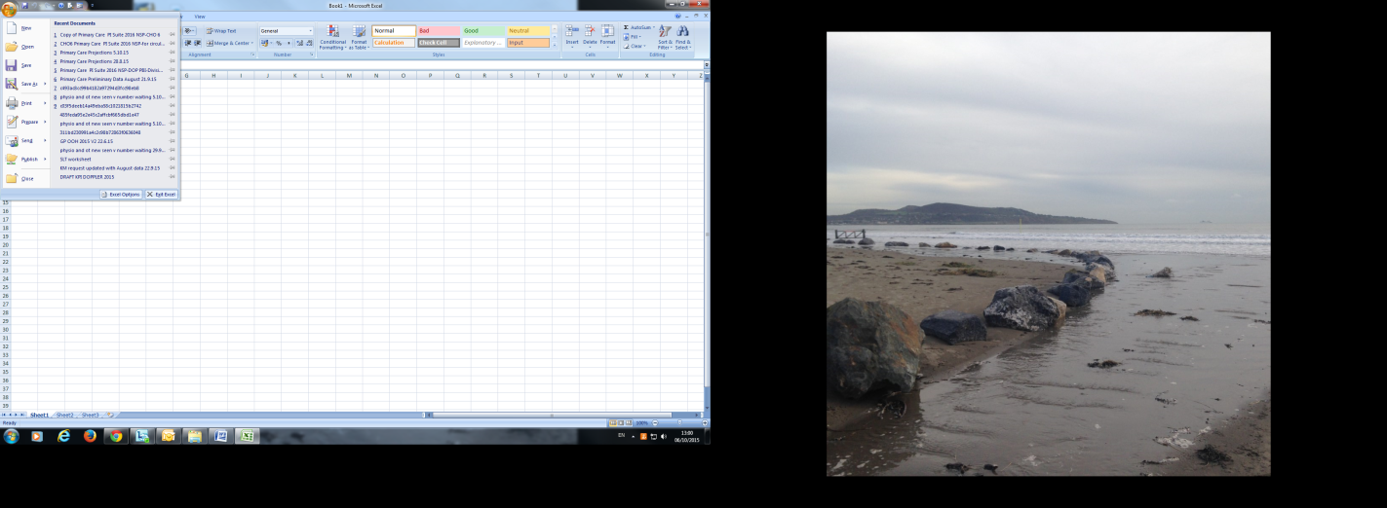

New dialogue box opens on screen - Select trust centre settings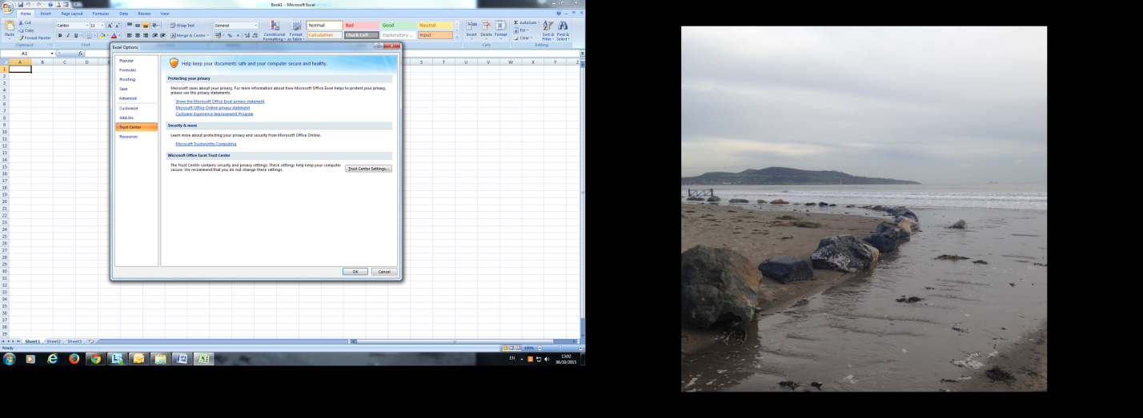

A new screen appears from the menu at the side select macro settings

* From the options that appear on screen select enable macros
* Click the ok button and then close out of excel

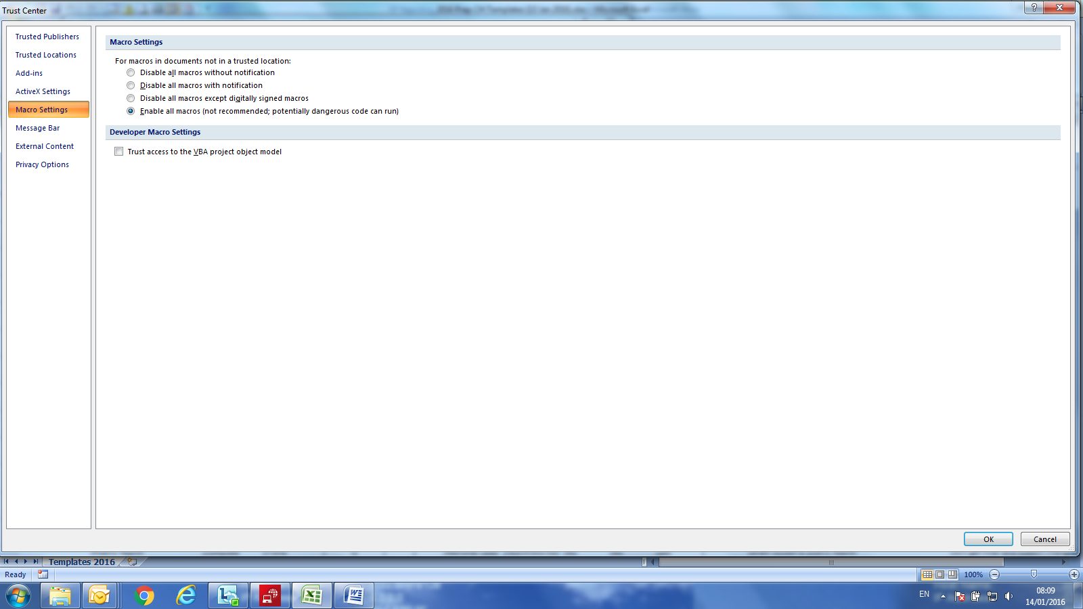

# Appendix 7: Example of no service in month/quarter

Scenario: An LHO provides Primary Care Physiotherapy services for the first 3 months of 2022, but suspends service on 1st April 2022 due to staff shortages. Below we outline how the April 2022 data should be reported.

|  |  |
| --- | --- |
| **Metric** | **Guidance** |
| Number of patient referrals accepted in the reporting month by age category | For each age category, enter the actual number of referrals accepted in April 2022, or zero if no referrals were accepted. |
| Number of patients seen for a first time assessment in the reporting month. | As no patients were seen during April 2022, zero should be entered. |
| Longest wait time for patient seen for first time assessment. | As no patients were seen during April 2022, this cannot be computed and so can be left blank. |
| Number of patients for whom an intervention occurred… | As no patients were seen during April 2022, zero should be entered. |
| Number of face to face contacts/visits/appointments in the reporting month | As no patients were seen during April 2022, zero should be entered. |
| Number of patients who did not attend their appointment (DNA). | As no appointments were offered in April 2022, this metric is not applicable and should be left blank. |
| Number of Patients waiting for assessment (by duration waiting) | Enter the number of patients waiting. This metric should be reported as normal, even though no service was available in the month. |
| Longest waiting time on assessment waiting list | Enter the longest waiting time of patients on the assessment waiting list. This metric should be reported as normal, even though no service was available in the month. |