HSE Mpox Immunisation System

Training to support PrEP vaccination operations

Contents

Introduction 1

1. Log In 1

2 Patient check-in 3

3. Process a patient vaccination 7

3.1 Find the patient’s appointment 7

3.2 Capture consent and eligibility details 8

3.3 Attend patient for vaccination 12

4. Book dose 2 appointment on behalf of the client 14

5. Recording Clinical Notes including Adverse Reaction 15

6. Book an Urgent Appointment on Behalf of the Client 17

6.1 Using Clinic Configuration 17

6.2 Override Clinic Configuration 18

# Introduction

This document outlines how to use the Mpox Immunisation System to process PrEP vaccinations for clients that self-refer for dose 1 PrEP vaccinations where dose 1 appointment is booked on behalf of a client.

## Log In

To access the system using the link <https://www.swiftqueue.com/login_splash.php>

If you experience an issue with logging in go [here](https://www.hse.ie/eng/health/immunisation/hcpinfo/mpximmsys.html), to section ‘General Support Request’, for details on how to get support.

* 1. Select Login/Create Account

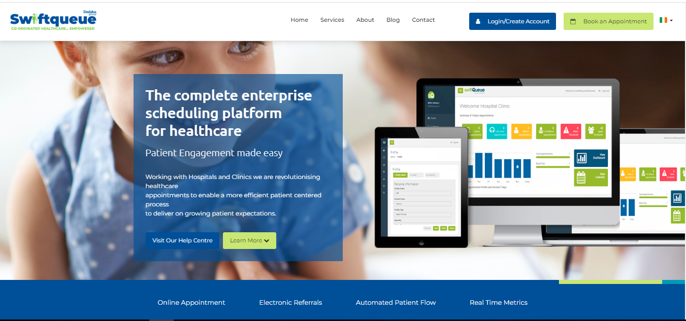

1.2 Select Clinic

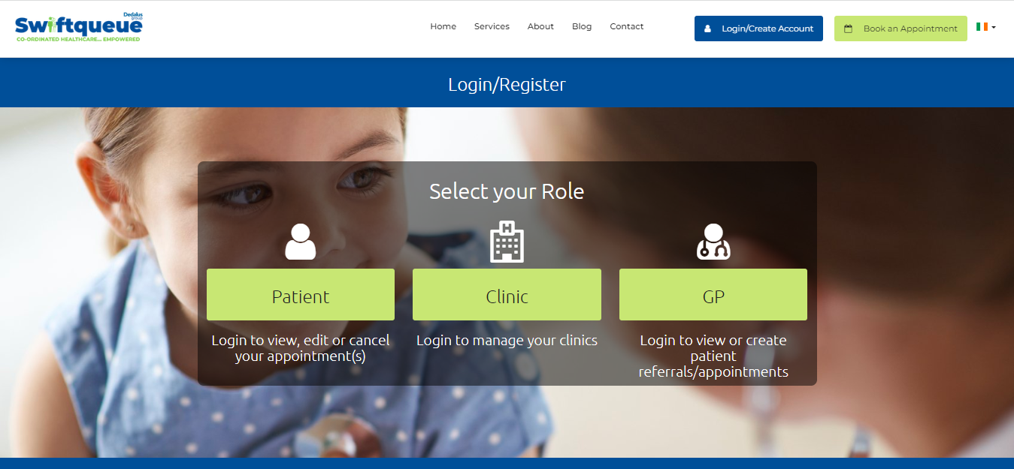

1.3 Input your username and password, then select the ‘Sign in’ button

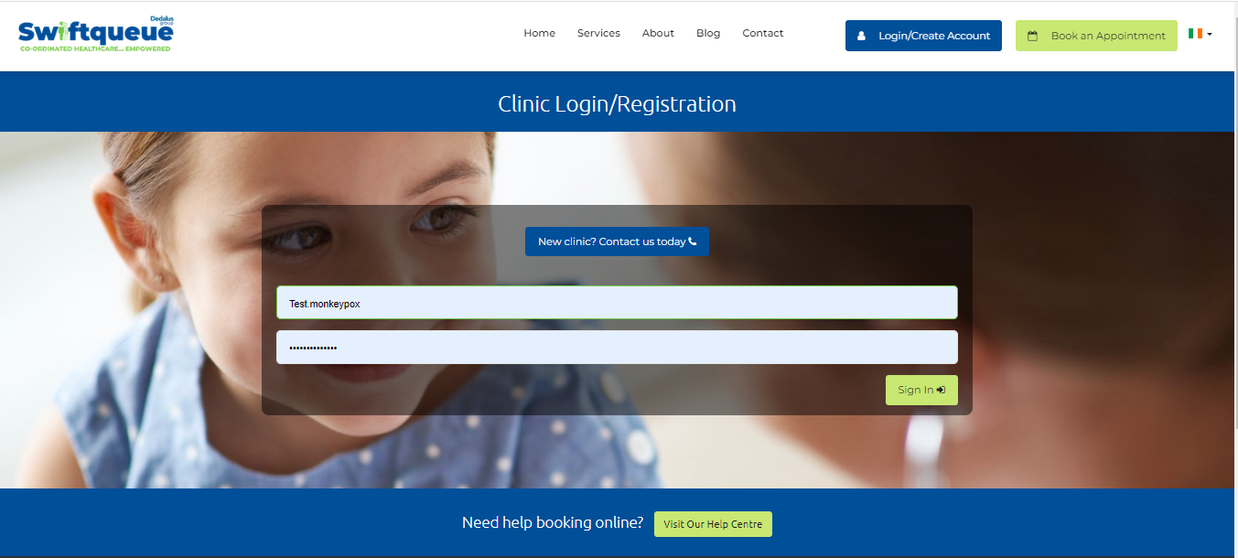

## Patient check-in

To find the patient that has booked a vaccination appointment follow these steps:

2.1 Go to ‘Reception’

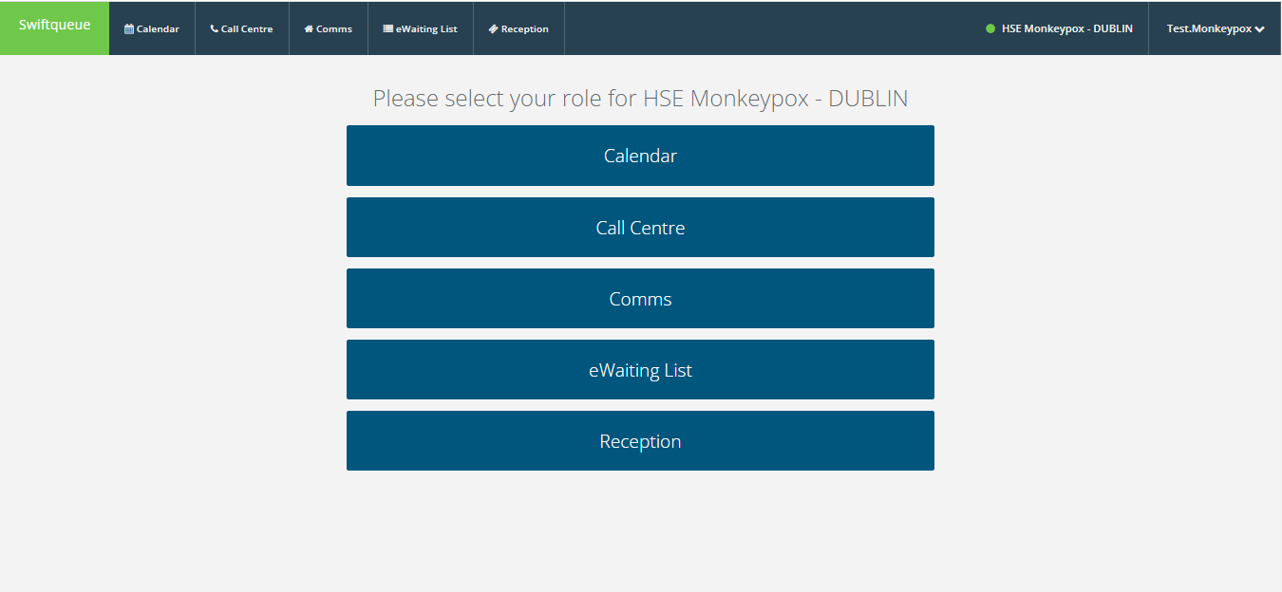

2.2. View the clinic’s list of appointments for the selected date

The selected date will default to today’s date. Change the date by clicking on the calendar icon next to current date.

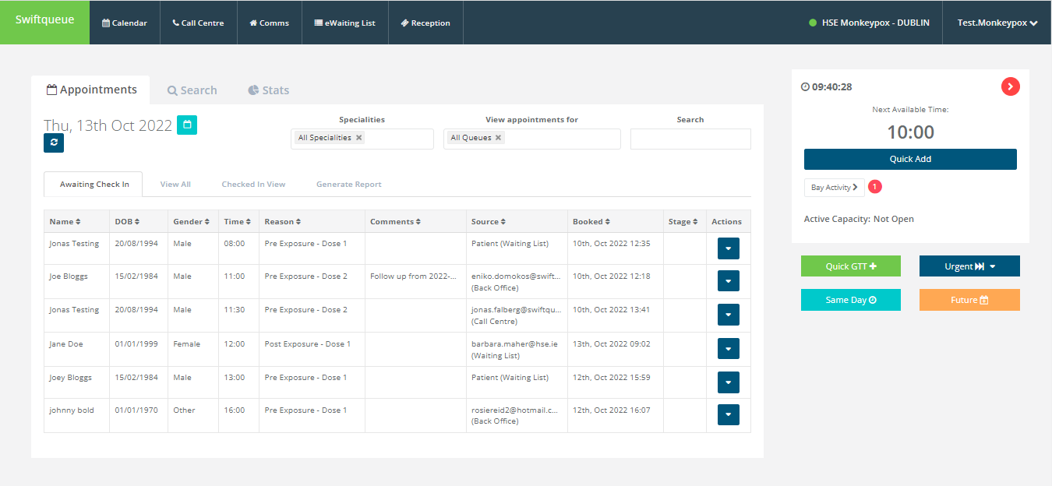

2.3 Check-in a patient for their appointment

1. Go to the patient details for the patient to be checked-in.
2. Click the ‘Action’ button to open a list of options
3. Select ‘Check-in’
4. The appointment ‘Stage’ for the patient will update to ‘Checked-in’

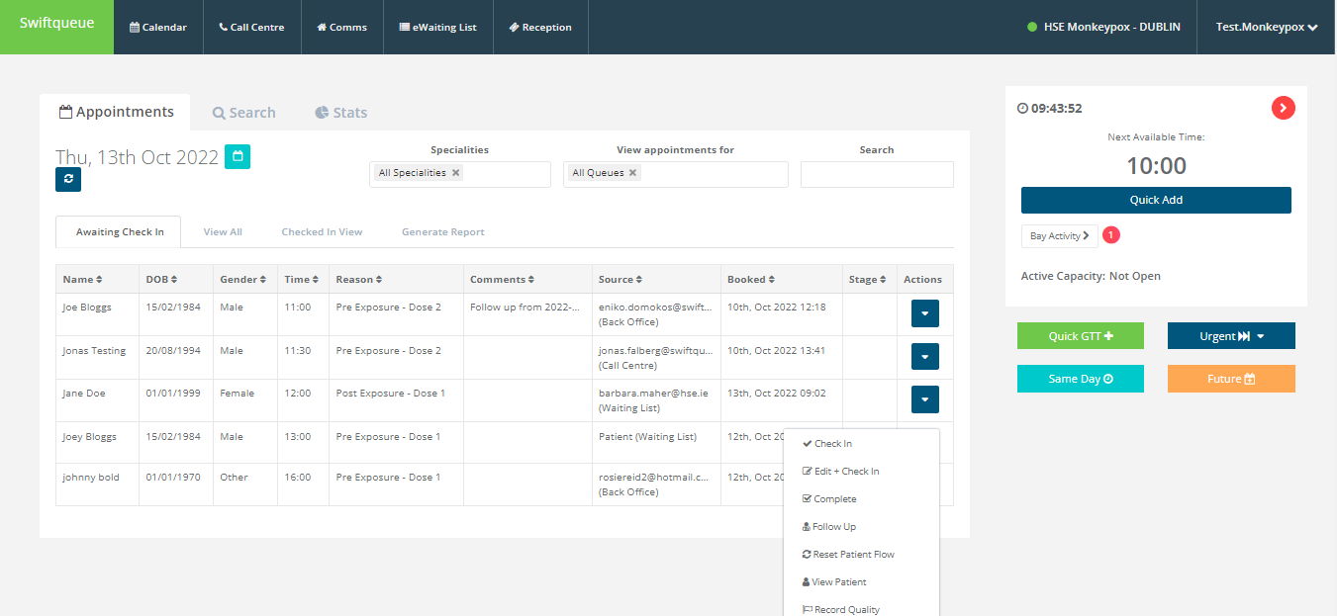

2.3.1Edit patient demographic details and Check-In

1. Go to the patient details for the patient to be checked-in.
2. Click the ‘Action’ button to open a list of options
3. Select ‘Edit and Check in’



1. Edit the patient details and click save

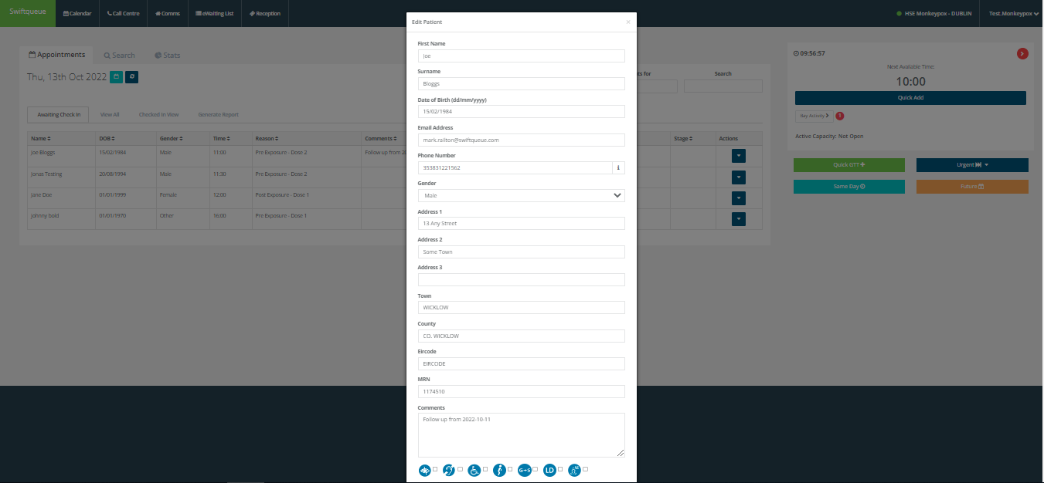

2.4 Record the patient as DNA

a) Go to the patient details for the patient to be checked-in.

b) Click the ‘Action’ button to open a list of options

c) Select Record DNA

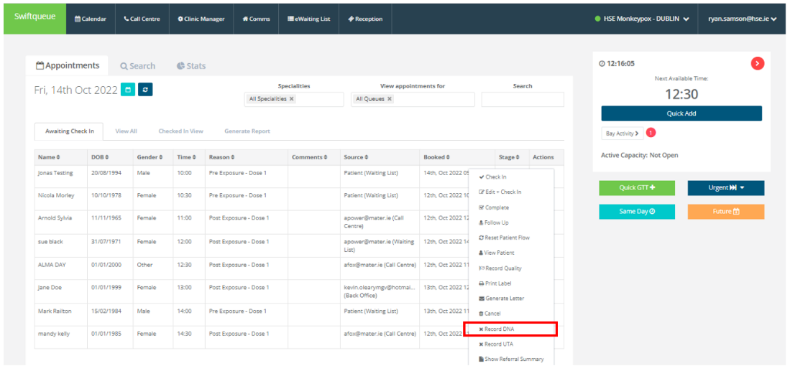

d) Select Yes to confirm patient is a DNA



e) The patient will be tagged as a DNA as shown below



## 3. Process a patient vaccination

### 3.1 Find the patient’s appointment

1. Select calendar option

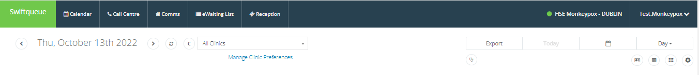

1. Confirm the vaccine the clinic is using
   1. Pick the vaccine manufacturer and vaccine name, and click ‘Select’.

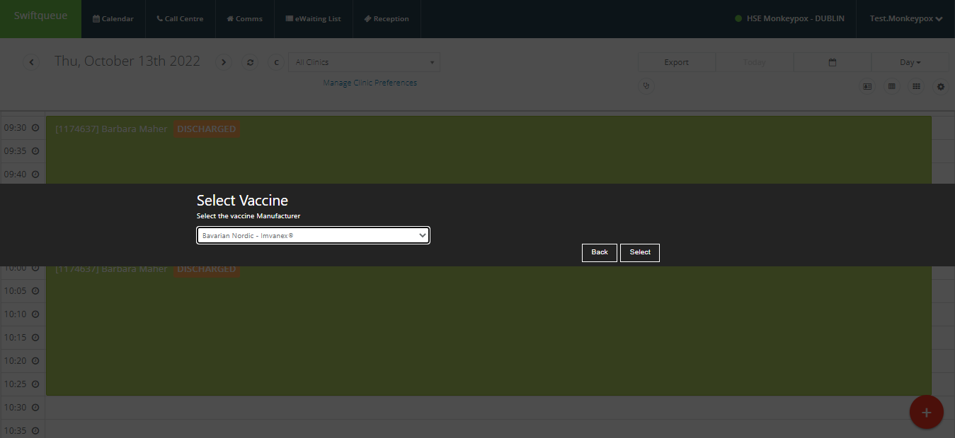

* 1. Pick the vaccine batch and Use by date, and click ‘Select’

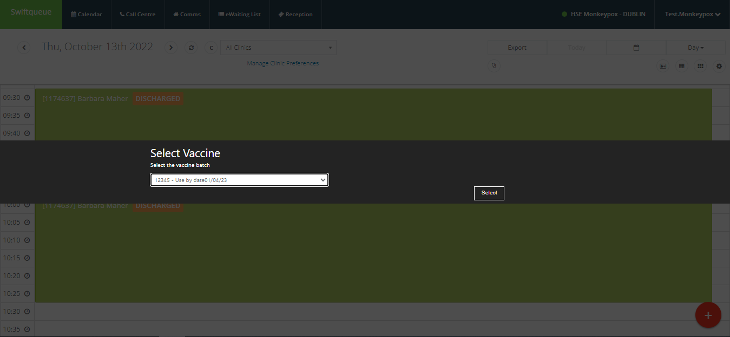

* 1. Confirm whether the Expiry date is correct by selecting ‘Yes’ or ‘No’

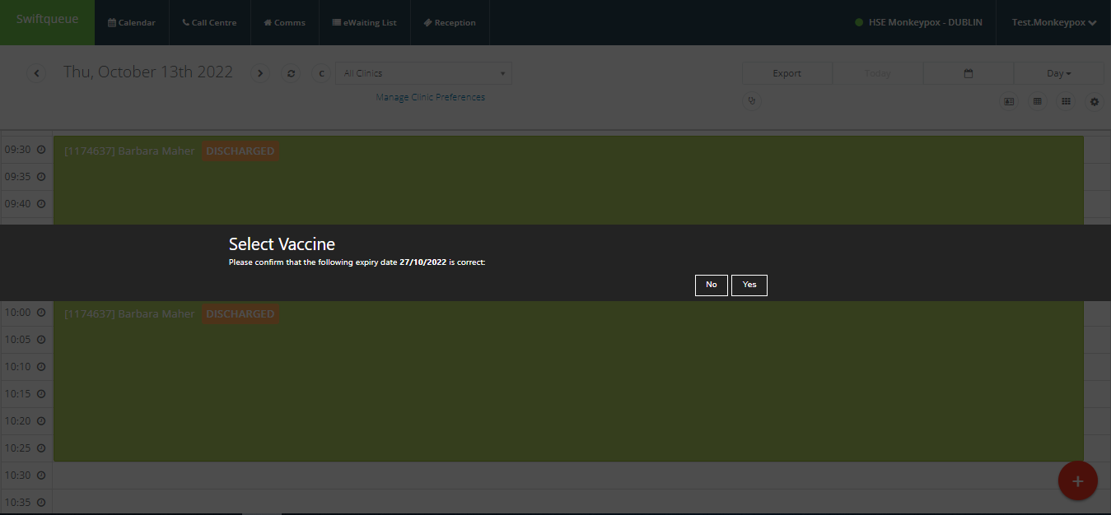

1. Select the client’s appointment

Make sure that the date is set to today. The client’s appointment will display with ‘Checked in’ status.

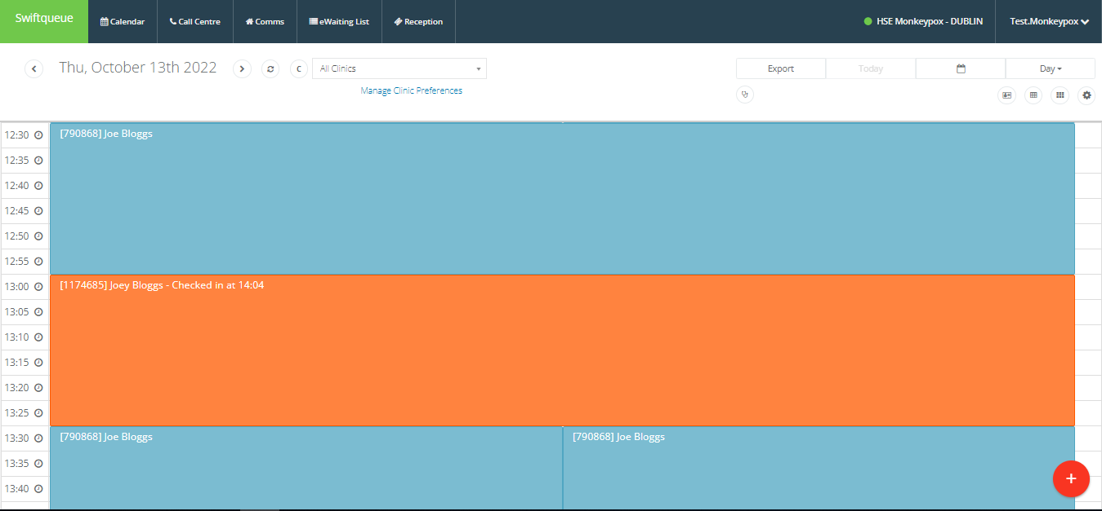

## 3.2 Capture consent and eligibility details

1. Review information displayed on the Appointment Details to ensure that the correct client appointment is open

2. Click on the Open Consent & Eligibility form (Dose 1/ Pre Exposure Prophyaxis) form

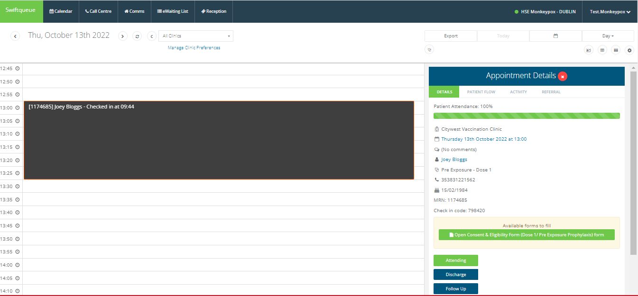3. Complete the Consent and Eligibility form

* 1. All questions and input fields with ‘*’ must be completed.
  2. Where a client doesn’t book an appointment via the booking portal, please collect PPSN if the client has it. This will ensure a successful IHI match.
  3. Click Submit to save details

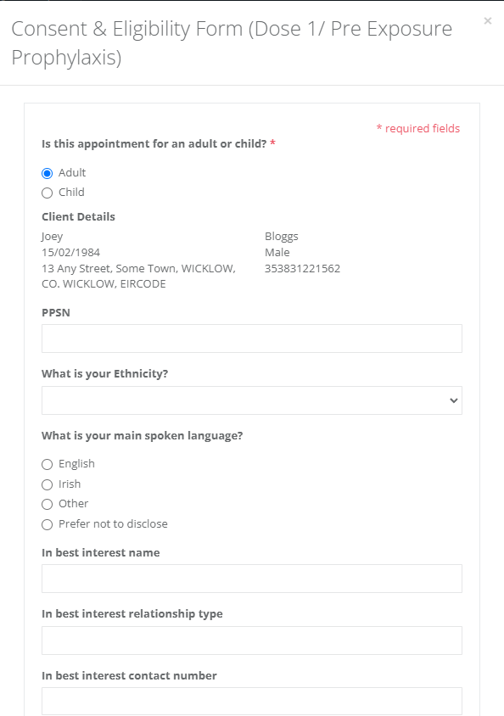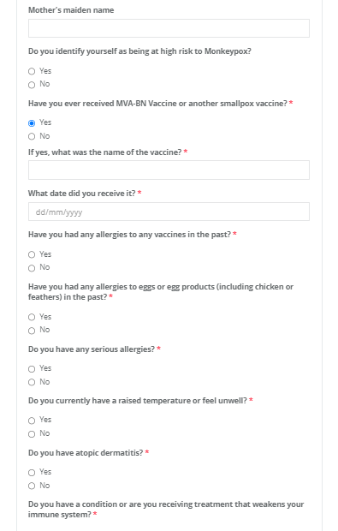

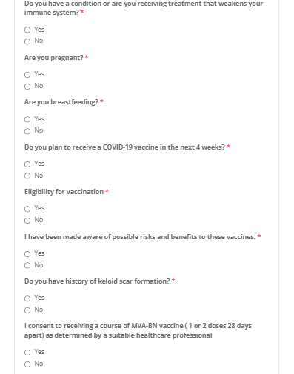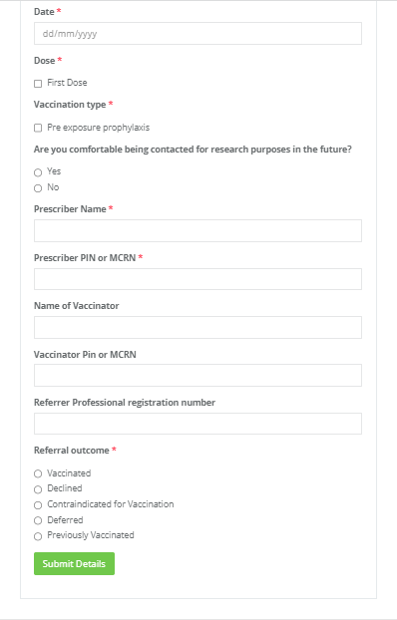

1. Edit completed consent and eligibility form
   1. Select the down arrow button and click on ‘Edit response’

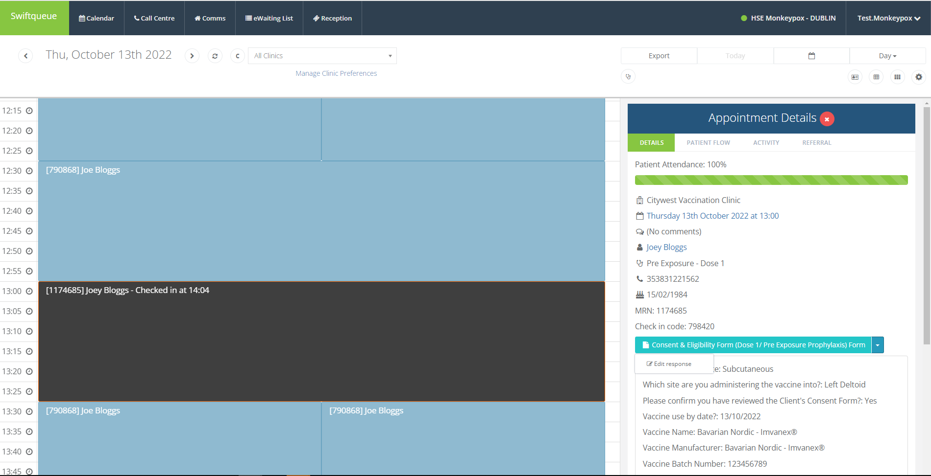

* 1. Complete the Call Log screen and click ‘Save’

This will allow a history of changes to be recorded for the form.

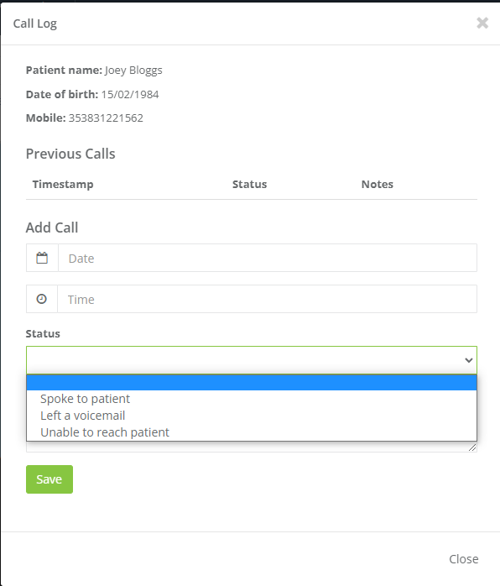

* 1. Update the form as required and click ‘Save’
  2. A history of changes will display on the form the next time it is opened

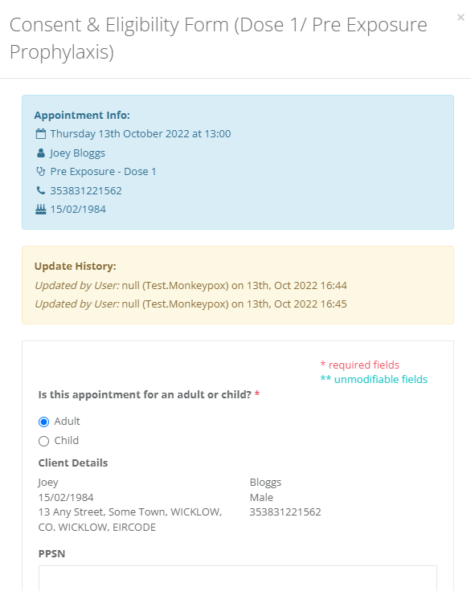

### 3.3 Attend patient for vaccination

1. Select ‘Attending’ on the Appointment details section

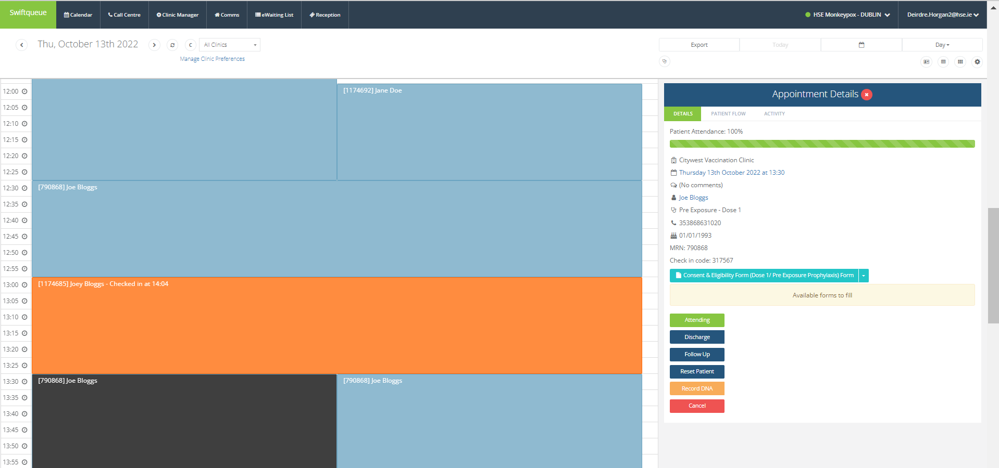

1. Input details on the Attending page displayed and click ‘Save’

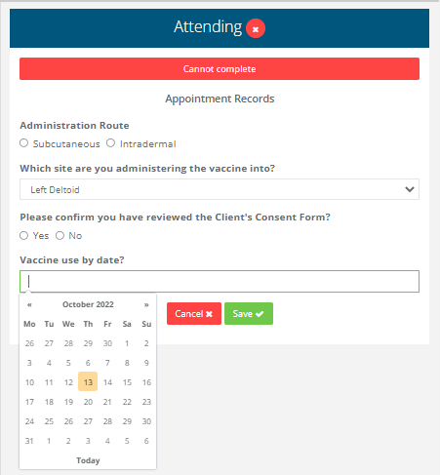

1. If the vaccine was not administered take the following steps
   1. Select ‘Cannot complete’ on the Attending screen

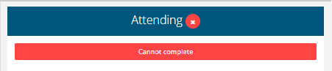

* 1. Pick the relevant cannot complete reason, add notes if necessary.
  2. Select ‘Record cannot complete’

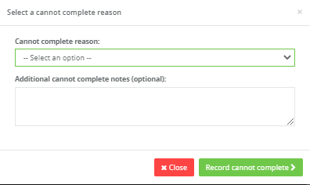

* 1. Edit Consent & Eligibility form (follow section 3, point 5)

Update referral outcome to reflect why the appointment cannot be completed.

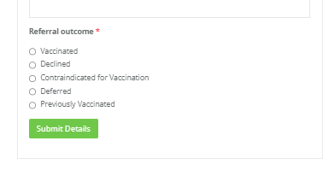

## Book dose 2 appointment on behalf of the client

1. On the patient appointment detail screen click ‘Follow up’

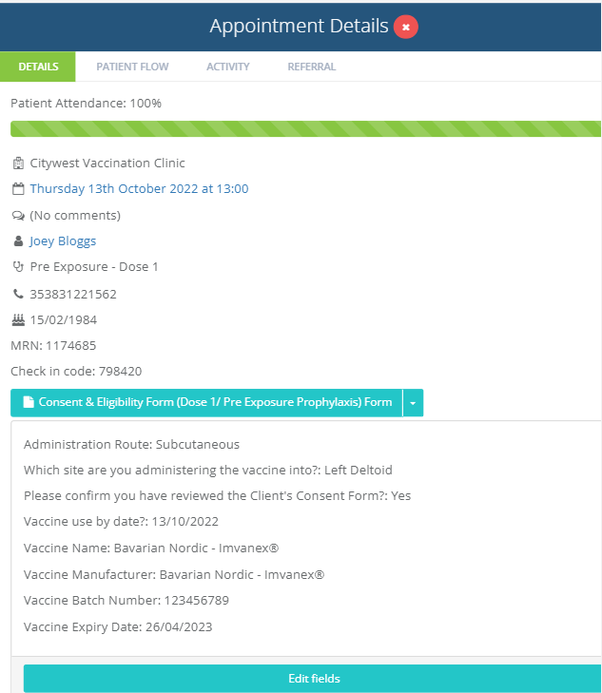

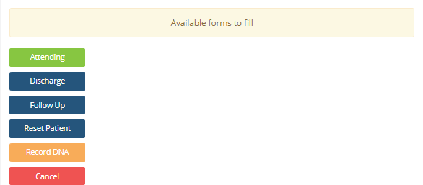

1. Select appointment details
   1. Select appointment type
   2. Select date and time of appointment
   3. Click ‘Create follow up’

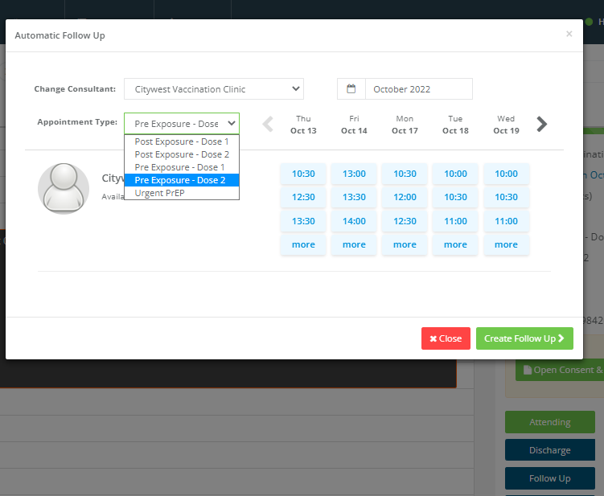

## Recording Clinical Notes including Adverse Reaction

1. Click on the Client’s appointment
2. Select the Referral Tab
3. Click Go to Referral

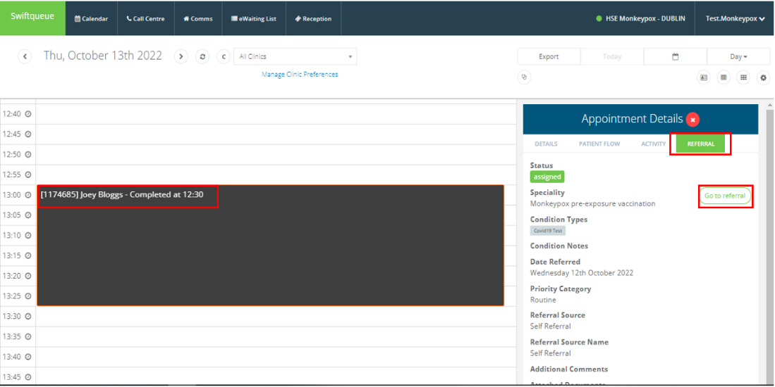

1. Click on the ‘edit referral’ action button.

1. Input the clinical note details in the ‘Condition Notes’ text box.

1. If note related to an adverse reaction select ‘Adverse Reaction’ as the flag and also select the appropriate adverse reaction ‘condition type’ tag – this will allow you to use the ‘condition type’ filter to identify your adverse reactions in the eWaiting list

1. The patient details will be displayed with the ‘Adverse Reaction’ flag as follows

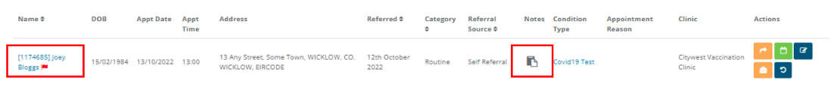

## Book an Urgent Appointment on Behalf of the Client

### 6.1 Using Clinic Configuration

1. Click ‘Call Centre’ and select ‘Home’ from the list of options
2. Go to the Clinic displayed at the bottom of the screen
   1. Pick the appropriate appointment reason
   2. Click ‘Select’

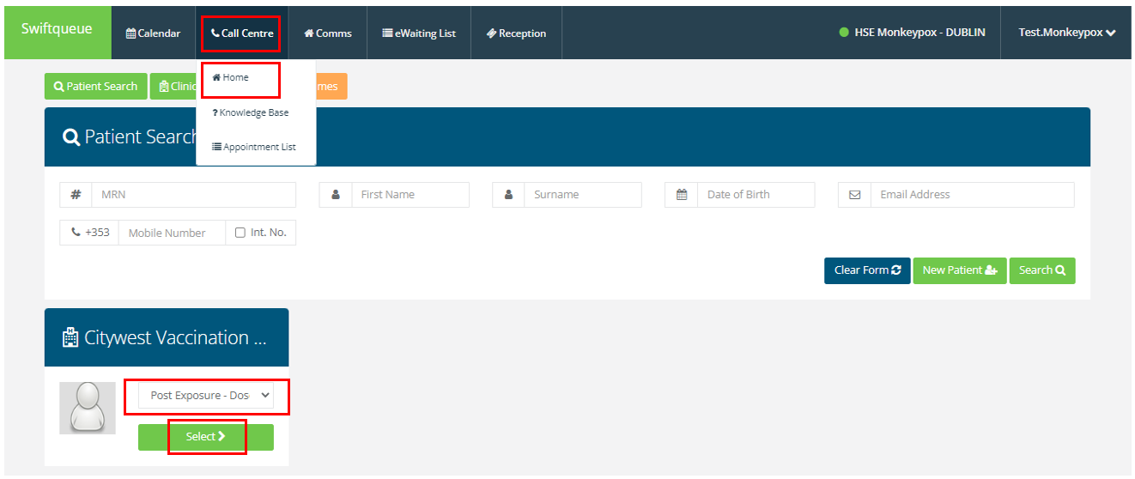

1. Select the appointment Date
   1. Change date view by clicking on the Left & Right arrow
   2. Change month using the calendar month picklist
2. Pick the appropriate appointment slot

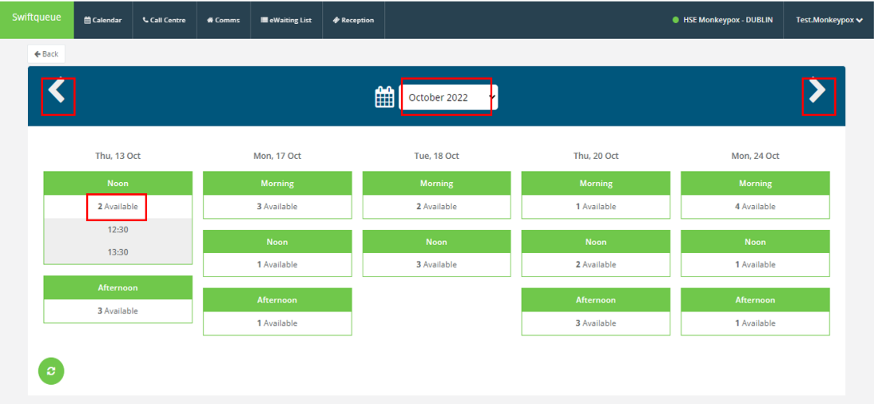

1. Create or search for the Client
   1. Input client details
   2. Click on ‘Search’
   3. Select the patient record from search results
   4. If patient record is not found then select ‘new’. This creates the new patient record.

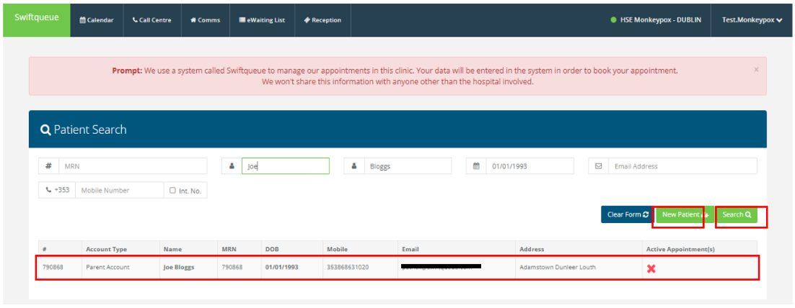

1. Review Appointment Details, and click ‘Book Appointment’

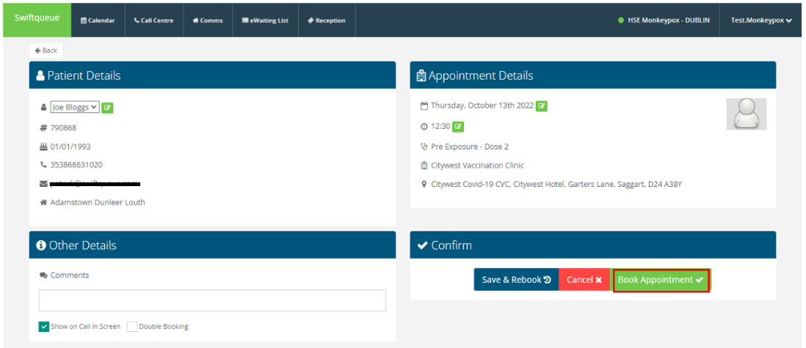

### 6.2 Override Clinic Configuration

To override the clinic configuration when booking an appointment follow the steps outlined here.

1. Click on Calendar
   1. Select any Time/ Date for the Appointment

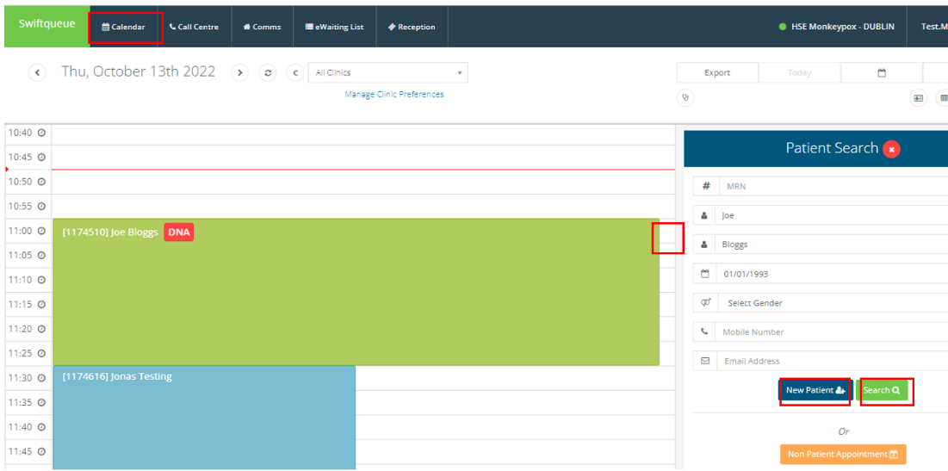

1. Patient Search
   1. Input patient details and select ‘Search’
   2. Review patient details and if it is the correct client, click on ‘Select Patient’ to assign to the appointment
   3. If the patient detail is not correct, click ‘Search Again’ or ‘New Patient’

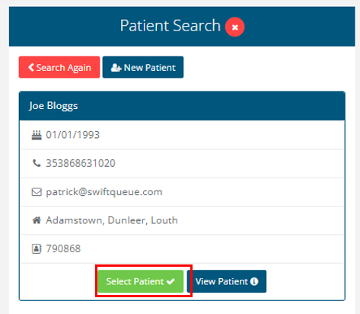

1. Create a New Patient

If the patient record does not exist in the system, then use the ‘New Patient’ option

* 1. Select ‘New Patient’
  2. Input details to the ‘New Patient’ screen
  3. Click Save

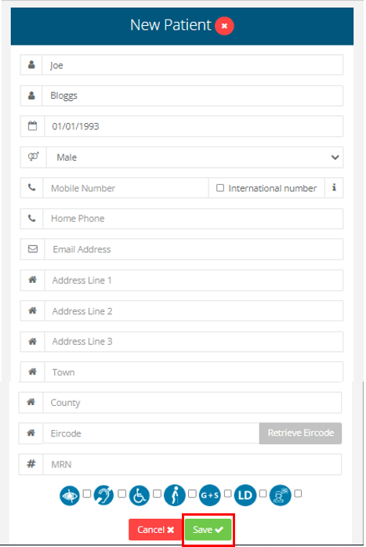

1. Create Appointment
   1. Select the ‘Clinic’ and ‘Appointment Reason’
   2. Click ‘Save’

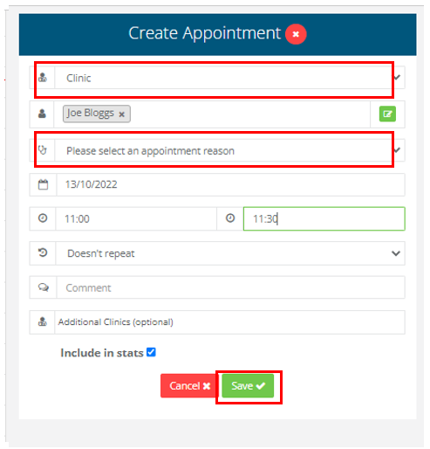

* 1. A popup screen will ask if you want to add an addition appointment to the clinic as you are overriding the clinic configuration.
  2. Click ‘Yes’ to complete appointment booking.

