How to submit an online notification under Section 4 Public Health (Alcohol) Act 2018 when making an application to Revenue
User Guide Version 2
Environmental Health Service, Health Service Executive

The Environmental Health Service has recently introduced
a secure On-line Portal to enable Licensees to submit Alcohol notifications under Section 4 of the Public Health (Alcohol) Act 2018 to the HSE.
This portal is to be used to notify the HSE:
- When renewing a Licence under the Licensing Acts with Revenue
- For applications made direct to Revenue that do not require a Court Certificate (see list below).
First time applications that do not require a Court Certificate:
- Wine Retailers on Licence
- Wholesaler Dealer in Spirits
- Wholesaler Dealer in Spirits of Wine
- Wholesaler Dealer in Wine
- Wholesaler Dealer in Wine & Spirits
- Manufacturer’s Licence - Brewer
- Manufacturer’s Licence - Cider Manufacturer
- Manufacturer’s Licence - Compounder of Spirits
- Manufacturer’s Licence - Distiller of Spirits
- Manufacturer’s Licence - Methylated Spirits
- Manufacturer’s Licence - Rectifier of Spirits
- Manufacturer’s Licence - Sweets Manufacturer.
This guide provides information to the user on how to submit an Alcohol Notification to the HSE via the online portal.
We recommend you use the latest version of Google Chrome as your browser to use the Online Portal.
Google Chrome

How to submit a notification to the Environmental Health Service/Health Service Executive when making your application to Revenue.

Go to https://ehonline.hse.ie/ using Chrome.
In order to submit an Alcohol Notification, you do not need to register for an EH portal account.
Step 1. Click on Submit Notification in Alcohol Licence Notification on the front page.
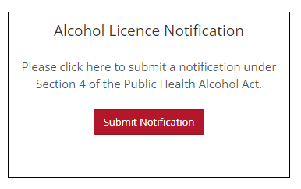
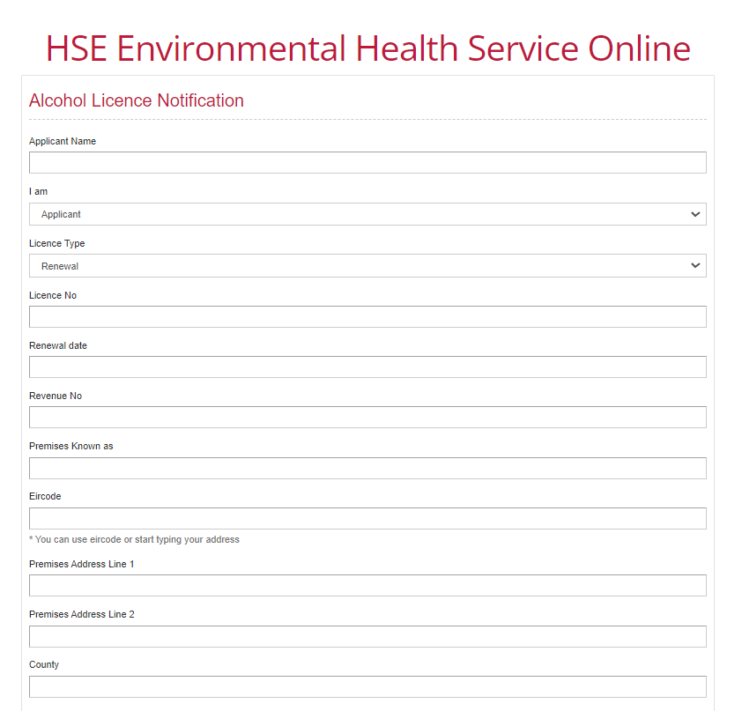
Step 2. Enter Notification Details

Applicant Name: Enter Name of Applicant here.
I am: Enter Applicant name or Agent name here.
Licence Type: Enter Renewal here.
Licence no.: Enter existing Licence number here.
Revenue no.: Enter Revenue number here
Premises Known as:
Enter Name by which Premises is known here e.g. the name over the door.
Eircode: Enter your Eircode here. This will populate the remaining address fields or you may enter the address details manually in the fields provided.
Premises Address Line 1: Enter the first line of the Premises address here
Premises Address Line 2: Enter the second line of the Premises address here
County: Enter your County here e.g. Co. Limerick, Co. Clare

Step 3. You must confirm all details entered and tick to indicate that you have read and understood the HSE Privacy Statement and the HSE Data Protection Policy prior to submitting.
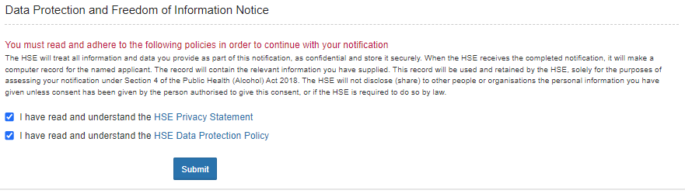
Step 4. Submit: Click on ‘Submit’ to submit the notification.
Once you submit the Notification, a pop-up window will appear with your reference number and a summary of the information which you have submitted.
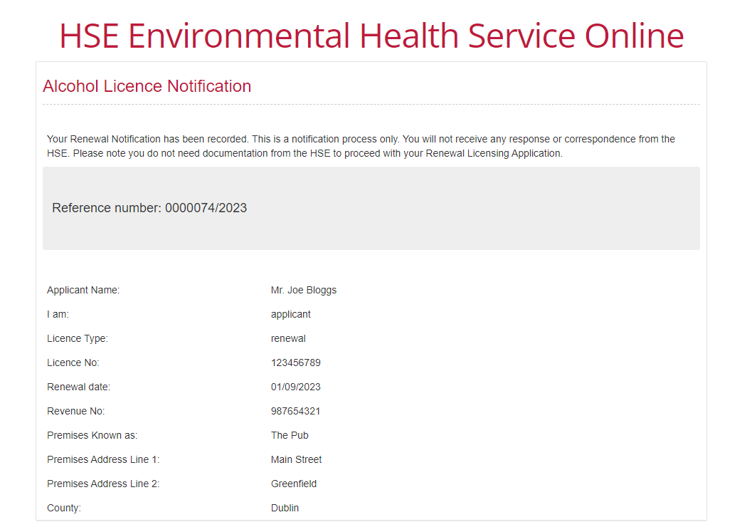
Your Alcohol Notification under Section 4 of the Public Health (Alcohol) Act 2018 is now complete.

