ENVIRONMENTAL HEATLH SERVICE
SUNBED NOTIFICATION ONLINE PORTAL GUIDE

EHIS AND DATA NETWORK SUPPORT UNIT
2023
You may notify your business using the secure HSE On-Line Portal using the following link: https://ehonline.hse.ie
It is recommended that you use Google Chrome search engine.
If you have previously registered on ‘ehonline’ click sign in and enter your username and password.
If not registered on ‘ehonline’ click Register
Enter email address and password and confirm both.
Enter name and address
Click Search
- If your address details are not on ‘ehonline’ database, an error message will appear.
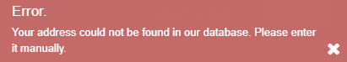
- Select ‘click here’ under the search button to enter address manually if error message appears.
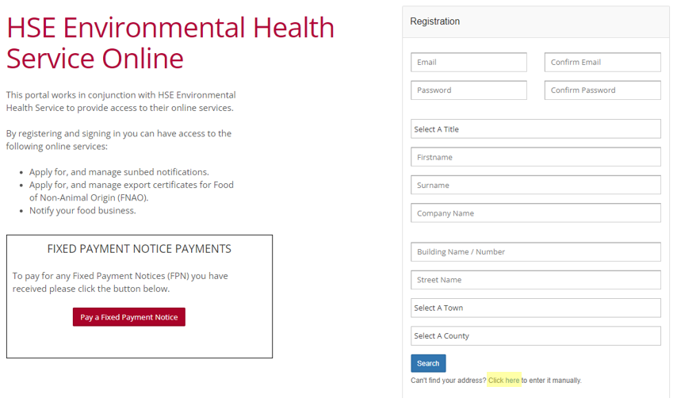
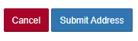
Once address has been entered manually select submit address
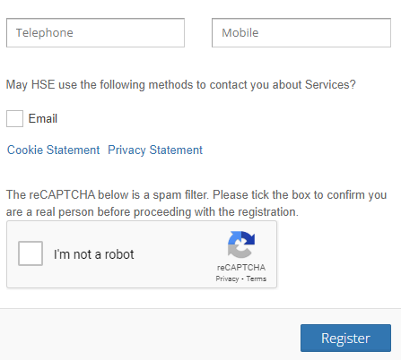
Enter contact number(s) and select the email tick box.
Verify ‘I’m not a robot’ and Register.

Once logged in, click on Sunbed Notifications to proceed.
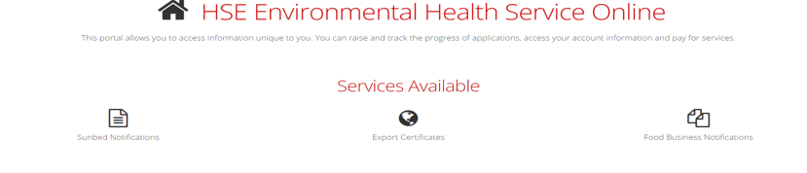

Choose relevant option:
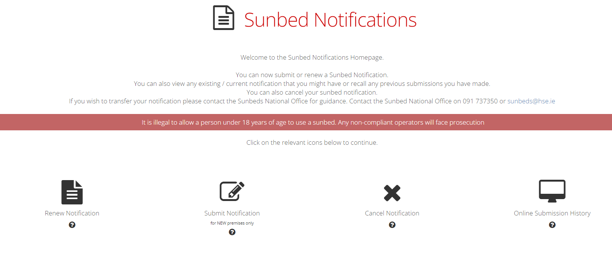
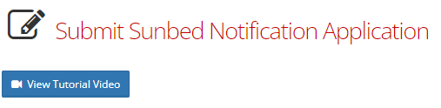
A Tutorial Video is available demonstrating how to complete an online Sunbed application when you select Submit Notification.
To submit a Notification:
For new premises select Submit Notification and to renew a notification select Renew Notification and you will be presented with a list of your current application(s).
Step 1: Enter trading address. There is an option to copy address from user profile available – use this if same address. Click Search.
If ‘no matches found’, an error message appears. Click on ‘enter it manually’ at the bottom of the screen
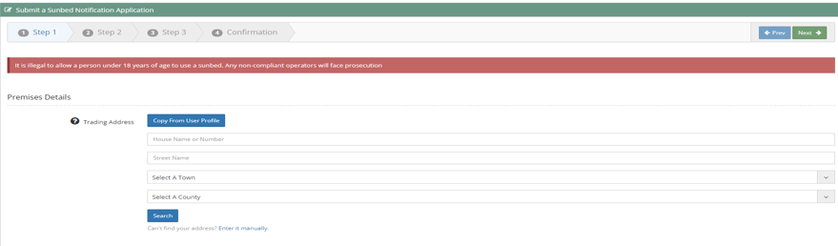
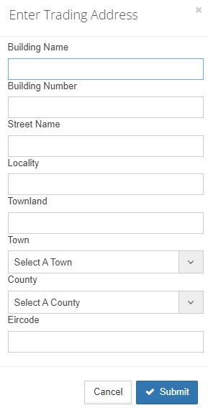
Enter the address and
click on submit

Complete details required in Step 1 and click on ‘Next’.
Note: When Category of Business is selected (use/hire/sale/online) another box pops up for business type to be completed as per 2nd screenshot below. You can scroll up and down to choose most appropriate business type.
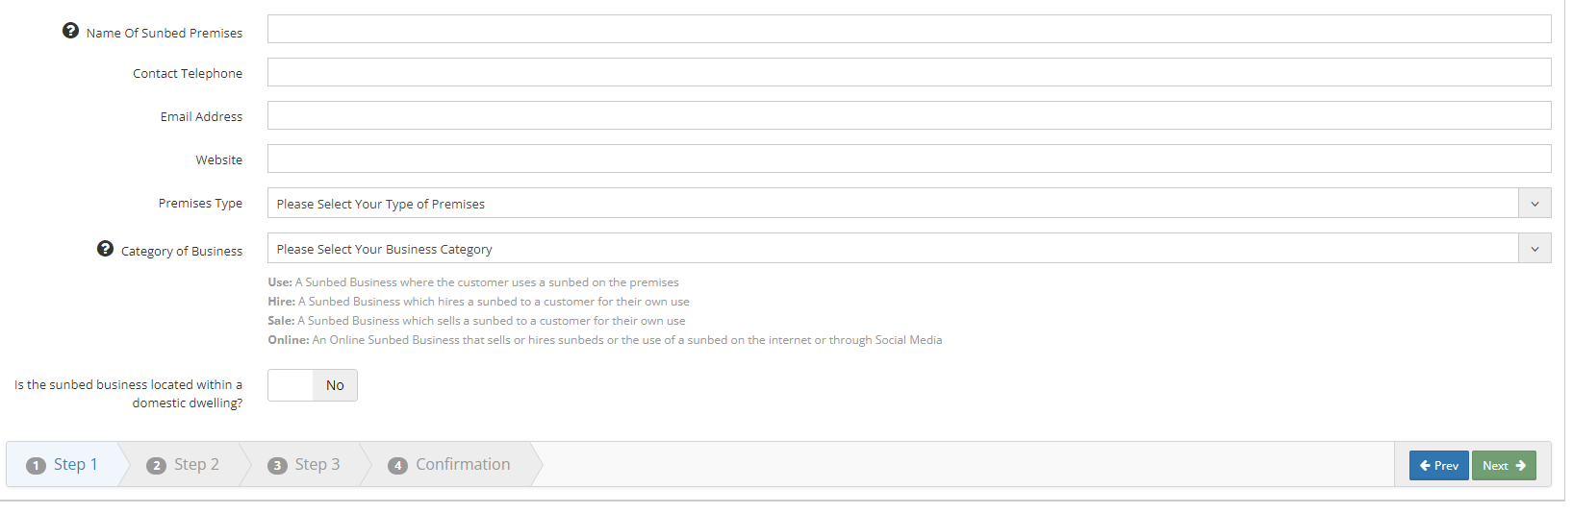
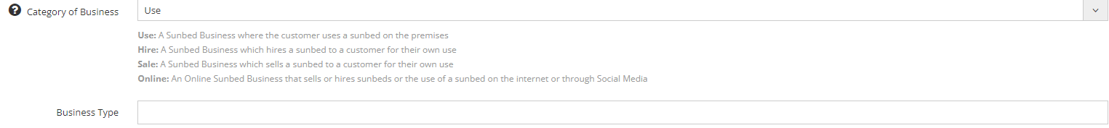
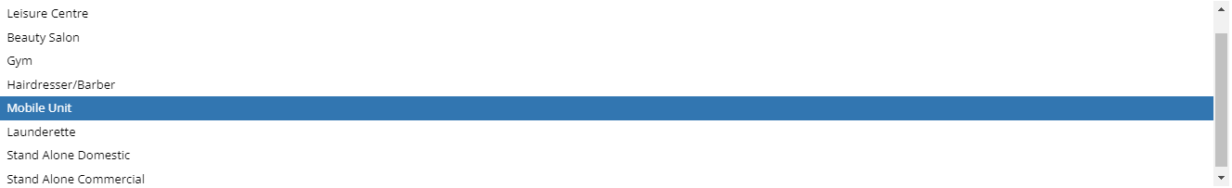
Step 2: Enter Business Details.
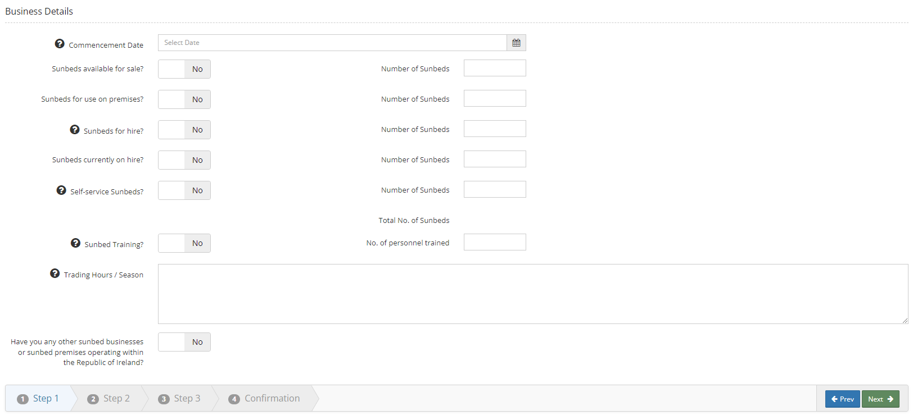
Step 3: Enter Contact Details.
Copy from User Profile also available to select here if details are the same this can be used.
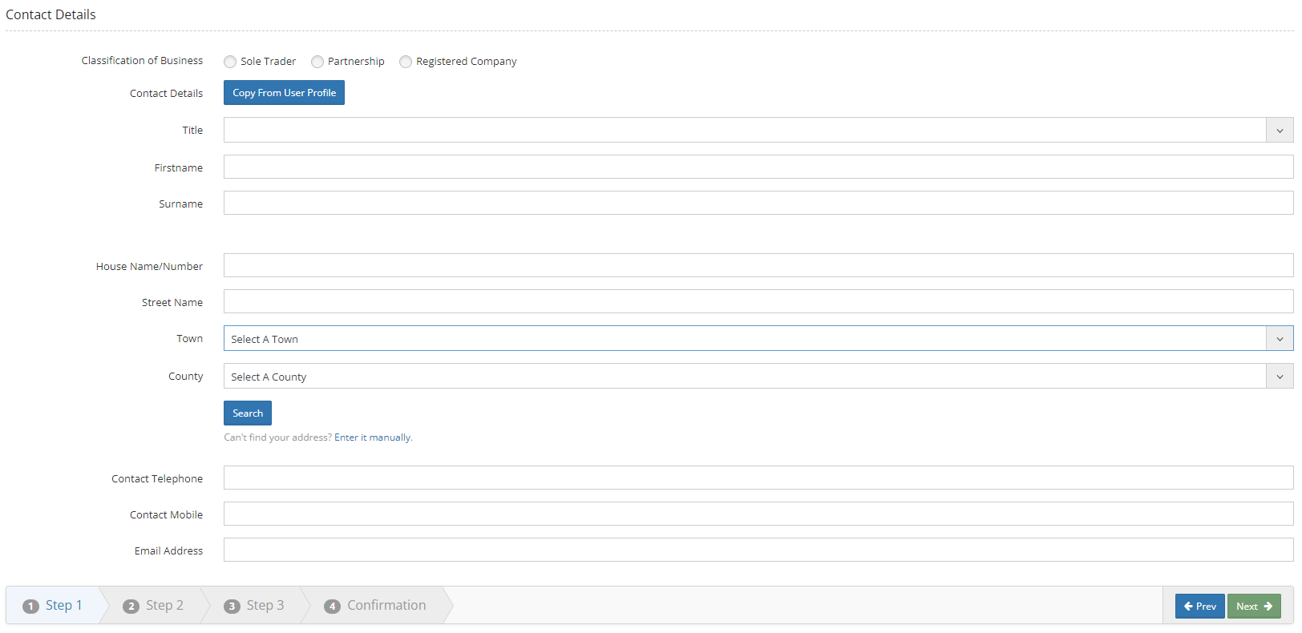
Step 4: Complete Confirmation and proceed to payment.
Complete declaration boxes and click on ‘finish’. A pop up box will appear to proceed to payment – click on ‘Pay’ and complete payment details.
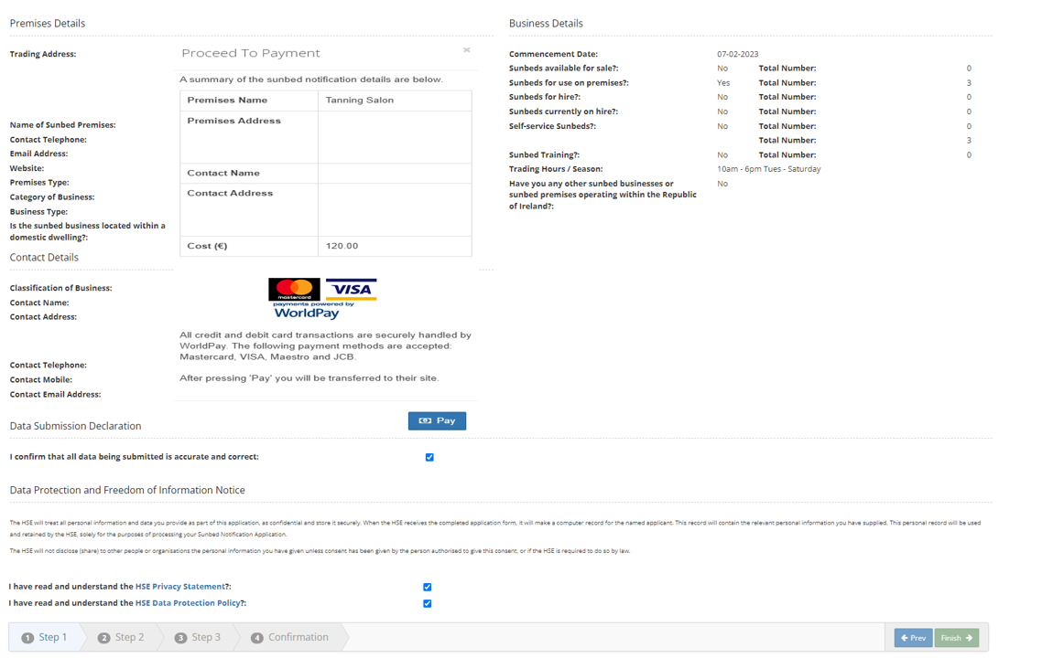
Once you have paid you will receive a message to say your payment was successful. 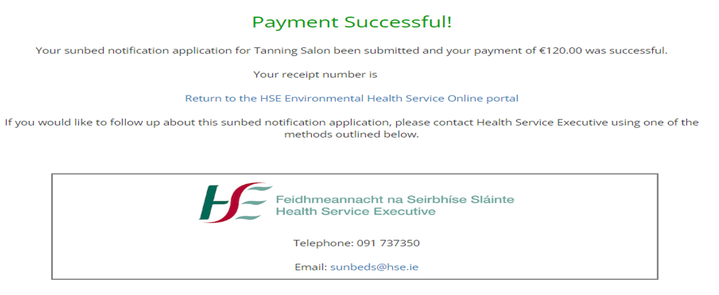
Details of your application will be available in your Online Submission History.

