`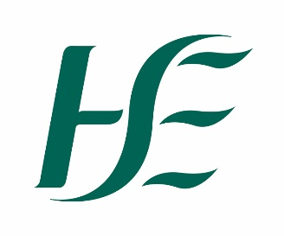

HSE Dental Service Christmas & New Year 2025
Dublin South-East Wicklow
Emergency appointments are available at the clinics listed below
Please contact the clinic by telephone before 9:30am to arrange an appointment
It may not be possible to provide a same day response to calls received later in the day

Wednesday 24th December at:

(Morning only) Balally Primary Care Centre 01 2924536

(Morning only) Dun Laoghaire Primary Care Centre 01 9211205

(Morning only) Wicklow Primary Care Centre 0404 63044

(Morning only) Bray Primary Care Centre 01 7786085

(Morning only) Arklow Primary Care Centre 0402 40544

Thursday 25th December & Friday 26th December all clinics closed

Monday 29thDecember Loughlinstown Health Centre 01 7785050

Balally Primary Care Centre 01 2924536

Greystones Health Centre 01 9213701

Tuesday 30th December Loughlinstown Health Centre 01 7785050

Balally Primary Care Centre 01 2924536

Greystones Health Centre 01 9213701

Wednesday 31st December Balally Primary Care Centre 01 2924536

Wicklow Primary Care Centre 0404 63044

(am only) Dun Laoghaire Primary Care Centre 01 9211205

(am only) Loughlinstown Health Centre 01 7785050

Thursday 1st January all clinics closed

Friday 2nd January Loughlinstown Health Centre 01 7785050
Bray Primary Care Centre 01 7786085
Wicklow Primary Care Centre 0404 63044

Clinic Addresses
Loughlinstown Health Centre, Loughlinstown Drive, Loughlinstown A96 P3Y6
Wicklow Primary Care Centre, Port Road, Knockrobin, Wicklow A67K5C7
Balally Primary Care Centre, Rockfield Medical Campus, Balally, Dublin 16. D16 A6K5
Dun Laoghaire Primary Care Centre, 3rd Floor, Dun Laoghaire Shopping Centre, Marine Rd,
Dun Laoghaire, Co Dublin A96 VA46
Bray Primary Care Centre, Killarney Rd. Bray, Co Wicklow A98KW13
Greystones Health Centre, Victoria Rd., Greystones, Co. Wicklow A63ET81

