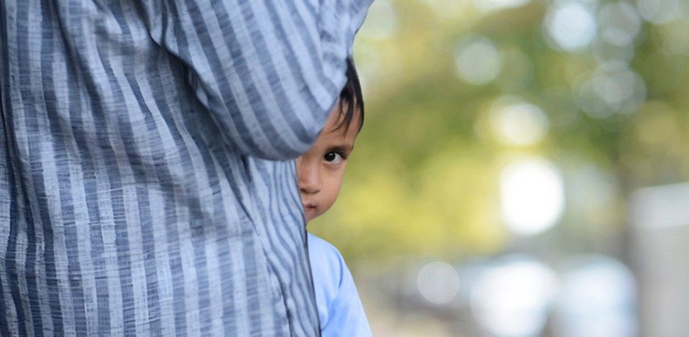



**Child Safeguarding is Everybody’s Business...**

...**protect the children you don’t see.**

Worried about an adult? You may need to worry about a child too!