CHILDREN FIRST

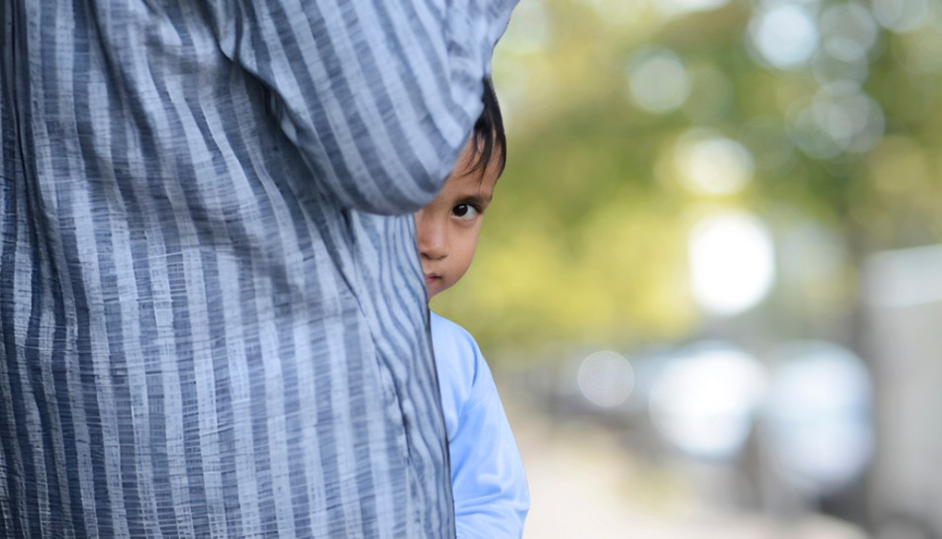

Child Safeguarding in Adult Services

Child safeguarding is everyone's responsibility

Staff working with adults have an important role to play in safeguarding children

All HSE staff have a responsibility to make a report to Tusla - Child and Family Agency, when they have reasonable grounds for concern about the

protection or welfare of a child.

For more information go online and visit

[www.hse.ie/childrenfirst](http://www.hse.ie/childrenfirst)