CHILDREN FIRST

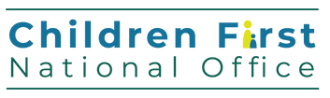

Services working with Children and Young People

Child safeguarding is everyone's responsibility

Services working with children and young people are Relevant Services. They are legally obliged, under the Children First Act 2015, to:

Keep children safe from harm (as far as practicable) Undertake a child safeguarding risk assessment

Develop a Child Safeguarding Statement

For more information go online and visit

[www.hse.ie/childrenfirst](http://www.hse.ie/childrenfirst)