

**HSE Children First Newsletter, June 2025 Edition.**

**Forward by Marion Martin, HSE Children First Lead.**

**Image of Marion Martin HSE Children First Lead**

As we welcome longer days and hope for more of the beautiful sunshine, it’s a perfect time to pause and reflect on the progress we’ve made so far this year in building a safer organisation for children. Across the HSE, staff continue to show dedication, compassion, and commitment to the values of Children First. Thank you for all that you do!

This summer edition introduces a range of new resources designed to support and strengthen your safeguarding practice. Among them is a new policy on child safeguarding and wellbeing within adult mental health services – a vital reminder that child safeguarding is everyone’s responsibility. You’ll also find tools to support your understanding of key legal obligations, including a video on the Criminal Justice (Withholding of Information) Act and a new eLearning module on responding to adult retrospective disclosures of abuse. A Train the Trainer programme has also been developed to support our funded services.

We spotlight the importance of rethinking when a child ‘was not brought’ to an appointment – prompting a more child-centred and proactive safeguarding lens.

Looking ahead, we hope to have new Children First Governance Structures in the second half of the year, to strengthen implementation and oversight across services.

We encourage everyone to explore the updates, take part in training opportunities, and embrace the support available. Your local Training and Development Officers are there to support you – please don’t hesitate to reach out to them if you have any queries.

Image of picture in Frame. Text reads Children First Awareness Week 15 - 21 September 2025. Please save the date. Resources to follow. 

**Contents**

New Policy for Child Safeguarding in Adult Mental Health Services

Leaflet on Limits to Confidentiality

Video on Withholding of Information legislation

eLearning Resource on Retrospective Disclosures of Childhood Abuse

Children First Training updates

Spotlight on: Rethinking ‘Did not Attend’ to safeguard children

**New Resources to strengthen your practice**

[**National Policy for Child Safeguarding and Wellbeing within Adult Mental Health Services**](https://www2.healthservice.hse.ie/organisation/national-pppgs/national-policy-for-child-safeguarding-and-wellbeing-within-adult-mental-health-services/)

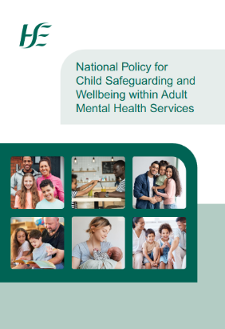

This new policy requires staff in Adult Mental Health Services to carefully consider and be responsive to child safeguarding concerns as part of the ongoing service user journey - from initial assessment through to recovery.

It sets out a clear step-by-step procedure to help staff identify and appropriately manage any potential child safeguarding concerns within a service setting.

The policy is designed to sit alongside and compliment the [HSE Child Protection and Welfare Policy](https://www.hse.ie/eng/services/list/2/primarycare/childrenfirst/hse-child-protection-and-welfare-policy/). In any instance where a child protection or welfare concern is identified the HSE Child Protection and Welfare Policy and [Reporting Procedure](https://www.hse.ie/eng/services/list/2/primarycare/childrenfirst/report-a-concern/) must be followed.

Introductory video available at <https://www.youtube.com/watch?v=1kGUYRP7X5Y>

[**Limits to Confidentiality Leaflet**](https://www.hse.ie/eng/services/list/2/primarycare/childrenfirst/resources/limits-to-confidentiality.html)



The Limits to Confidentiality Leaflet explains to service users why, as HSE staff, we may need to share sensitive or personal information to protect children's safety and well-being.

While we are committed to respecting every service user's right to privacy and keeping their information secure, there are situations where confidentiality must be limited.

If we have concerns about a child’s safety or welfare, we may be legally obliged to share information with Tusla - Child and Family Agency or An Garda Síochána. This is to ensure that children are protected from harm.

[**Criminal Justice (Withholding of Information on Offences Against Children and Vulnerable Persons) Act 2012**](https://www.irishstatutebook.ie/eli/2012/act/24/enacted/en/html)

[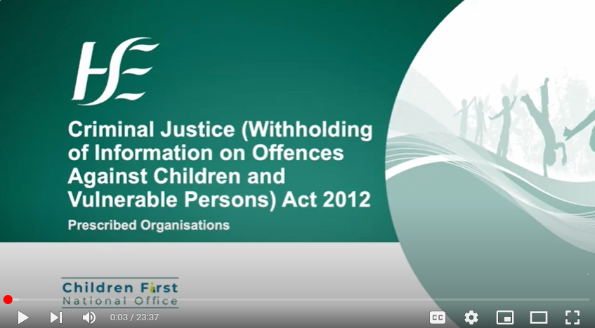](https://www.irishstatutebook.ie/eli/2012/act/24/enacted/en/html)

This legislation requires all individuals to report specified offences against children and vulnerable persons to An Garda Síochána in certain circumstances. It also created an offence of withholding information in this regard.

Specific professionals may have a legal defence available to them if they fail to disclose information to the Gardaí. Some services can also apply to become a ‘Prescribed Organisation’ so that particular staff in those services would also have a legal defence for withholding information.

The first 15 minutes of our video provides information on the Act which is relevant to all HSE staff. The full video is especially useful for services considering applying to become Prescribed Organisations under the Act. The video along with all resources referenced in it can be found at [www.hse.ie/childrenfirst](https://www.hse.ie/eng/services/list/2/primarycare/childrenfirst/resources/#Withholding).

**Responding to Adult Retrospective Disclosures of Childhood Abuse**

This eLearning programme, which will be available on HSeLanD, is designed to equip staff with the knowledge and confidence to recognise and respond to adult retrospective disclosures of childhood abuse.

This module is aimed at frontline staff working in HSE roles, including those in HSE funded and contracted services or with General Practice services. All staff and those who have line manager responsibilities can benefit from this programme, as adult disclosures can arise in any service context.

More on Children First Compliance Assurance is available at <https://www.hse.ie/eng/services/list/2/primarycare/childrenfirst/compliance-self-audit-checklist/>

More on Resources for Line Managers is available at <https://www.hse.ie/eng/services/list/2/primarycare/childrenfirst/hse-staff/children-first-resource-pack-for-hse-line-managers.pdf>

More on Children Fist National Office Frequently Asked Questions is available at <https://www.hse.ie/eng/services/list/2/primarycare/childrenfirst/faqs/>

More on Reporting a Concern is available at <https://www.hse.ie/eng/services/list/2/primarycare/childrenfirst/report-a-concern/>

More on Mandated Persons is available at <https://www.hse.ie/eng/services/list/2/primarycare/childrenfirst/resources/mandated-persons.pdf>

**Training updates**

Training for Mandated Persons, Train the Trainer Programme now available.

Funded Services are invited to express an interest in our Train the Trainer Programme - for Children First Mandated Persons training.

The aim of the programme is to equip participants to deliver the training in their own organisations. A programme will run later this year. Email us at [**childrenfirst@hse.ie**](mailto:childrenfirst@hse.ie) with “FAO Train the Trainer Programme” in the subject line to express interest.

**Training Resources**

For information on all Children First training available from the [HSE Children First National Office](https://www.hse.ie/eng/services/list/2/primarycare/childrenfirst/training/) please visit our website.

Briefings, workshops and bespoke child safeguarding training can be accessed through your local Children First Training and Development Officer. You can contact us at <https://www.hse.ie/eng/services/list/2/primarycare/childrenfirst/contactus/>.

**Staff Survey**

We want to hear from you! This summer, we'll be inviting you to take part in a short, important survey - landing in your email inbox soon! We want to know how confident you feel in recognising and responding to Child Protection and Welfare concerns. Your honest responses will help us to plan for future training and resources.

Please take that time. Thank you.

**Spotlight on Rethinking Did not Attend**

The phrase ‘did not attend’ is widely used in the HSE when people do not present for appointments. When used in relation to children, it can imply that the child is responsible for their own attendance.

If we rethink this, and consider that a child ‘was not brought’ to an appointment, we shift the focus to adult responsibility. This reminds us that children rely on adults to have their needs met. It prompts us to think about what might be going on for the child and family, including the possibility of child protection or welfare concerns.

Some questions to consider:

* Are there any factors or vulnerabilities that might be making it difficult for these parents/carers to bring this child to appointments?
* What are the implications of missing the appointment for the child?
* Could this missed appointment negatively affect the child’s health, development or welfare?

If you are reporting concerns to Tusla, it is essential that you provide **detailed information** about your concerns. It is not sufficient to submit a report saying that you are concerned about, “missed appointments”. You must explain what your concerns are and why they are significant.

Key messages:

* Adults are responsible for bringing children to appointments.
* Caregivers should be supported to bring children to appointments when possible.
* The welfare of the child must always be paramount!

For more discussion on this topic and more joinus for one of our live Q&A Webinars. Click on the following link to register: <https://hse.webex.com/weblink/register/r4f67e75ba74f0508986f1e1204bd267a>

**Child Safeguarding Live Q&A Webinars**

We run four interactive webinars per year. We look at key child safeguarding topics and real-world challenges faced by practitioners.

These sessions provide opportunity to ask questions and gain valuable insights. One of the topics that will be explored is the subject of this issue’s ‘Spotlight on’ feature Rethinking “Did not Attend”.

Join the discussion to strengthen your child safeguarding knowledge and practice.

**Coming Soon**

New! HSE National Child Protection and Welfare Policy.

Currently in the final stages of development, the new HSE National Child Protection

and Welfare Policy is expected to be published in Q4 2025.

Image of New HSE National Child Protection and Welfare Policy front cover. Includes images of four guides that will accompany the policy. 
Guide 1: Developing and Reviewing Child Safeguarding Statements
Guide 2: Reporting Child Protection and Welfare Concerns
Guide 3: Managing Child Protection and Welfare Records
Guide 4: Sharing Child Safeguarding and Protection Information