

**Child Safeguarding is Everybody’s Business...**

...make it yours. Do your mandatory

**Children First Training.**

[](https://www.hse.ie/eng/services/list/2/primarycare/childrenfirst/training/)Complete 'An Introduction to Children First' eLearning on HSeLanD every three years.

WE CAN ALL MAKE A DIFFERENCE.

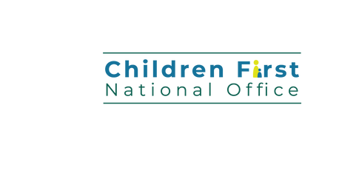

For more information visit [www.hse.ie/childrenfirst](https://www.hse.ie/eng/services/list/2/primarycare/childrenfirst/training/)