CHILDREN FIRST AWARENESS WEEK QUIZ

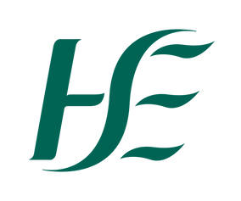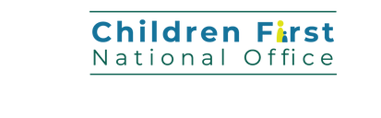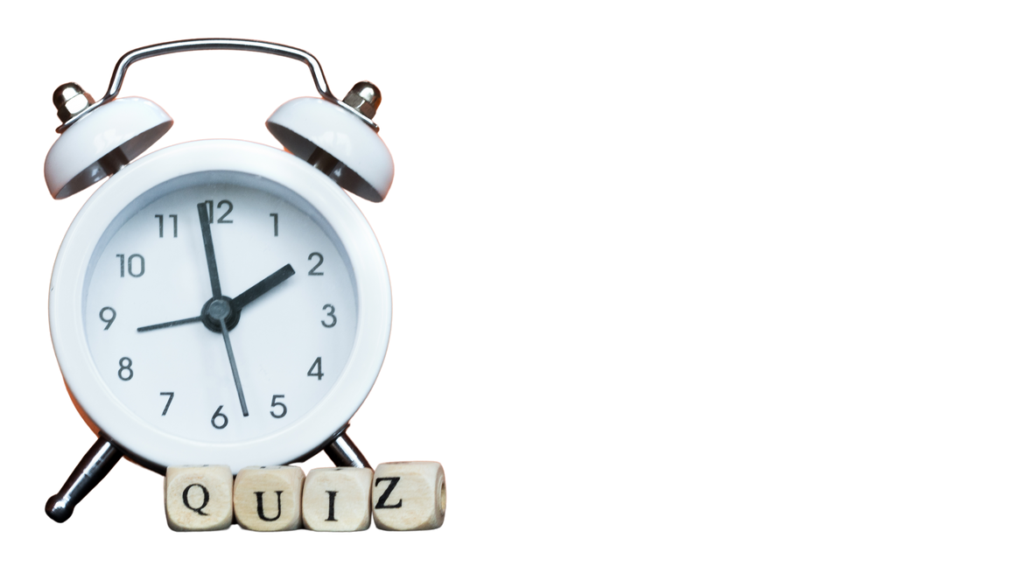

Take 3 mins out for Children

First...

15 - 21 September 2025

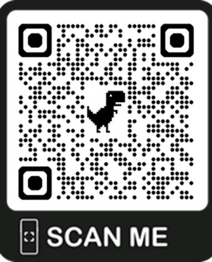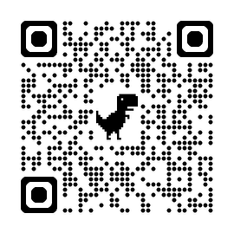

1. SCAN THE CODE
2. READ THE KEY MESSAGES
3. 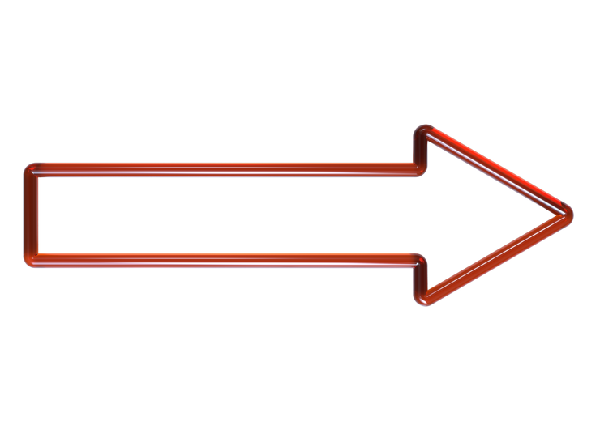TAKE THE QUIZ!

... and be in with a chance to win a €150 Voucher