

**Child Safeguarding is Everybody’s Business...**

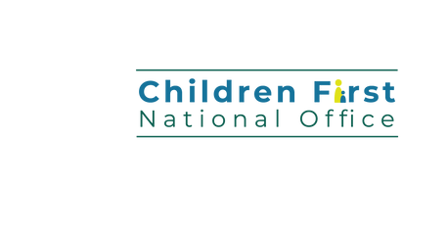

...make sure that your service **protects children and families.**

Complete a Child Safeguarding Risk Assessment  Develop a Child Safeguarding Statement

WE CAN ALL MAKE A DIFFERENCE.

For more information visit

[www.hse.ie/childrenfirst](https://www.hse.ie/eng/services/list/2/primarycare/childrenfirst/child-safeguarding-statement/)

