Word Search

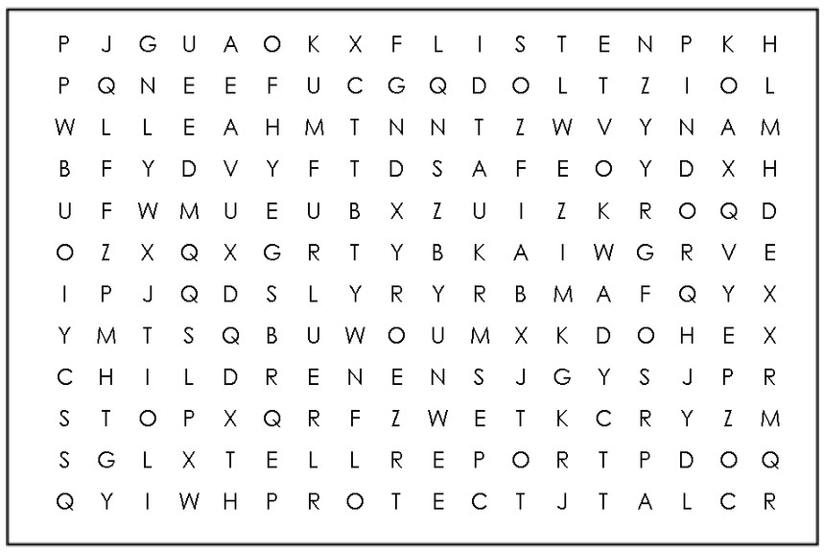

**CHILDREN EVERYONE**

**PROTECT LISTEN**

**REPORT TRUST**

**WORRY SAFE**

**TELL STOP**

**Child Safeguarding is everybody’s business.**

If you are worried or are not safe or someone you know

is not safe you can talk to a staff member today. You can also scan here

**to send Tusla a message**

**or ring 0818 776 315**