

GP Access to Diagnostics -Radiology *Referral Overview*

Please refer to the GP Access to Diagnostics FAQ document for further information.

1. High-level GP Referral Pathway

Please refer to the Radiology Diagnostics Referral Pathway for the detailed process from pre scan to post scan. The image below is a high-level overview of the GP referral pathway process before making a referral:

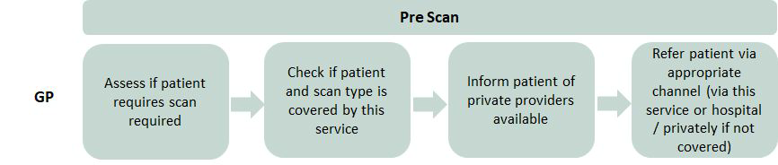

2. How do I make a referral?

You can make a referral to all private providers (except Global Diagnostics) by submitting an e-referral using the General Referral Form on Healthlink. Healthlink can be accessed via the Healthlink web portal or via your accredited practice management software.

If you are referring to Global Diagnostics, you can email referrals to [​hse@globaldiagnostics.ie​](mailto:​hse@globaldiagnostics.ie​) or use the secure ‘fax to email’ line at 01 5313425.

3. What information do I need to include on the referral?

When filling out the General Referral Form via Healthlink, all required fields should be filled out.

**Please note the new code: ‘GP Access to Community Diagnostics’ which is to be used for referrals.**

You must also include the following information specified below in the free text box on the General Referral Form:

|  |  |  |
| --- | --- | --- |
| **#** | **Information Required in General Referral Free Text Box** | **Example** |
| **1** | Code: ‘GP Access to Community Diagnostics’ | GP Access to Community Diagnostics |
| **2** | CHO | CHO 1 |
| **3** | Area (per ‘GP Access to Diagnostics CHO Private Providers’  document) | Cavan and Monaghan |
| **4** | Medical card or GP visit card number if available  (8 characters) | A1B23456C |
| **5** | Provider and Location | Alliance Medical, Galway |
| **6** | Modality | CT |
| **7** | Part of the body to be scanned (depending on type of scan  being requested) | Sinuses |
| **8** | Urgent or Routine | Routine |
| **9** | Patient mobile number (if not provided already) | 086-123-4567 |
| **10** | Relevant clinical information, including previous imaging and where this was done | MRI Brain at St James’  Hospital |

It is particularly important that all of the above information is specified correctly on the referral, particularly the **valid medical card or GP visit card number where applicable**. Failure to include this will result in the private providers not accepting a referral or the patient being charged.